|  |  |
| --- | --- |
| London Output Area Classification 2021  Borough Profiles |  |
|  |  |
| 14/08/23  Consumer Data Research Centre  Authored by: [Alex Singleton, Paul Longley] |  |

# Westminster

## Spatial Distribution

The following map shows the spatial distribution of LOAC Groups across the London borough of Westminster.

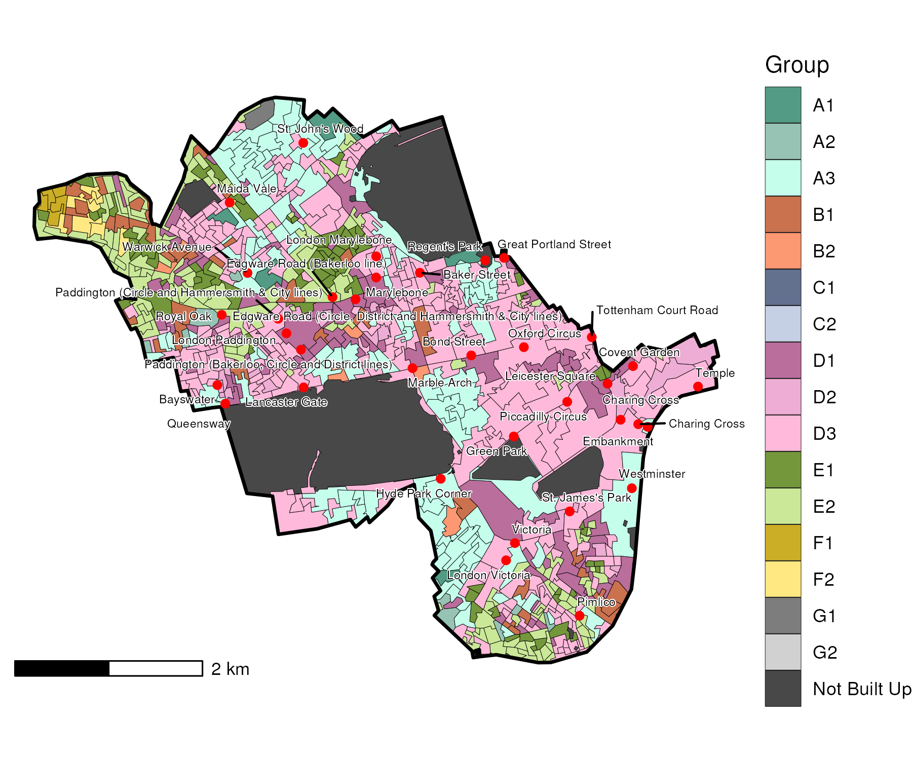

## Index Scores

The distribution of LOAC Groups within Westminster relative to the London average can be shown by calculating an index score. If a distribution was the same as the London average the score would be 100. A score of 200 represents double the London average, and 50 a half. Scores that are less than 80 and greater than 120 are typically indicators of an interesting pattern to interpret, and are the thresholds used to describe the LOAC Super Groups and Groups. Where LOAC Groups are not present within a borough, the LOAC Group codes are 'greyed out'.

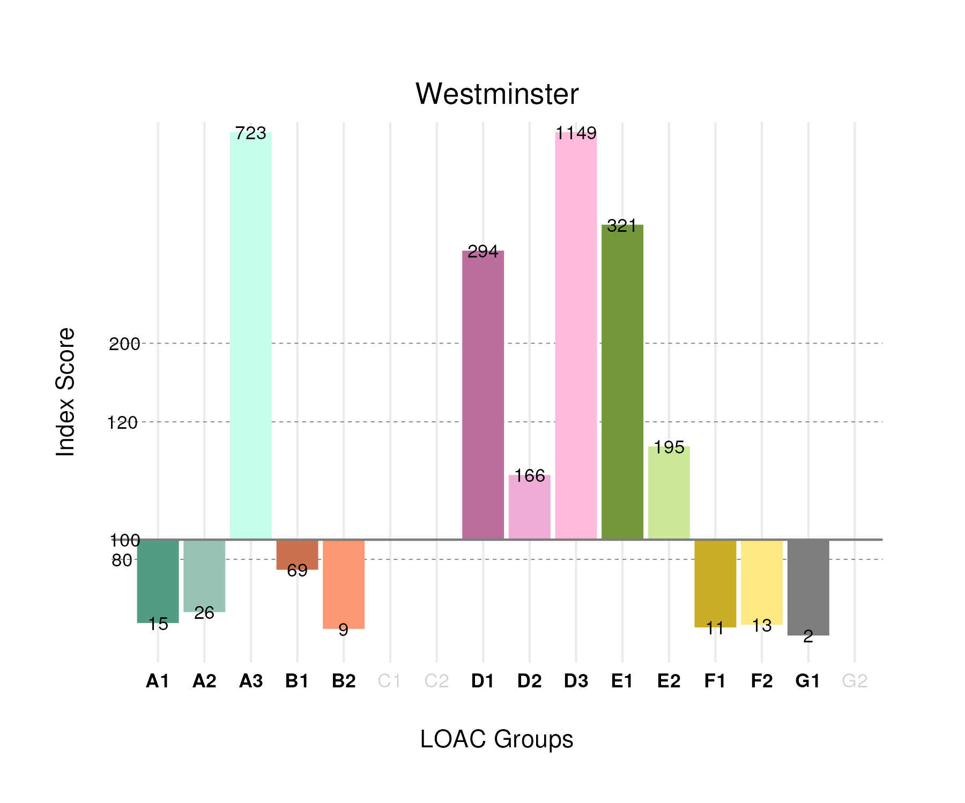

## Population Counts

The distribution of the population by LOAC Groups is shown in the following table.

| Group | Total Population (Census 2021) |
| --- | --- |
| A1 | 1,194 |
| A2 | 1,992 |
| A3 | 25,925 |
| B1 | 12,335 |
| B2 | 1,481 |
| C1 | 0 |
| C2 | 0 |
| D1 | 24,215 |
| D2 | 6,213 |
| D3 | 58,292 |
| E1 | 23,951 |
| E2 | 43,197 |
| F1 | 1,922 |
| F2 | 3,137 |
| G1 | 353 |
| G2 | 0 |

# Wandsworth

## Spatial Distribution

The following map shows the spatial distribution of LOAC Groups across the London borough of Wandsworth.

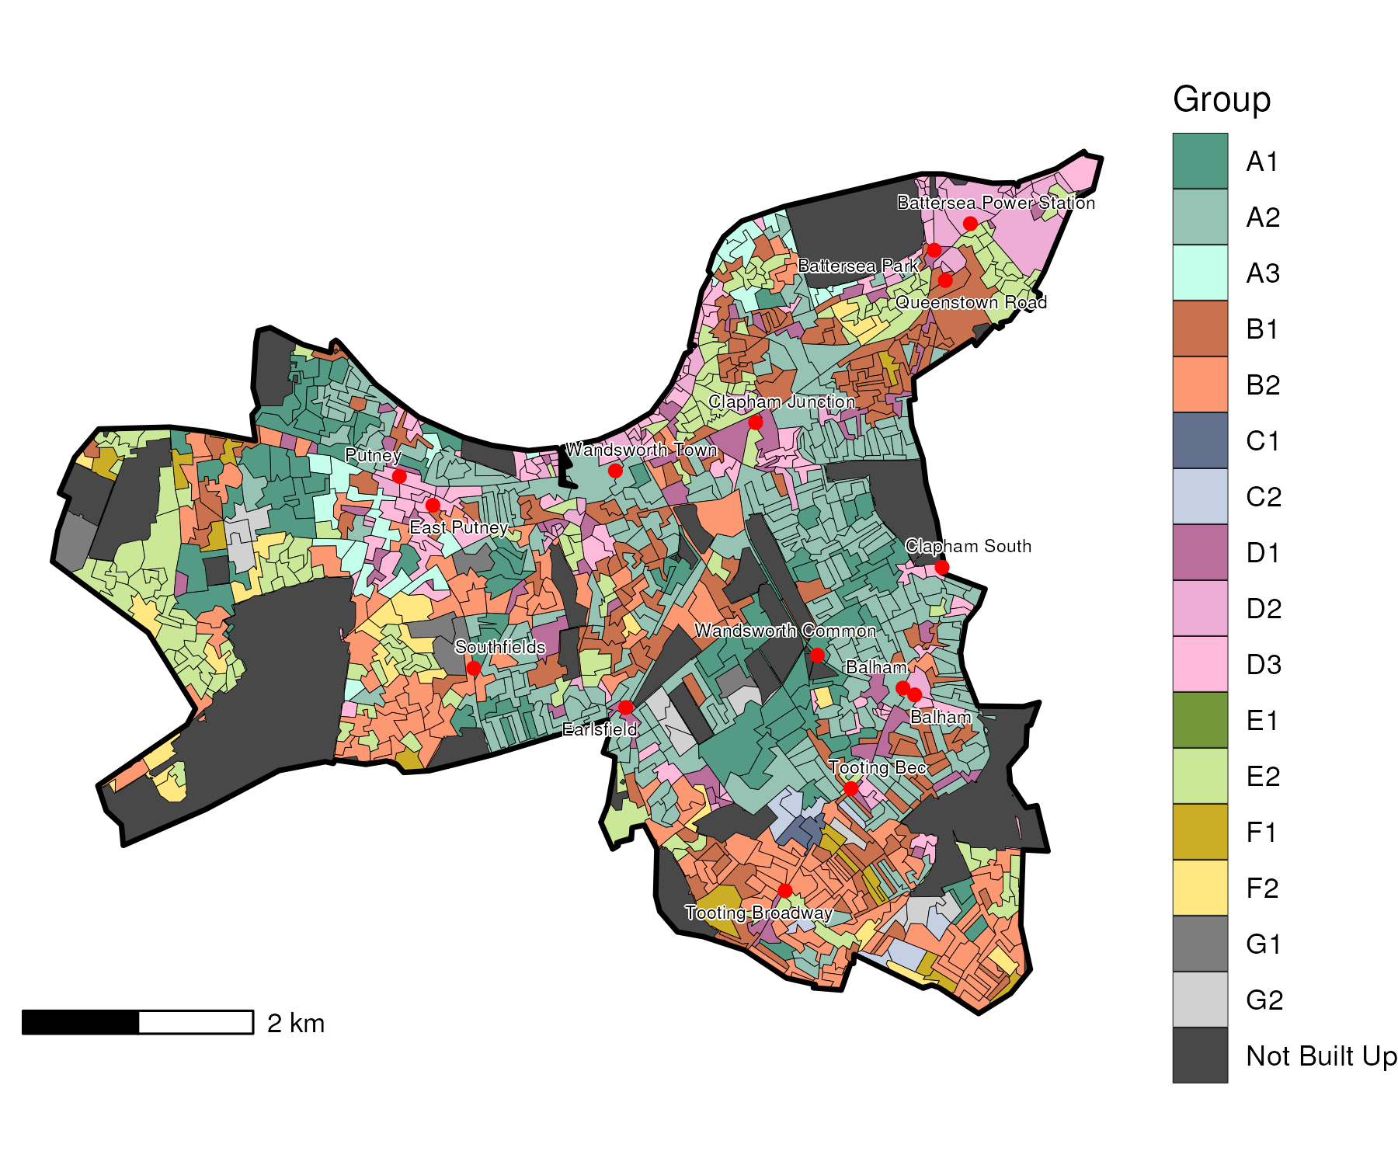

## Index Scores

The distribution of LOAC Groups within Wandsworth relative to the London average can be shown by calculating an index score. If a distribution was the same as the London average the score would be 100. A score of 200 represents double the London average, and 50 a half. Scores that are less than 80 and greater than 120 are typically indicators of an interesting pattern to interpret, and are the thresholds used to describe the LOAC Super Groups and Groups. Where LOAC Groups are not present within a borough, the LOAC Group codes are 'greyed out'.

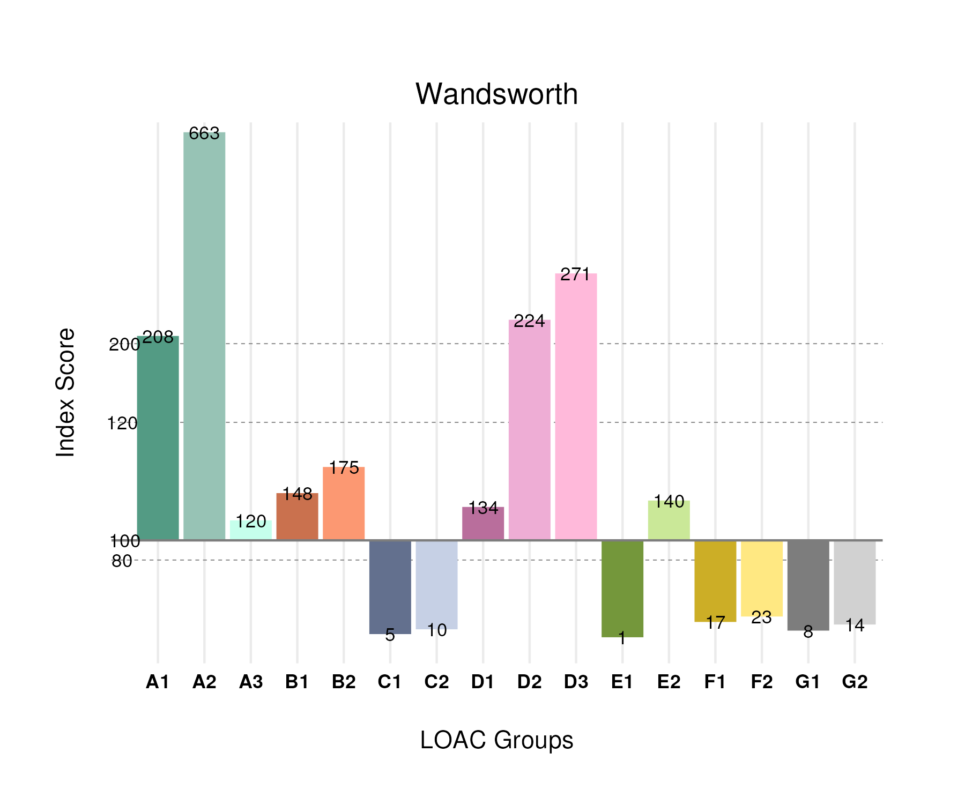

## Population Counts

The distribution of the population by LOAC Groups is shown in the following table.

| Group | Total Population (Census 2021) |
| --- | --- |
| A1 | 26,230 |
| A2 | 80,596 |
| A3 | 6,913 |
| B1 | 42,206 |
| B2 | 45,031 |
| C1 | 895 |
| C2 | 3,091 |
| D1 | 17,679 |
| D2 | 13,470 |
| D3 | 22,087 |
| E1 | 174 |
| E2 | 49,889 |
| F1 | 4,911 |
| F2 | 8,506 |
| G1 | 1,914 |
| G2 | 3,840 |

# Waltham Forest

## Spatial Distribution

The following map shows the spatial distribution of LOAC Groups across the London borough of Waltham Forest.

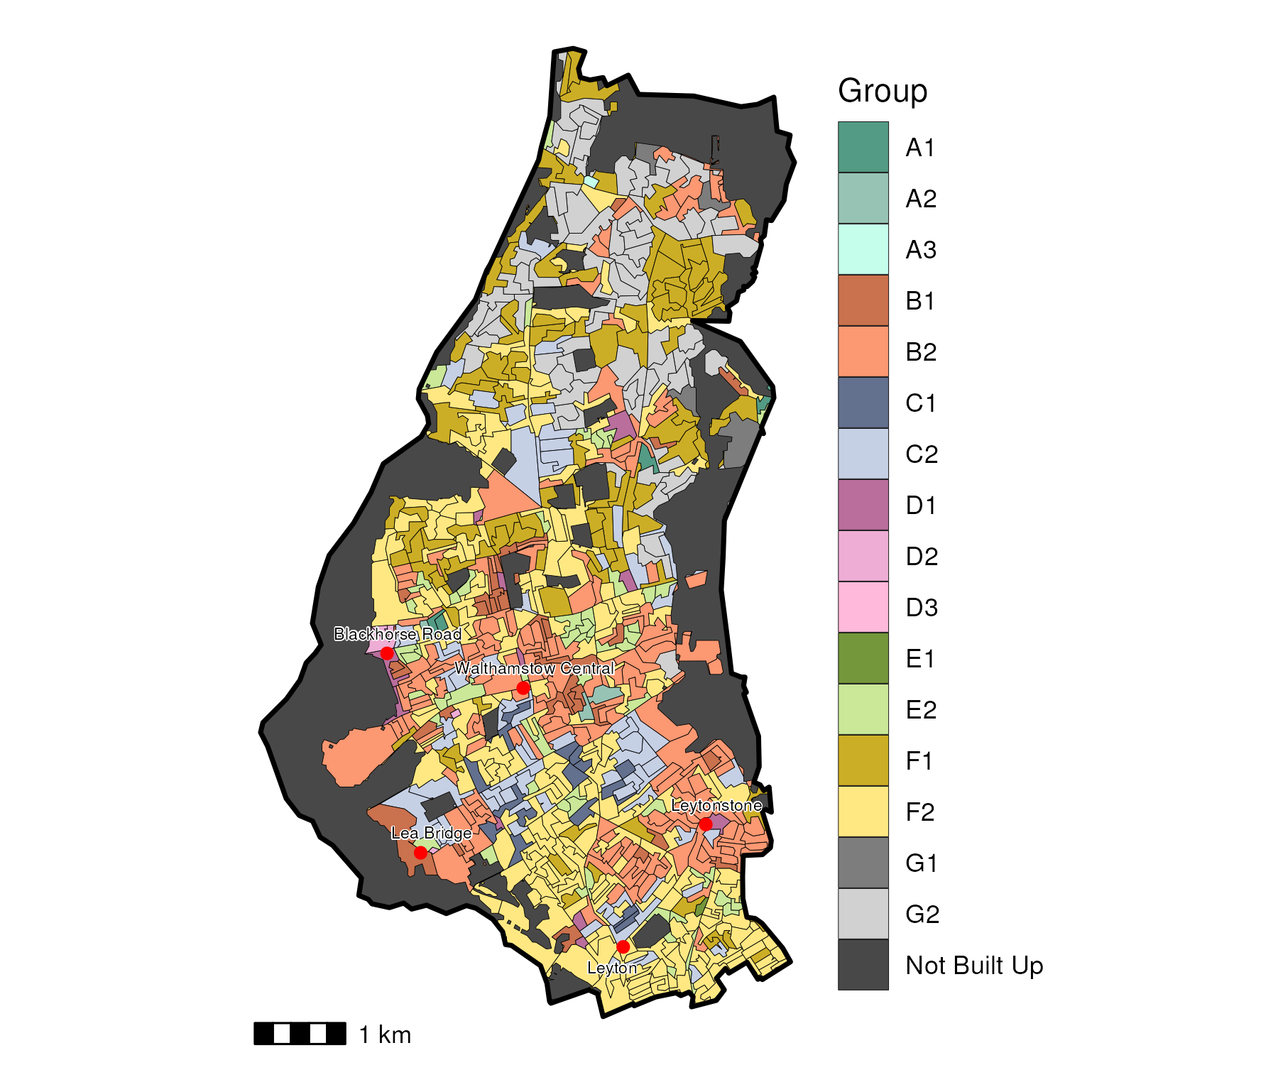

## Index Scores

The distribution of LOAC Groups within Waltham Forest relative to the London average can be shown by calculating an index score. If a distribution was the same as the London average the score would be 100. A score of 200 represents double the London average, and 50 a half. Scores that are less than 80 and greater than 120 are typically indicators of an interesting pattern to interpret, and are the thresholds used to describe the LOAC Super Groups and Groups. Where LOAC Groups are not present within a borough, the LOAC Group codes are 'greyed out'.

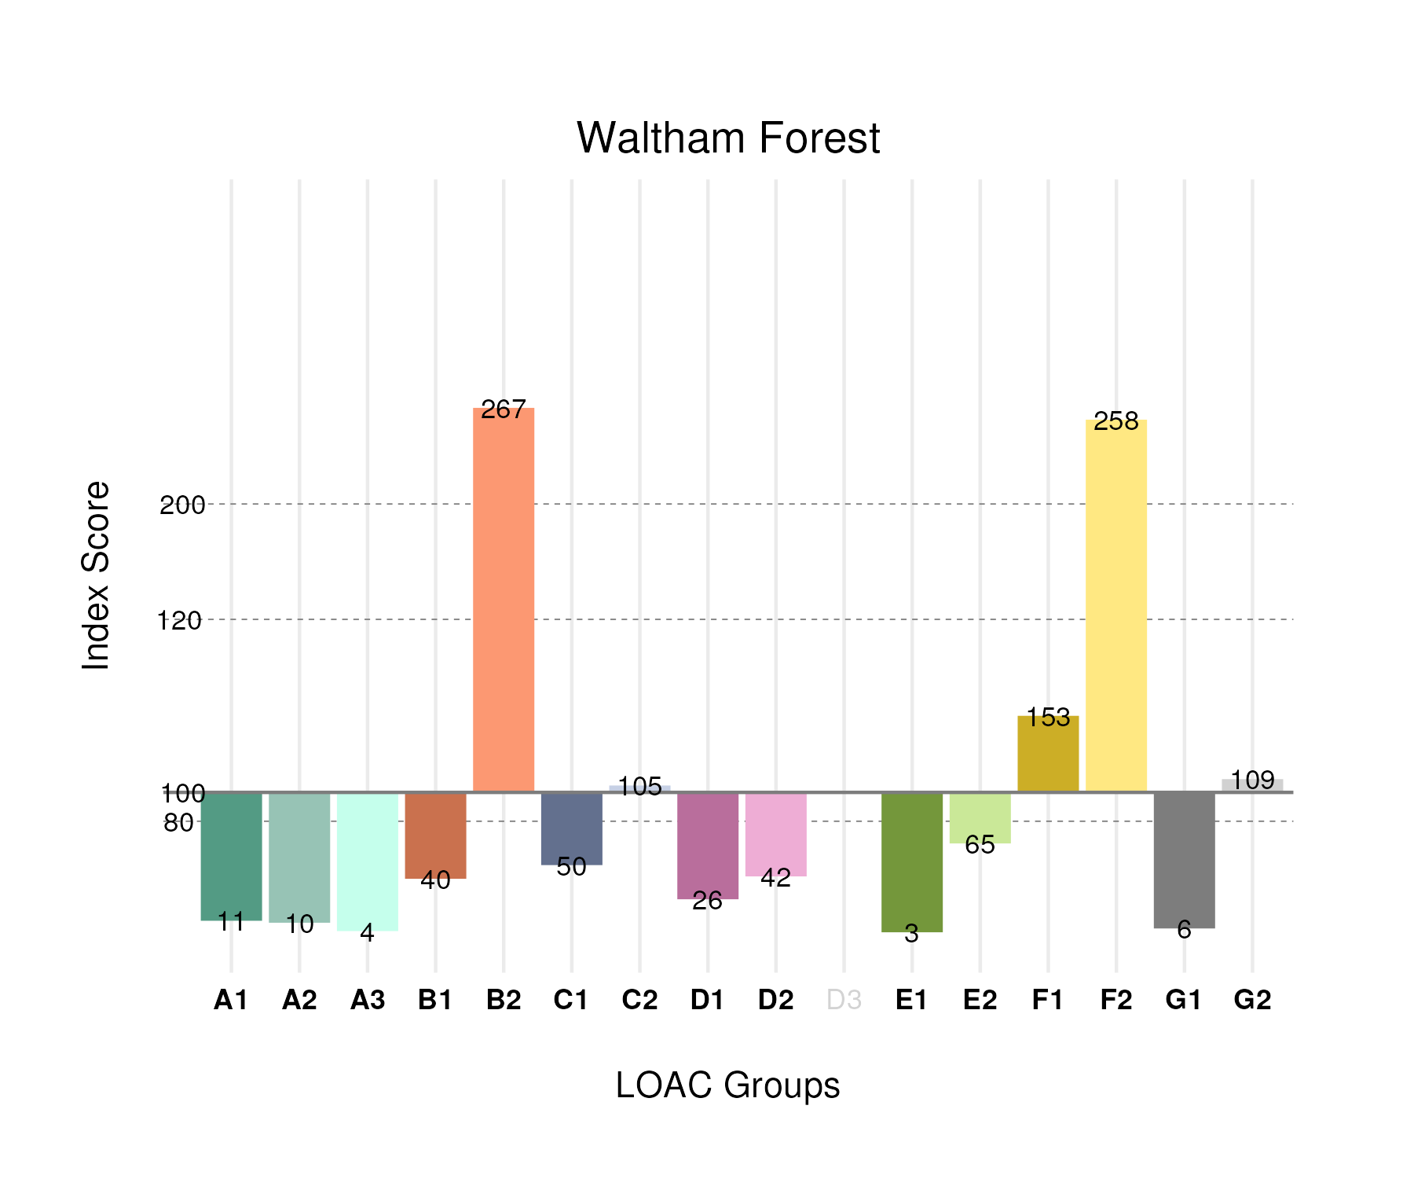

## Population Counts

The distribution of the population by LOAC Groups is shown in the following table.

| Group | Total Population (Census 2021) |
| --- | --- |
| A1 | 1,179 |
| A2 | 995 |
| A3 | 188 |
| B1 | 9,723 |
| B2 | 58,477 |
| C1 | 8,043 |
| C2 | 28,769 |
| D1 | 2,906 |
| D2 | 2,132 |
| D3 | 0 |
| E1 | 306 |
| E2 | 19,513 |
| F1 | 37,511 |
| F2 | 82,870 |
| G1 | 1,119 |
| G2 | 24,727 |

# Tower Hamlets

## Spatial Distribution

The following map shows the spatial distribution of LOAC Groups across the London borough of Tower Hamlets.

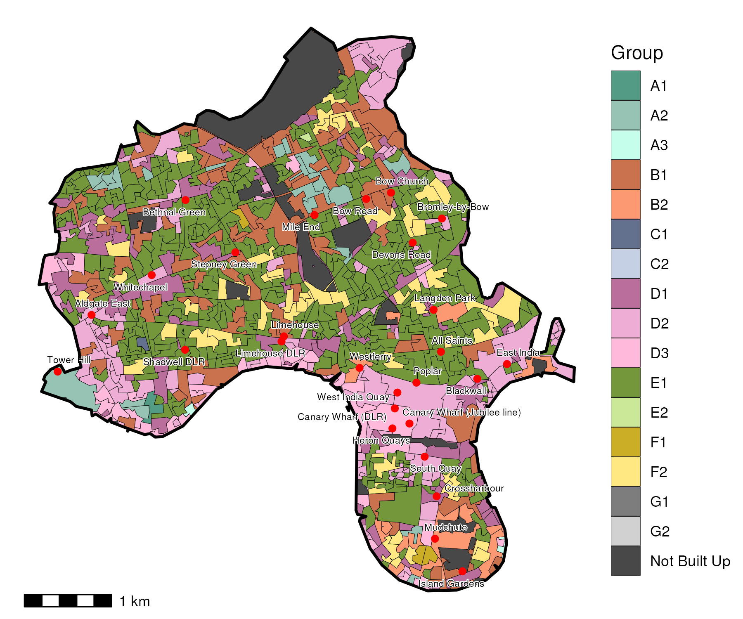

## Index Scores

The distribution of LOAC Groups within Tower Hamlets relative to the London average can be shown by calculating an index score. If a distribution was the same as the London average the score would be 100. A score of 200 represents double the London average, and 50 a half. Scores that are less than 80 and greater than 120 are typically indicators of an interesting pattern to interpret, and are the thresholds used to describe the LOAC Super Groups and Groups. Where LOAC Groups are not present within a borough, the LOAC Group codes are 'greyed out'.

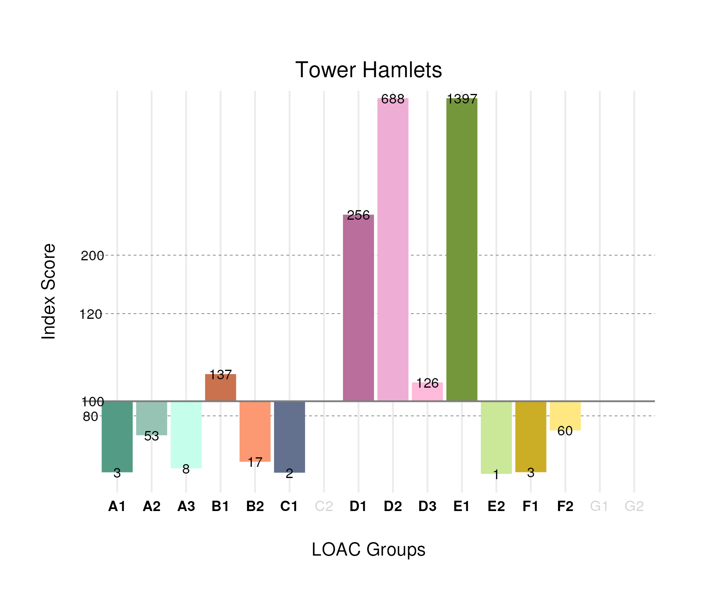

## Population Counts

The distribution of the population by LOAC Groups is shown in the following table.

| Group | Total Population (Census 2021) |
| --- | --- |
| A1 | 319 |
| A2 | 6,156 |
| A3 | 442 |
| B1 | 37,064 |
| B2 | 4,194 |
| C1 | 391 |
| C2 | 0 |
| D1 | 31,953 |
| D2 | 39,150 |
| D3 | 9,702 |
| E1 | 158,508 |
| E2 | 186 |
| F1 | 775 |
| F2 | 21,478 |
| G1 | 0 |
| G2 | 0 |

# Sutton

## Spatial Distribution

The following map shows the spatial distribution of LOAC Groups across the London borough of Sutton.

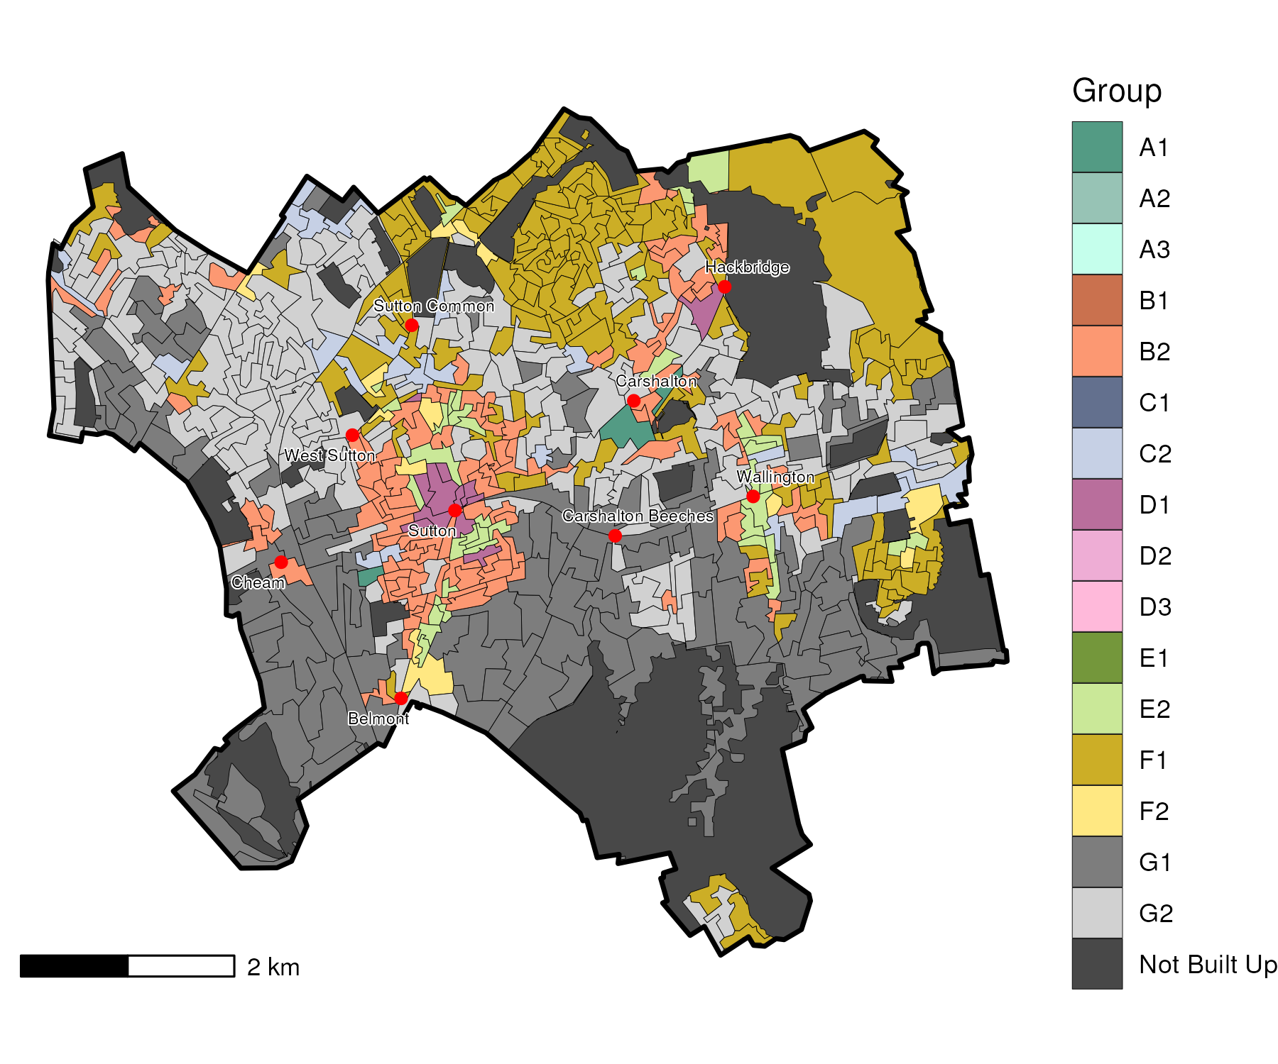

## Index Scores

The distribution of LOAC Groups within Sutton relative to the London average can be shown by calculating an index score. If a distribution was the same as the London average the score would be 100. A score of 200 represents double the London average, and 50 a half. Scores that are less than 80 and greater than 120 are typically indicators of an interesting pattern to interpret, and are the thresholds used to describe the LOAC Super Groups and Groups. Where LOAC Groups are not present within a borough, the LOAC Group codes are 'greyed out'.

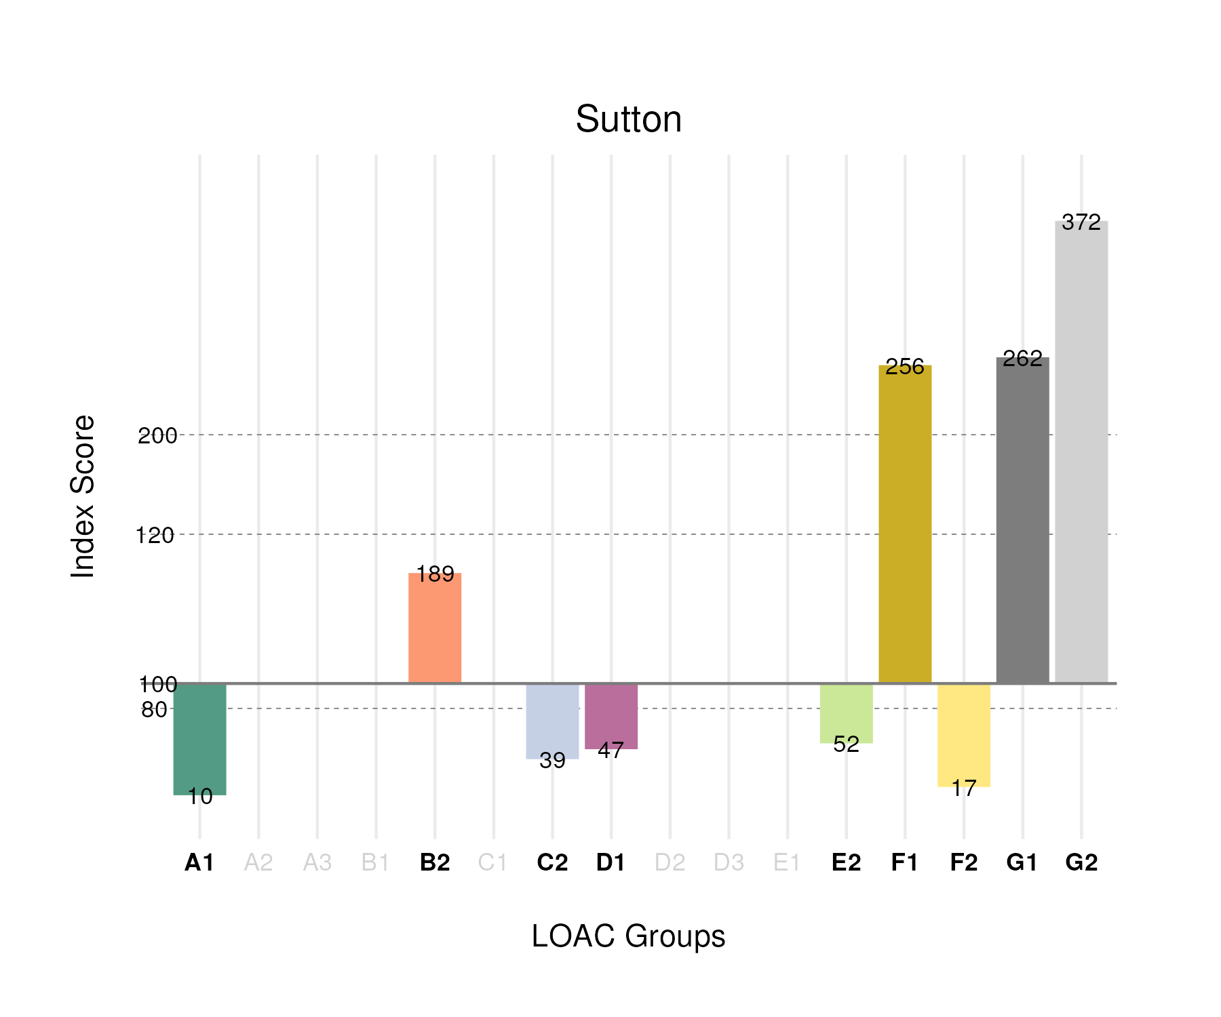

## Population Counts

The distribution of the population by LOAC Groups is shown in the following table.

| Group | Total Population (Census 2021) |
| --- | --- |
| A1 | 824 |
| A2 | 0 |
| A3 | 0 |
| B1 | 0 |
| B2 | 31,167 |
| C1 | 0 |
| C2 | 8,107 |
| D1 | 3,988 |
| D2 | 0 |
| D3 | 0 |
| E1 | 0 |
| E2 | 11,798 |
| F1 | 47,202 |
| F2 | 4,054 |
| G1 | 39,081 |
| G2 | 63,398 |

# Southwark

## Spatial Distribution

The following map shows the spatial distribution of LOAC Groups across the London borough of Southwark.

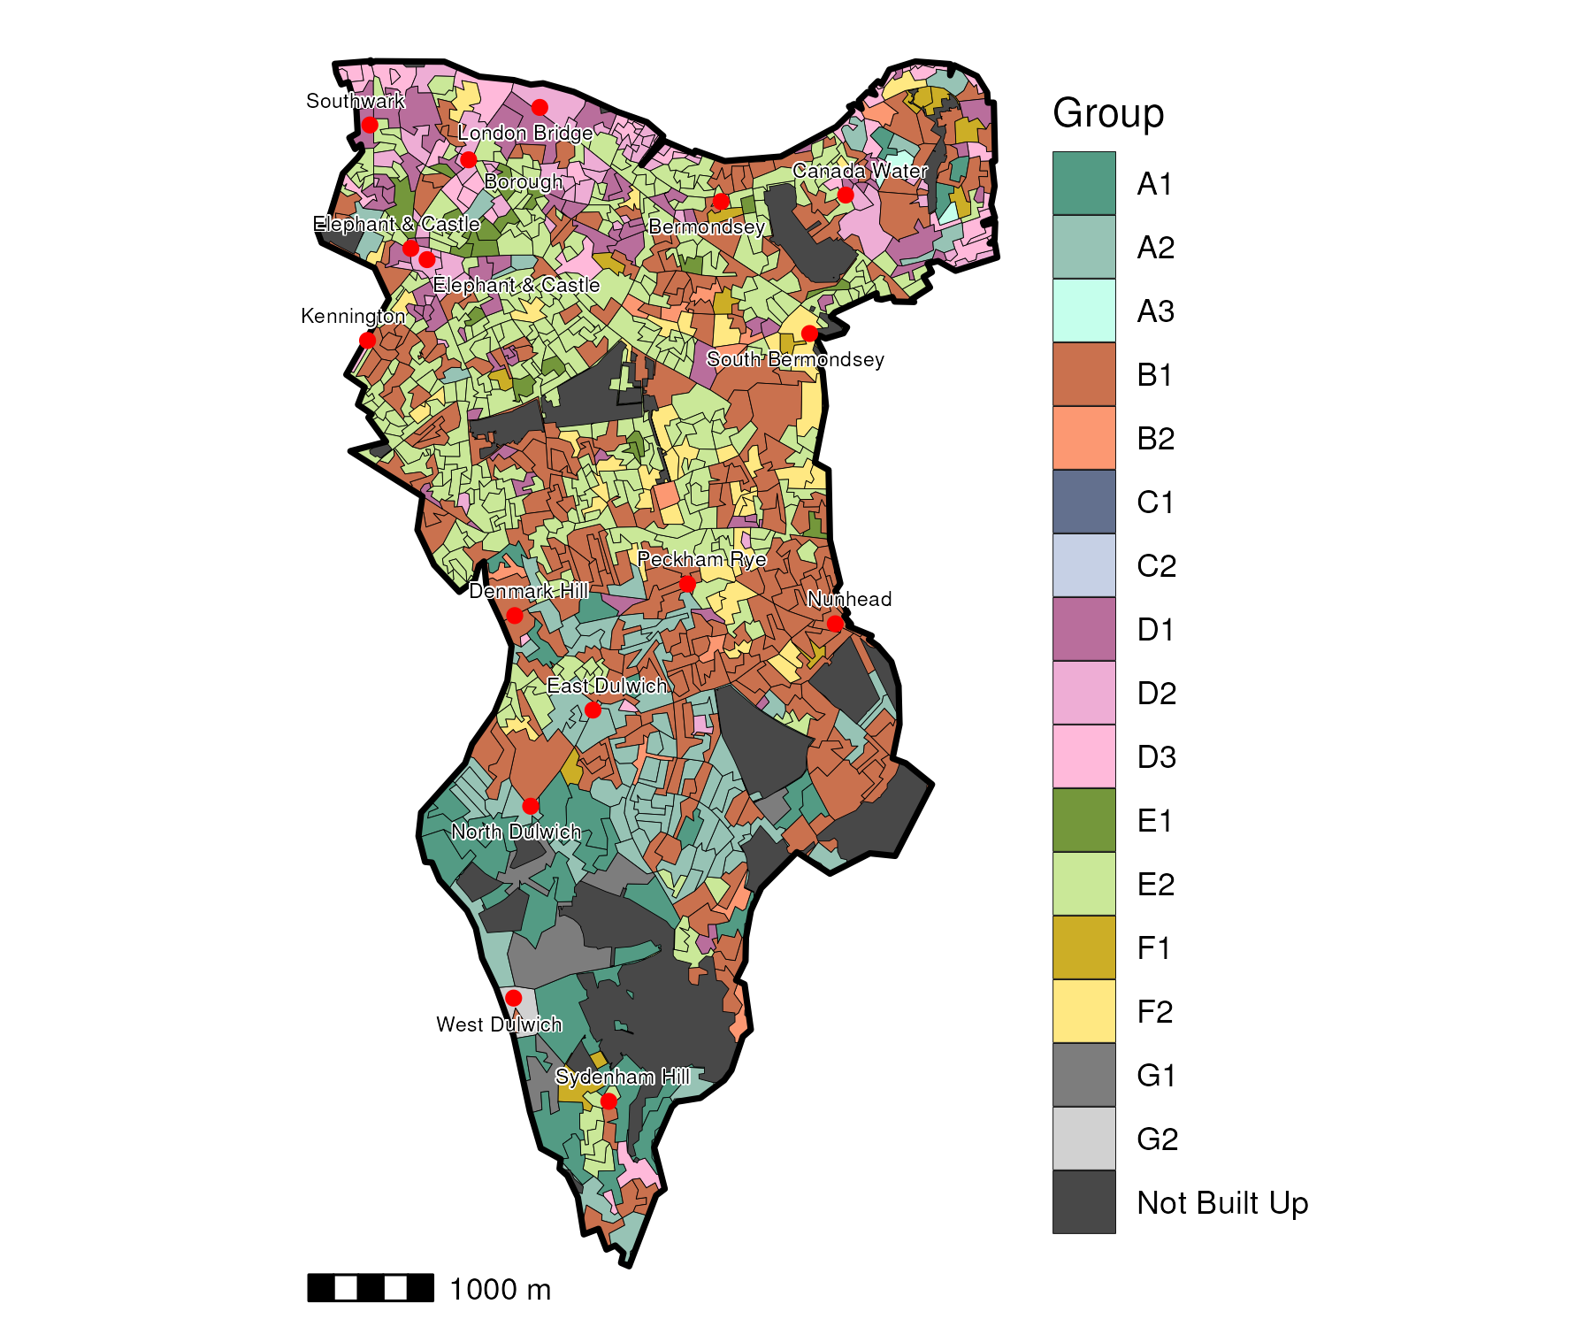

## Index Scores

The distribution of LOAC Groups within Southwark relative to the London average can be shown by calculating an index score. If a distribution was the same as the London average the score would be 100. A score of 200 represents double the London average, and 50 a half. Scores that are less than 80 and greater than 120 are typically indicators of an interesting pattern to interpret, and are the thresholds used to describe the LOAC Super Groups and Groups. Where LOAC Groups are not present within a borough, the LOAC Group codes are 'greyed out'.

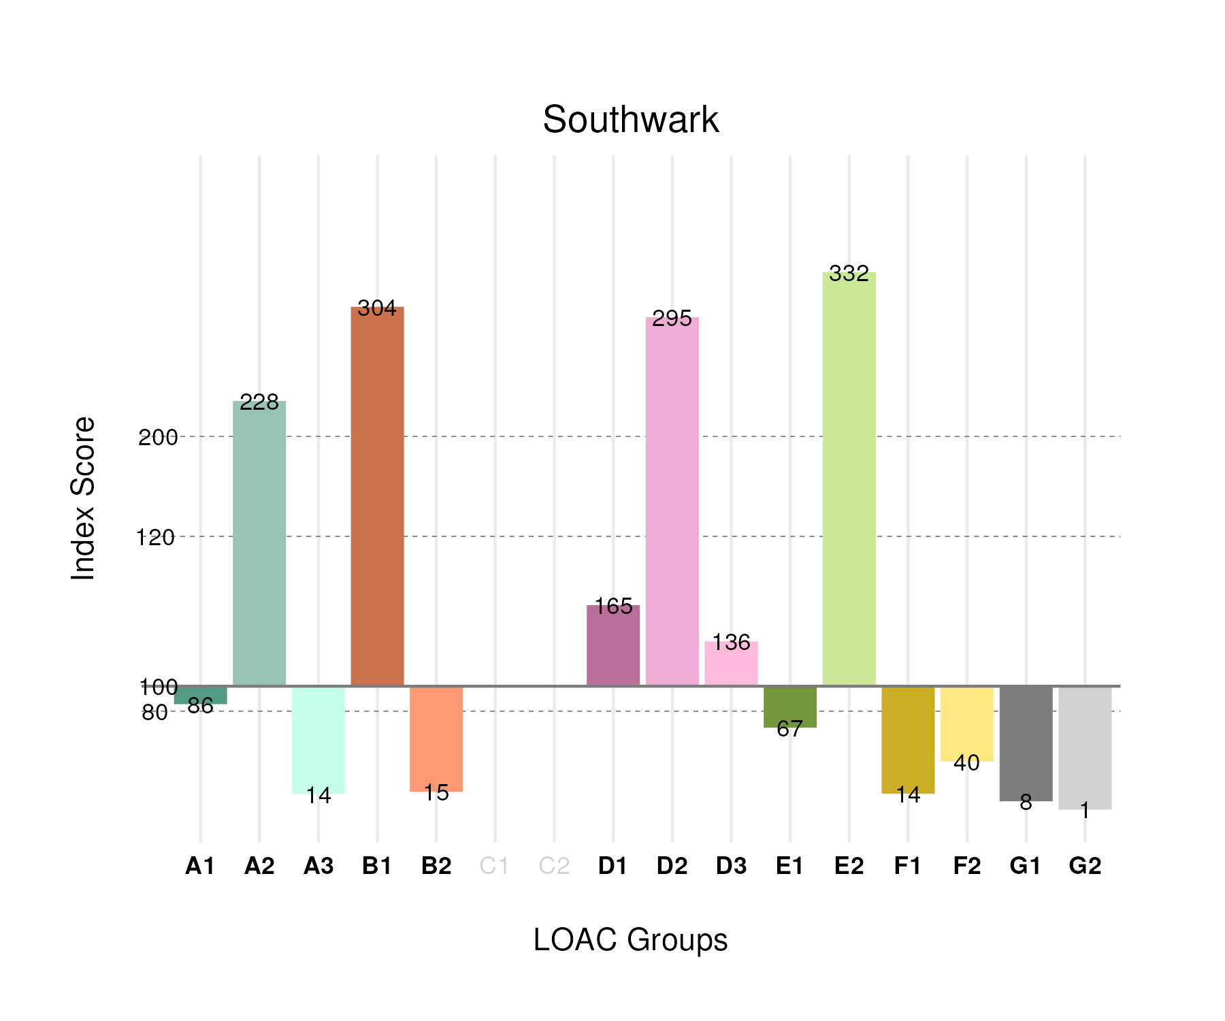

## Population Counts

The distribution of the population by LOAC Groups is shown in the following table.

| Group | Total Population (Census 2021) |
| --- | --- |
| A1 | 10,156 |
| A2 | 26,107 |
| A3 | 737 |
| B1 | 81,408 |
| B2 | 3,738 |
| C1 | 0 |
| C2 | 0 |
| D1 | 20,461 |
| D2 | 16,679 |
| D3 | 10,395 |
| E1 | 7,521 |
| E2 | 110,697 |
| F1 | 3,764 |
| F2 | 14,096 |
| G1 | 1,717 |
| G2 | 292 |

# Richmond upon Thames

## Spatial Distribution

The following map shows the spatial distribution of LOAC Groups across the London borough of Richmond upon Thames.

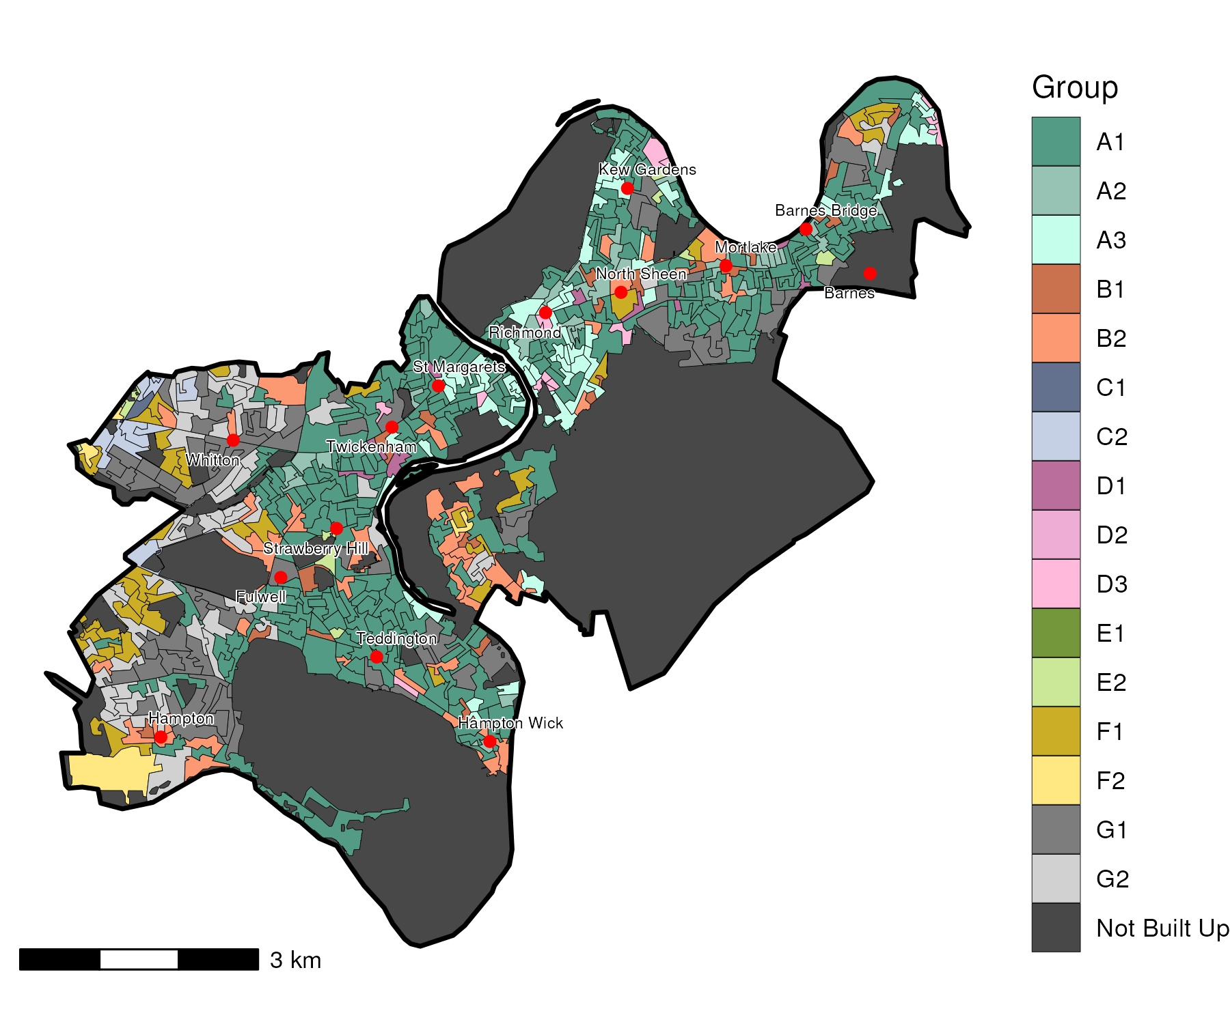

## Index Scores

The distribution of LOAC Groups within Richmond upon Thames relative to the London average can be shown by calculating an index score. If a distribution was the same as the London average the score would be 100. A score of 200 represents double the London average, and 50 a half. Scores that are less than 80 and greater than 120 are typically indicators of an interesting pattern to interpret, and are the thresholds used to describe the LOAC Super Groups and Groups. Where LOAC Groups are not present within a borough, the LOAC Group codes are 'greyed out'.

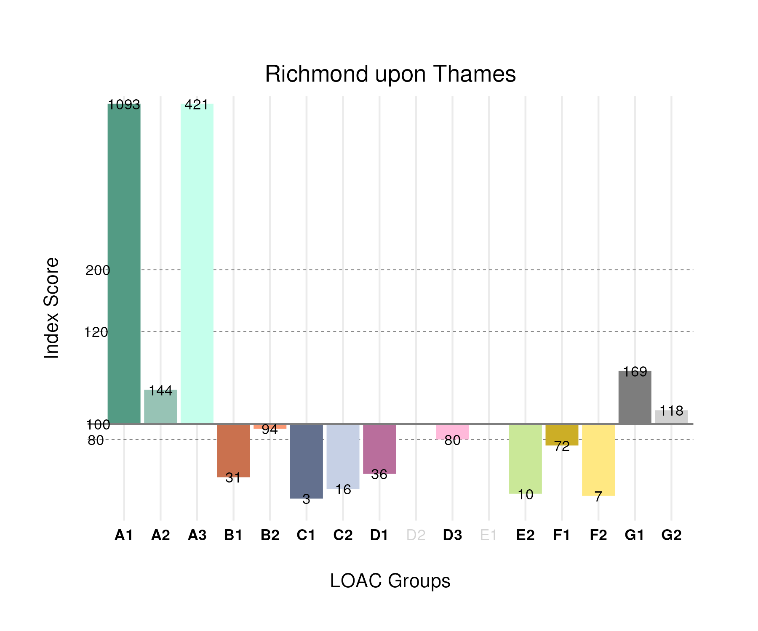

## Population Counts

The distribution of the population by LOAC Groups is shown in the following table.

| Group | Total Population (Census 2021) |
| --- | --- |
| A1 | 82,248 |
| A2 | 10,470 |
| A3 | 14,440 |
| B1 | 5,293 |
| B2 | 14,453 |
| C1 | 389 |
| C2 | 3,064 |
| D1 | 2,806 |
| D2 | 0 |
| D3 | 3,890 |
| E1 | 0 |
| E2 | 2,063 |
| F1 | 12,419 |
| F2 | 1,570 |
| G1 | 23,437 |
| G2 | 18,723 |

# Redbridge

## Spatial Distribution

The following map shows the spatial distribution of LOAC Groups across the London borough of Redbridge.

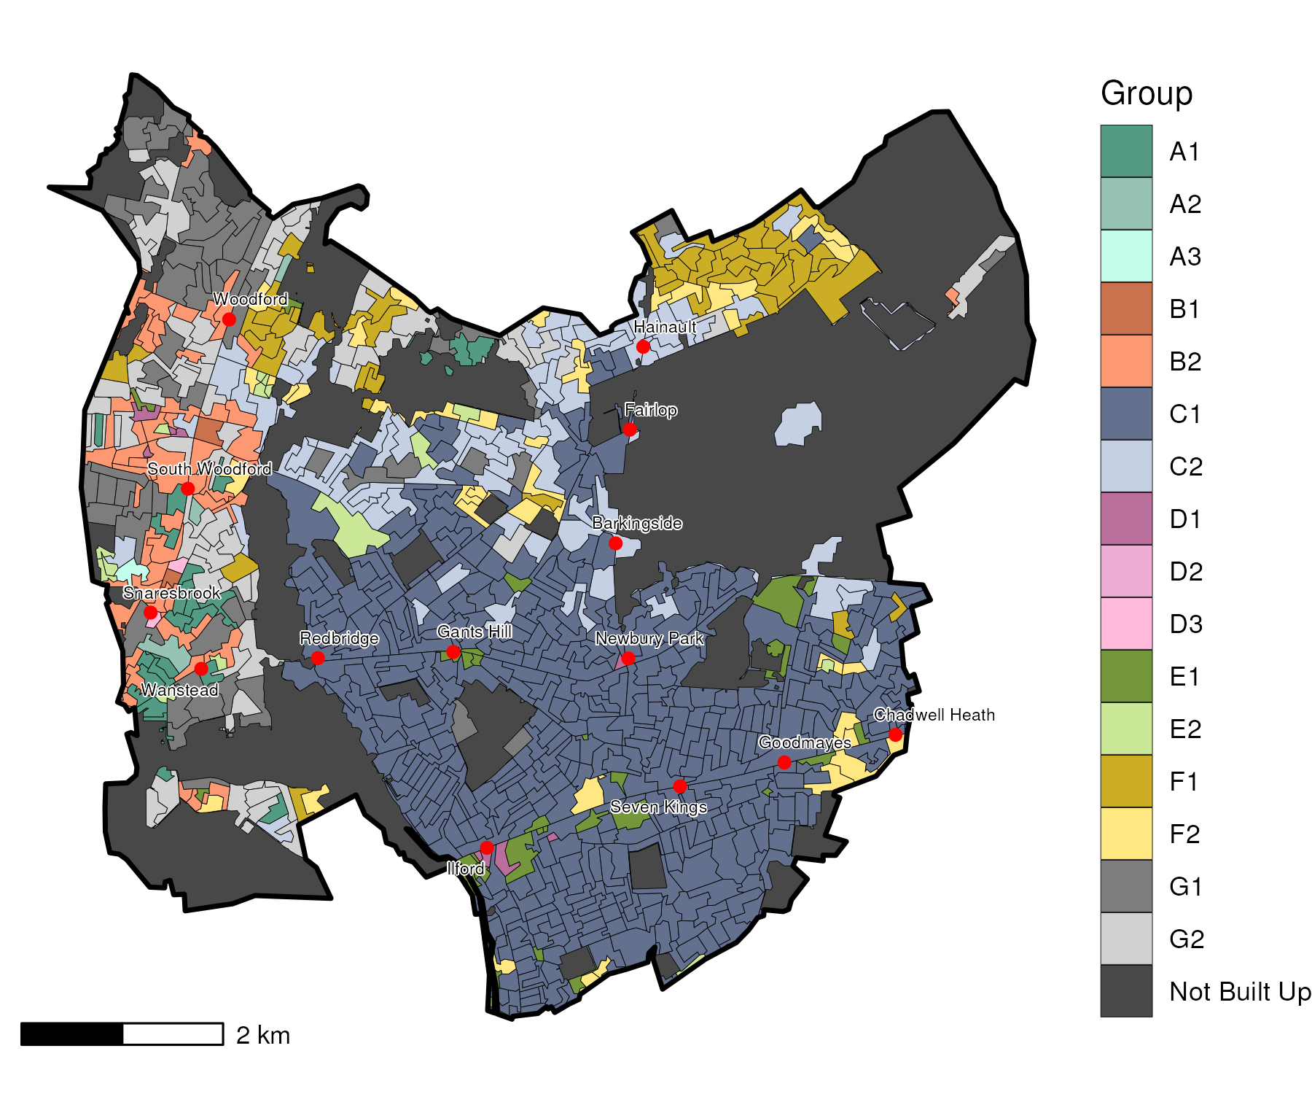

## Index Scores

The distribution of LOAC Groups within Redbridge relative to the London average can be shown by calculating an index score. If a distribution was the same as the London average the score would be 100. A score of 200 represents double the London average, and 50 a half. Scores that are less than 80 and greater than 120 are typically indicators of an interesting pattern to interpret, and are the thresholds used to describe the LOAC Super Groups and Groups. Where LOAC Groups are not present within a borough, the LOAC Group codes are 'greyed out'.

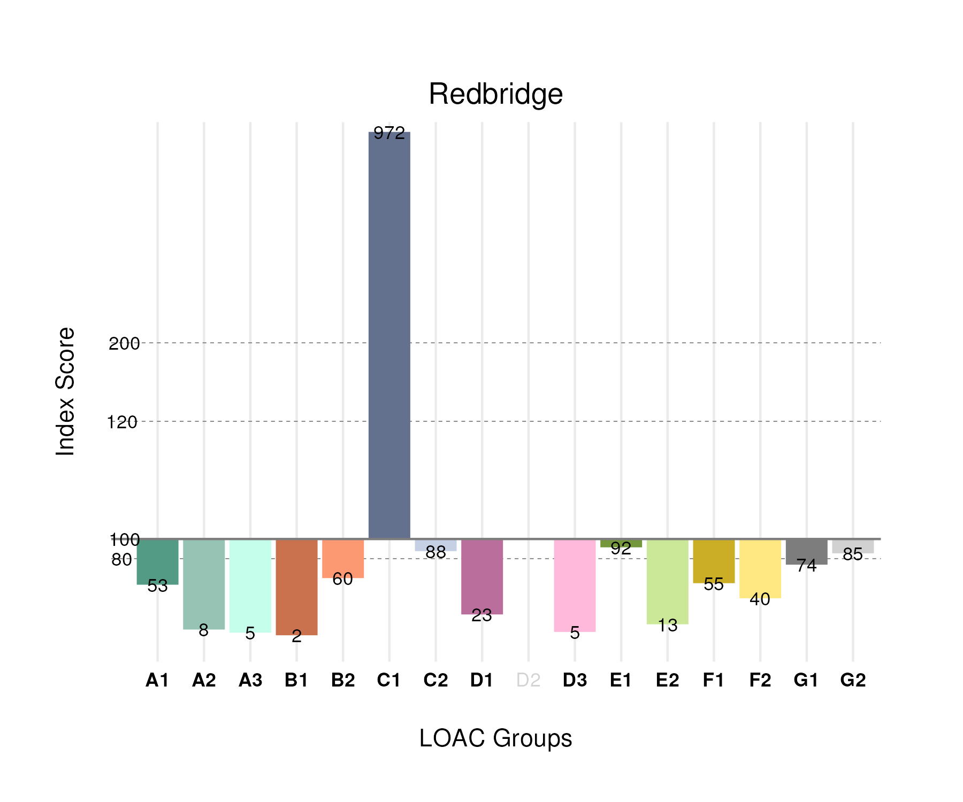

## Population Counts

The distribution of the population by LOAC Groups is shown in the following table.

| Group | Total Population (Census 2021) |
| --- | --- |
| A1 | 6,389 |
| A2 | 891 |
| A3 | 247 |
| B1 | 508 |
| B2 | 14,703 |
| C1 | 175,593 |
| C2 | 26,812 |
| D1 | 2,890 |
| D2 | 0 |
| D3 | 408 |
| E1 | 10,386 |
| E2 | 4,406 |
| F1 | 15,010 |
| F2 | 14,152 |
| G1 | 16,287 |
| G2 | 21,552 |

# Newham

## Spatial Distribution

The following map shows the spatial distribution of LOAC Groups across the London borough of Newham.

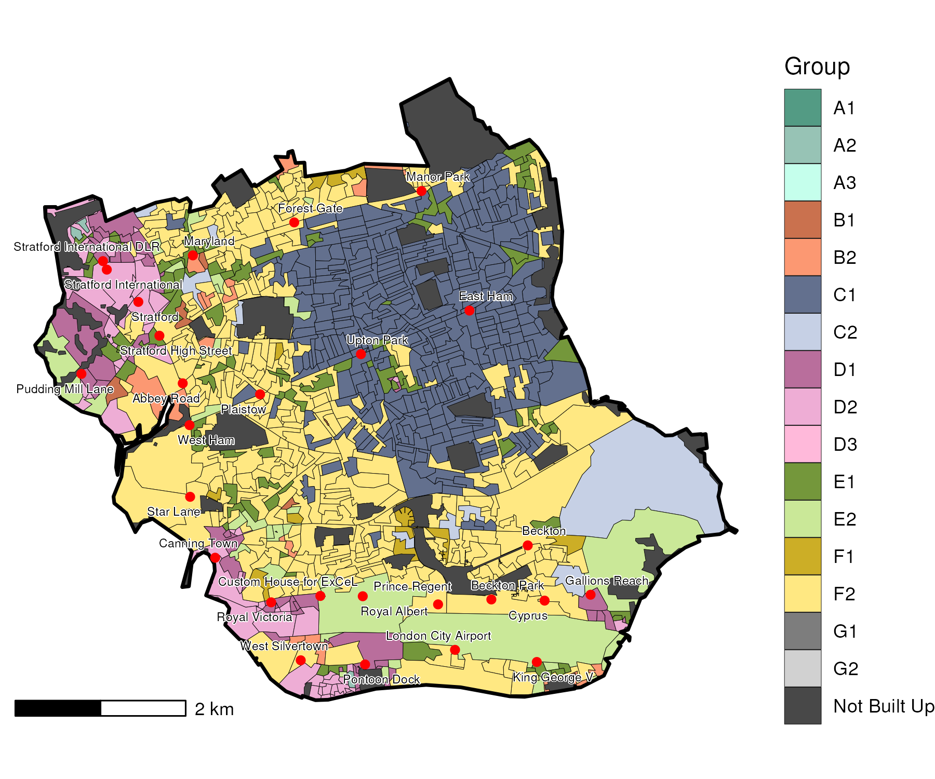

## Index Scores

The distribution of LOAC Groups within Newham relative to the London average can be shown by calculating an index score. If a distribution was the same as the London average the score would be 100. A score of 200 represents double the London average, and 50 a half. Scores that are less than 80 and greater than 120 are typically indicators of an interesting pattern to interpret, and are the thresholds used to describe the LOAC Super Groups and Groups. Where LOAC Groups are not present within a borough, the LOAC Group codes are 'greyed out'.

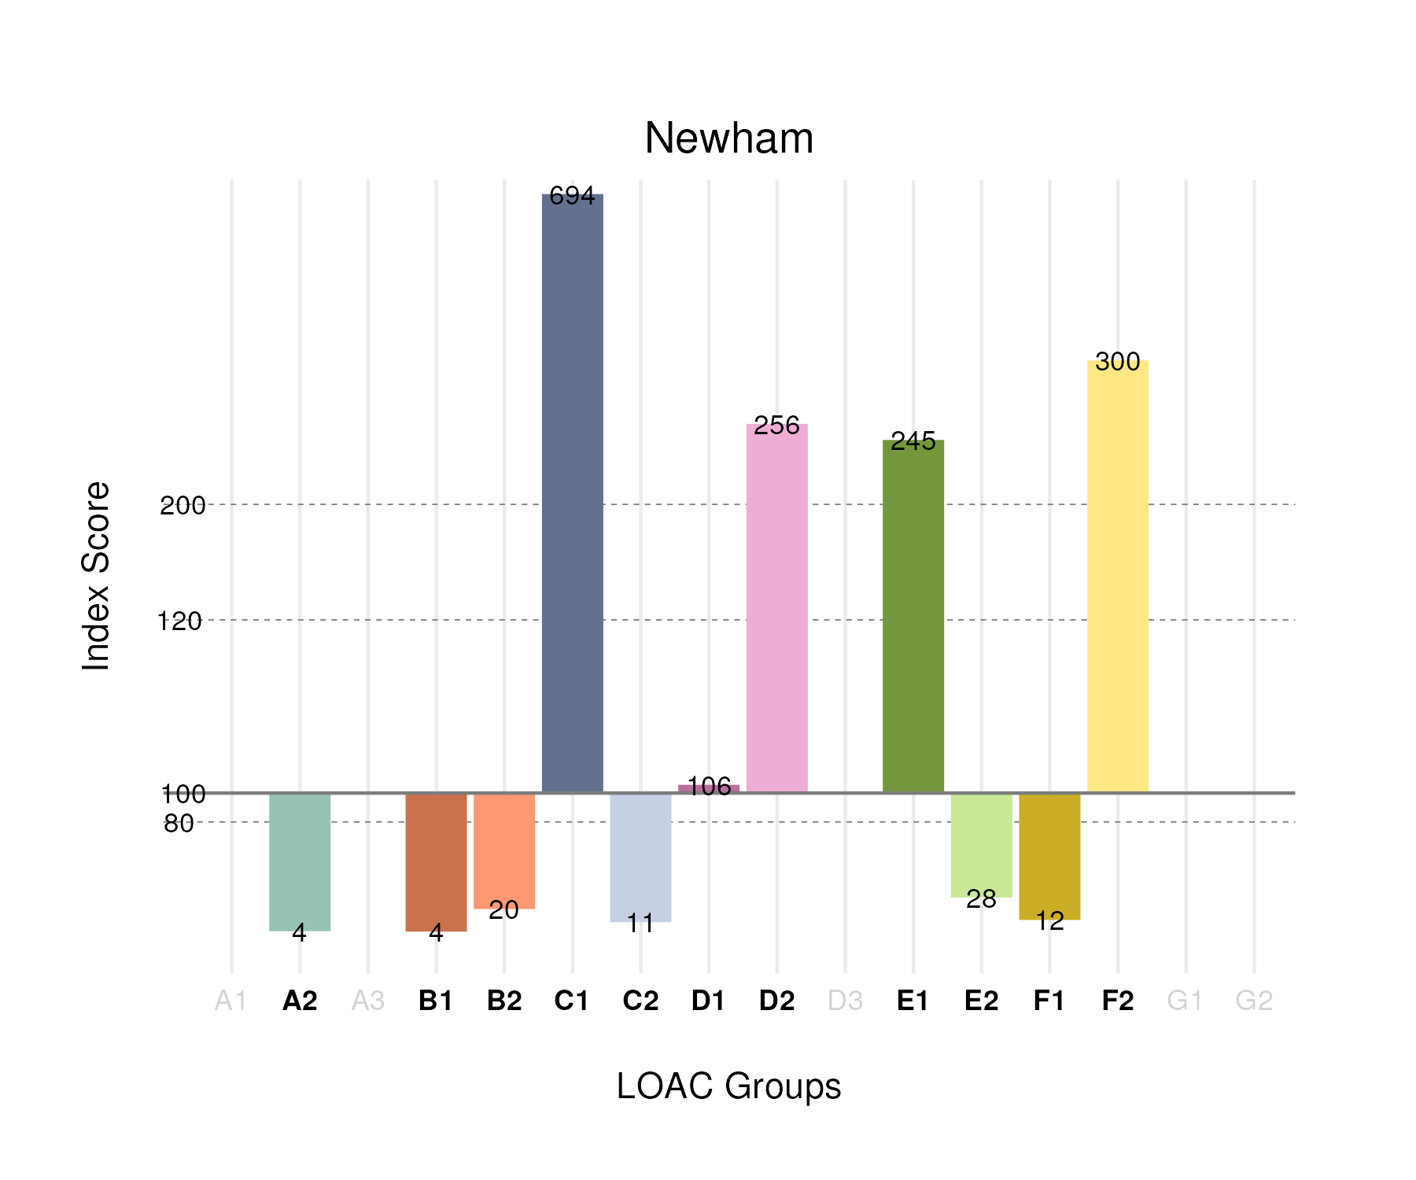

## Population Counts

The distribution of the population by LOAC Groups is shown in the following table.

| Group | Total Population (Census 2021) |
| --- | --- |
| A1 | 0 |
| A2 | 560 |
| A3 | 0 |
| B1 | 1,223 |
| B2 | 5,444 |
| C1 | 141,959 |
| C2 | 3,644 |
| D1 | 14,959 |
| D2 | 16,472 |
| D3 | 0 |
| E1 | 31,414 |
| E2 | 10,521 |
| F1 | 3,730 |
| F2 | 121,179 |
| G1 | 0 |
| G2 | 0 |

# Merton

## Spatial Distribution

The following map shows the spatial distribution of LOAC Groups across the London borough of Merton.

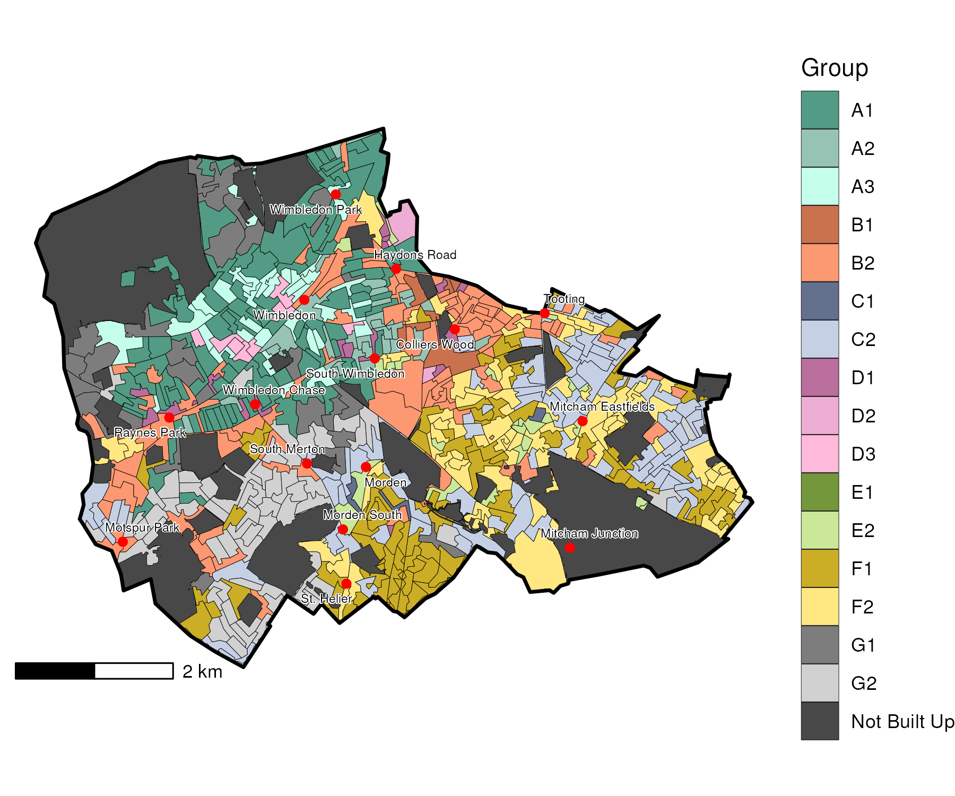

## Index Scores

The distribution of LOAC Groups within Merton relative to the London average can be shown by calculating an index score. If a distribution was the same as the London average the score would be 100. A score of 200 represents double the London average, and 50 a half. Scores that are less than 80 and greater than 120 are typically indicators of an interesting pattern to interpret, and are the thresholds used to describe the LOAC Super Groups and Groups. Where LOAC Groups are not present within a borough, the LOAC Group codes are 'greyed out'.

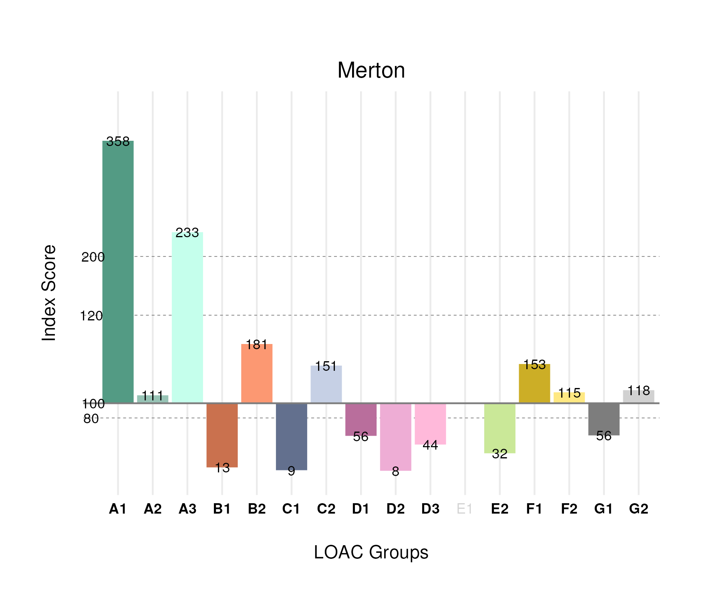

## Population Counts

The distribution of the population by LOAC Groups is shown in the following table.

| Group | Total Population (Census 2021) |
| --- | --- |
| A1 | 29,672 |
| A2 | 8,862 |
| A3 | 8,806 |
| B1 | 2,363 |
| B2 | 30,641 |
| C1 | 1,100 |
| C2 | 32,121 |
| D1 | 4,822 |
| D2 | 316 |
| D3 | 2,340 |
| E1 | 0 |
| E2 | 7,432 |
| F1 | 29,070 |
| F2 | 28,489 |
| G1 | 8,600 |
| G2 | 20,623 |

# Lewisham

## Spatial Distribution

The following map shows the spatial distribution of LOAC Groups across the London borough of Lewisham.

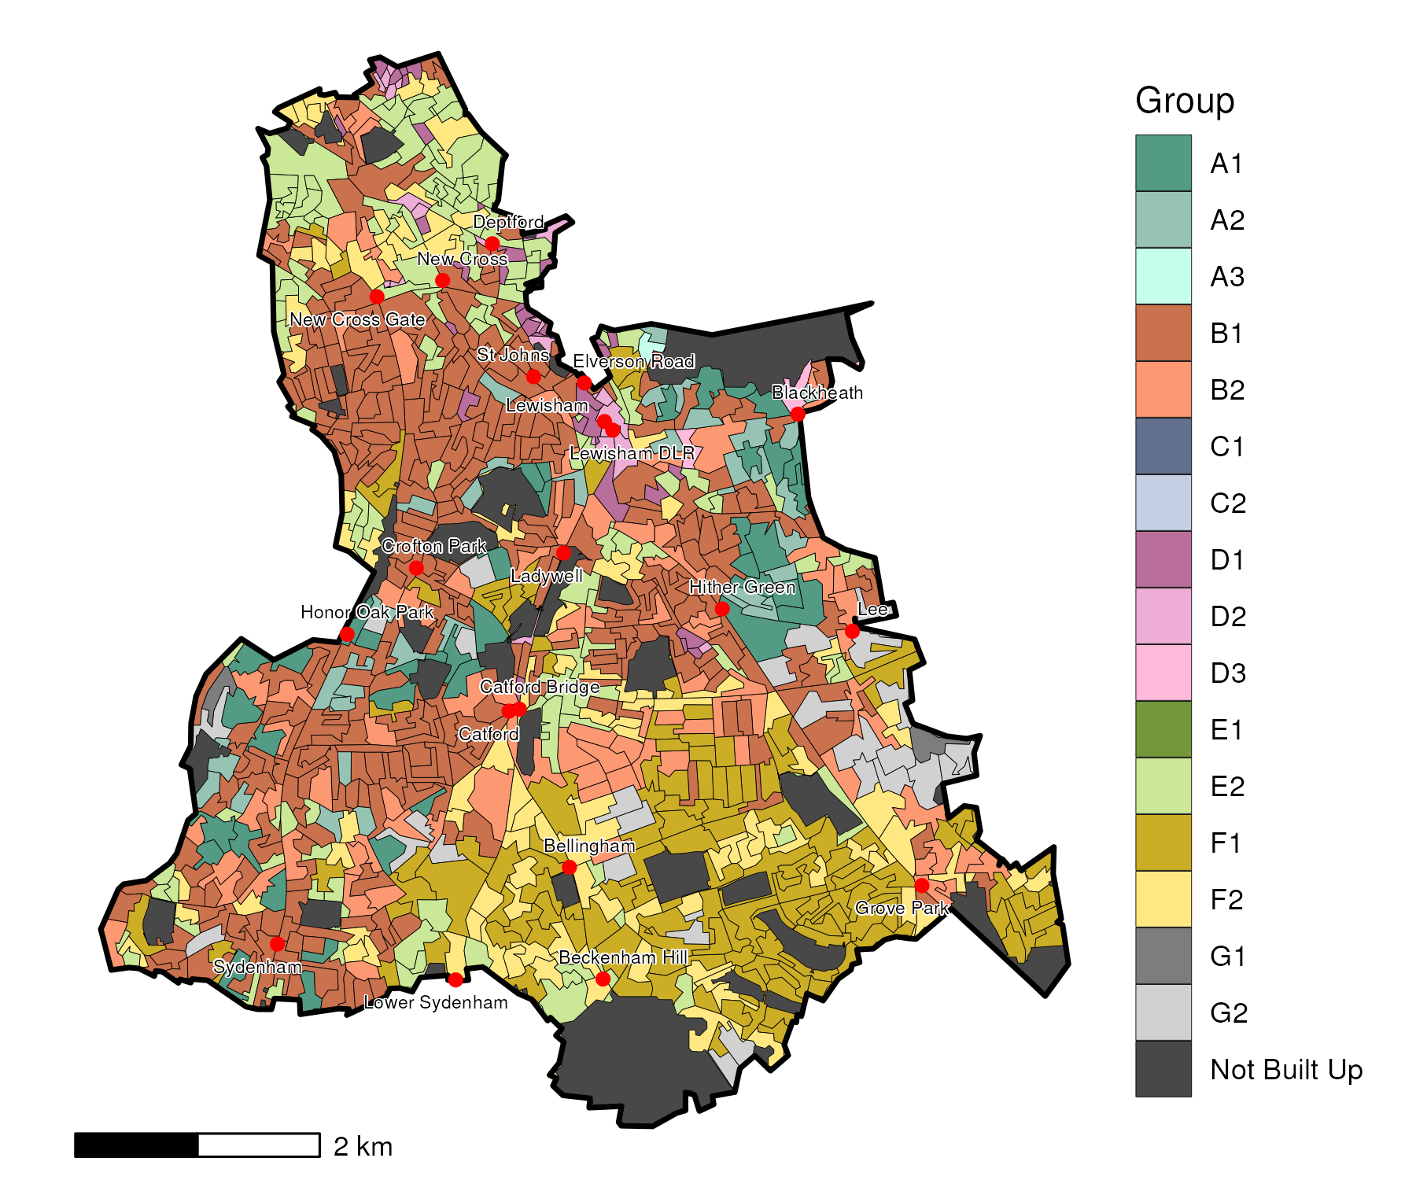

## Index Scores

The distribution of LOAC Groups within Lewisham relative to the London average can be shown by calculating an index score. If a distribution was the same as the London average the score would be 100. A score of 200 represents double the London average, and 50 a half. Scores that are less than 80 and greater than 120 are typically indicators of an interesting pattern to interpret, and are the thresholds used to describe the LOAC Super Groups and Groups. Where LOAC Groups are not present within a borough, the LOAC Group codes are 'greyed out'.

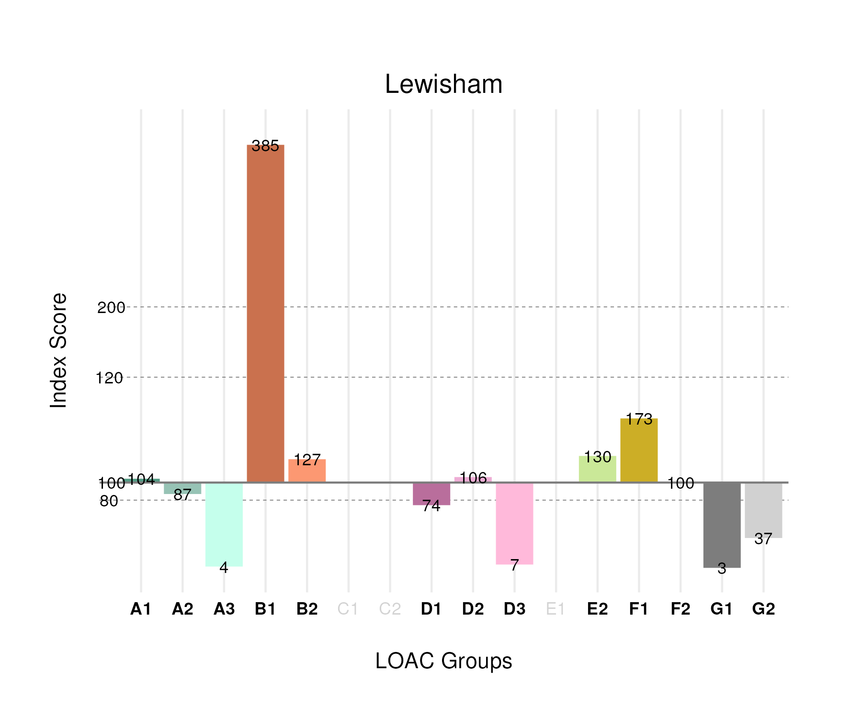

## Population Counts

The distribution of the population by LOAC Groups is shown in the following table.

| Group | Total Population (Census 2021) |
| --- | --- |
| A1 | 12,087 |
| A2 | 9,708 |
| A3 | 230 |
| B1 | 100,628 |
| B2 | 29,960 |
| C1 | 0 |
| C2 | 0 |
| D1 | 8,993 |
| D2 | 5,858 |
| D3 | 497 |
| E1 | 0 |
| E2 | 42,475 |
| F1 | 45,754 |
| F2 | 34,715 |
| G1 | 616 |
| G2 | 9,012 |

# Lambeth

## Spatial Distribution

The following map shows the spatial distribution of LOAC Groups across the London borough of Lambeth.

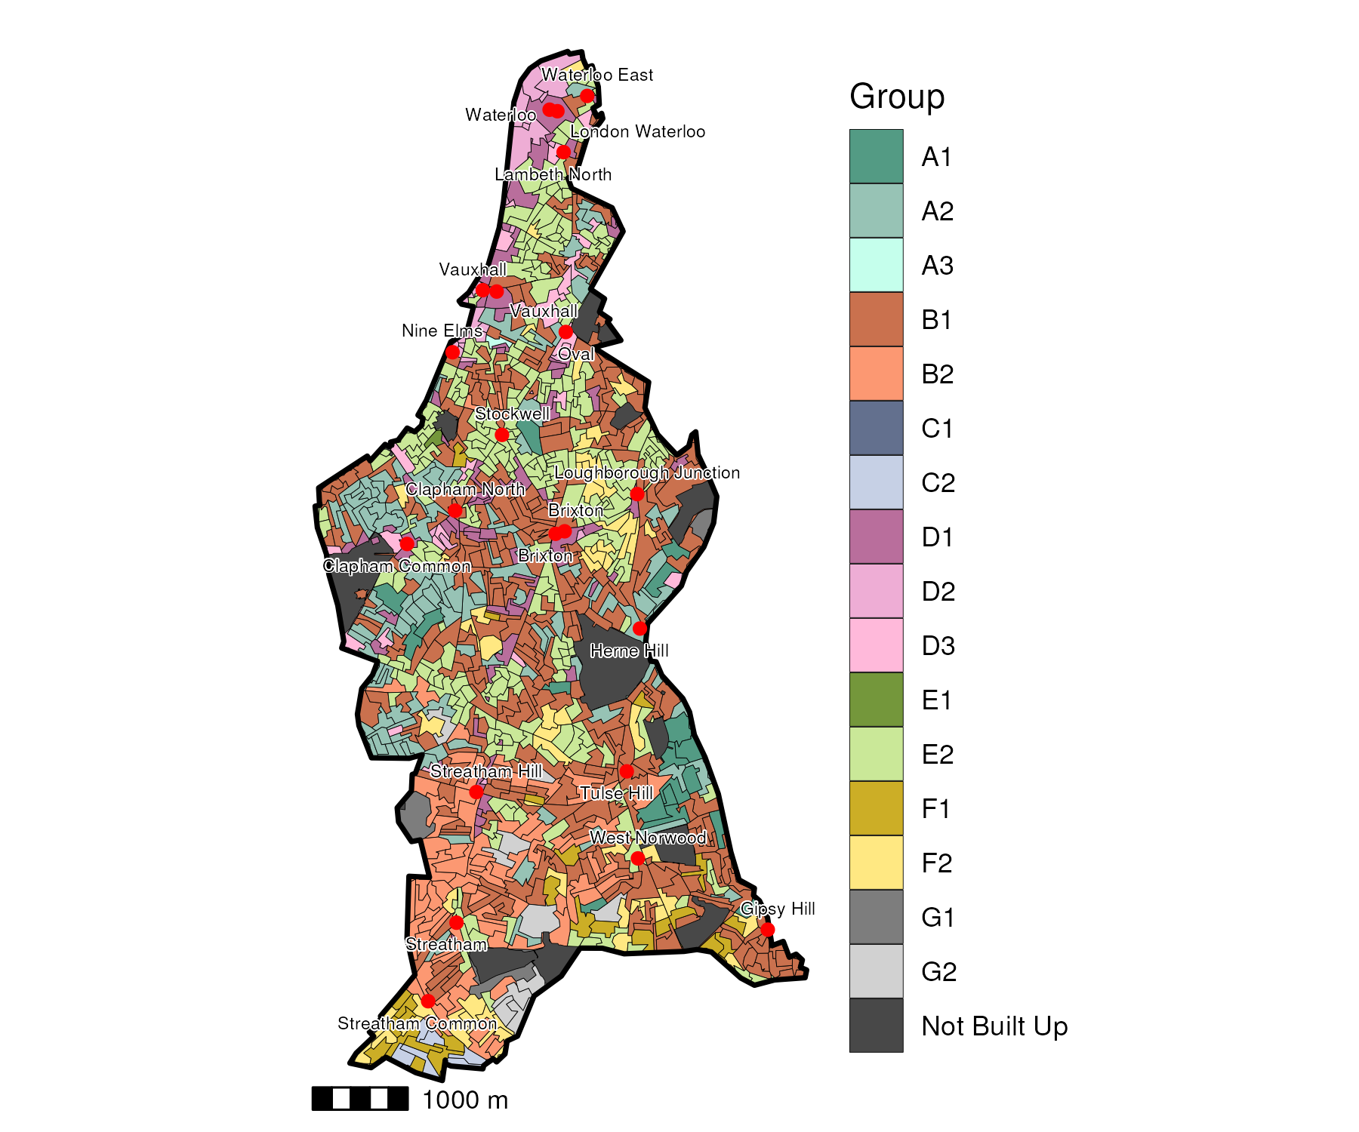

## Index Scores

The distribution of LOAC Groups within Lambeth relative to the London average can be shown by calculating an index score. If a distribution was the same as the London average the score would be 100. A score of 200 represents double the London average, and 50 a half. Scores that are less than 80 and greater than 120 are typically indicators of an interesting pattern to interpret, and are the thresholds used to describe the LOAC Super Groups and Groups. Where LOAC Groups are not present within a borough, the LOAC Group codes are 'greyed out'.

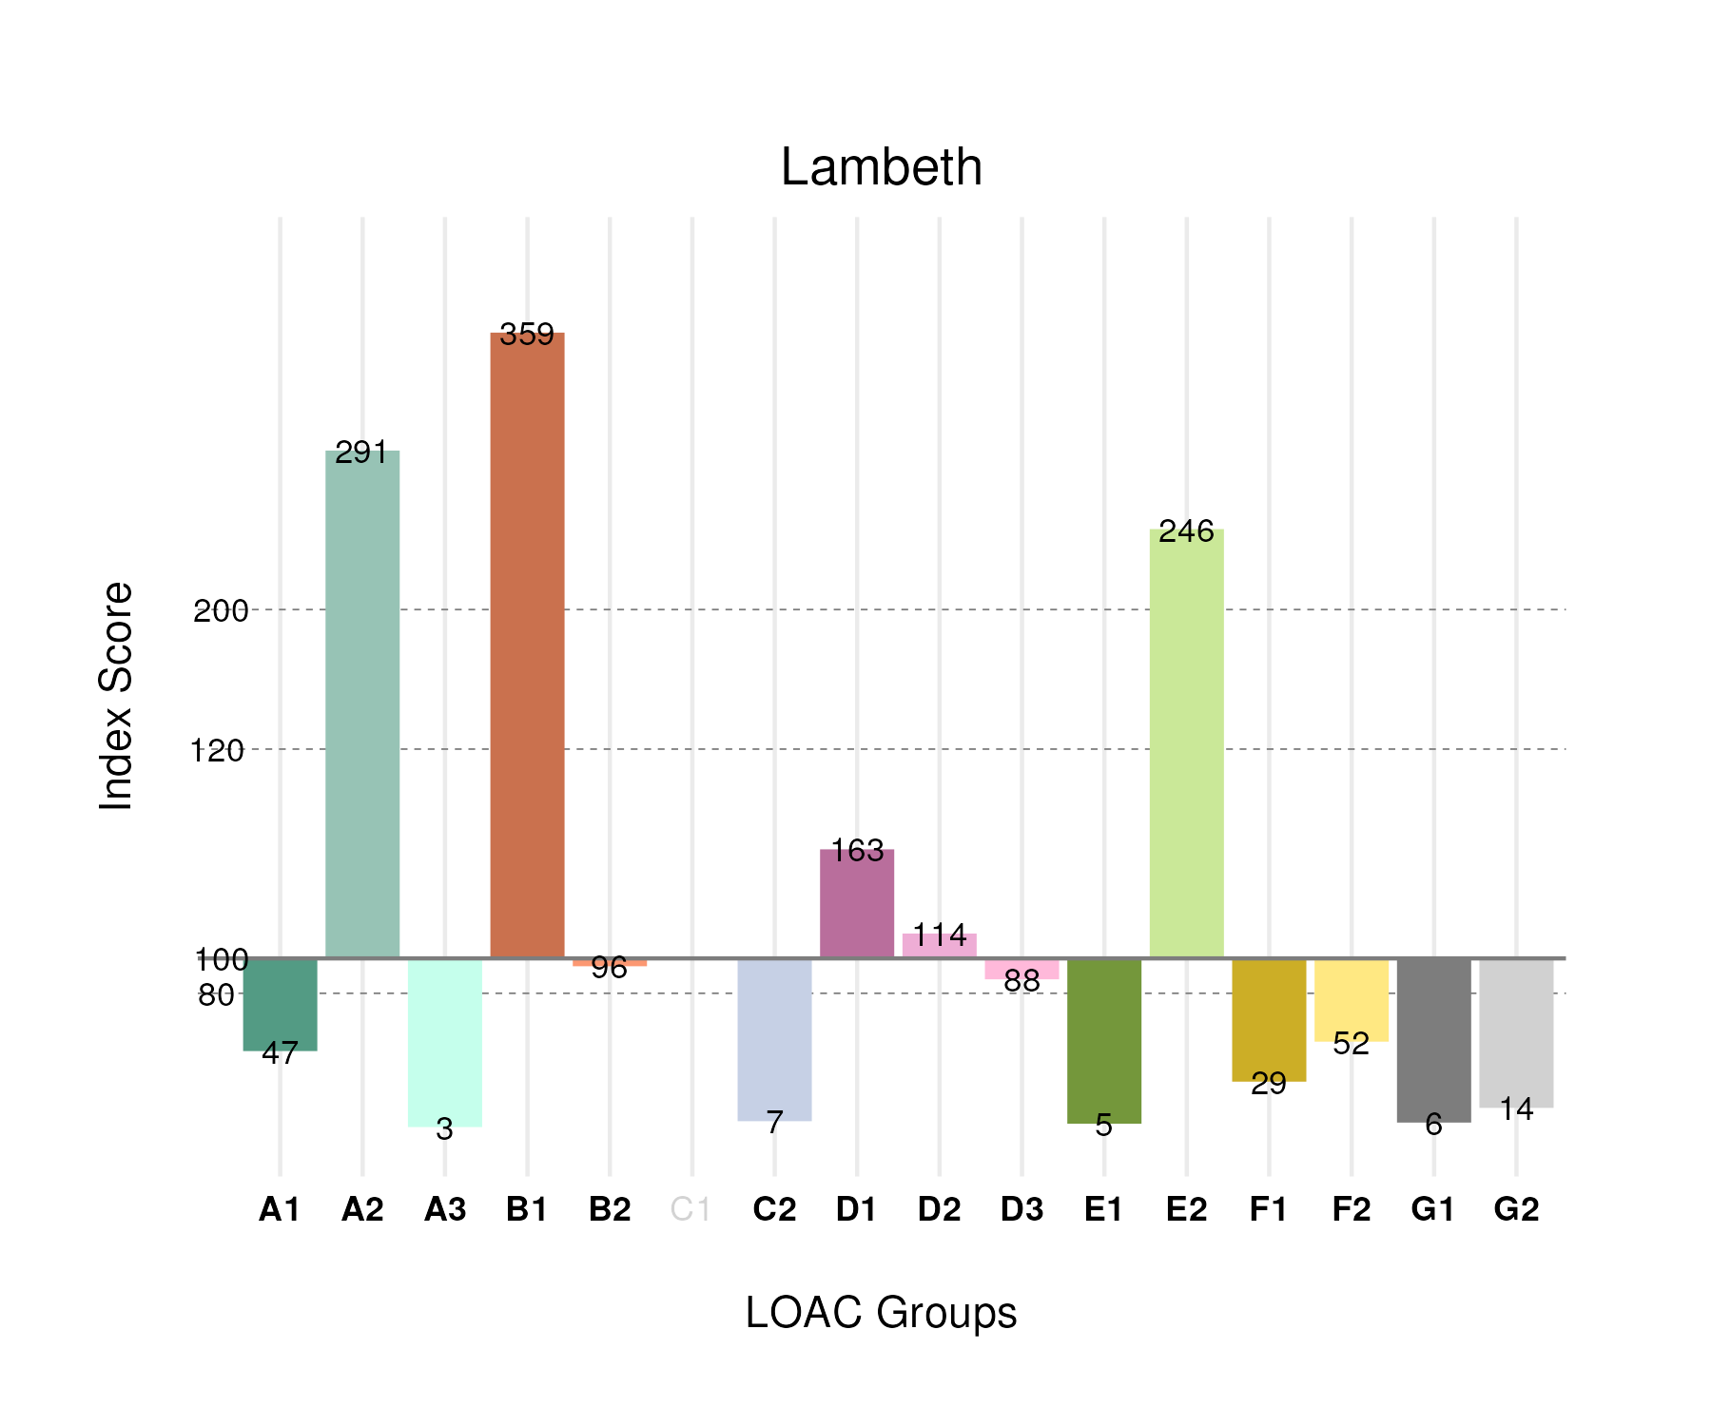

## Population Counts

The distribution of the population by LOAC Groups is shown in the following table.

| Group | Total Population (Census 2021) |
| --- | --- |
| A1 | 5,737 |
| A2 | 34,348 |
| A3 | 184 |
| B1 | 99,216 |
| B2 | 23,891 |
| C1 | 0 |
| C2 | 2,088 |
| D1 | 20,803 |
| D2 | 6,655 |
| D3 | 6,947 |
| E1 | 608 |
| E2 | 84,796 |
| F1 | 8,201 |
| F2 | 19,118 |
| G1 | 1,327 |
| G2 | 3,697 |

# Kingston upon Thames

## Spatial Distribution

The following map shows the spatial distribution of LOAC Groups across the London borough of Kingston upon Thames.

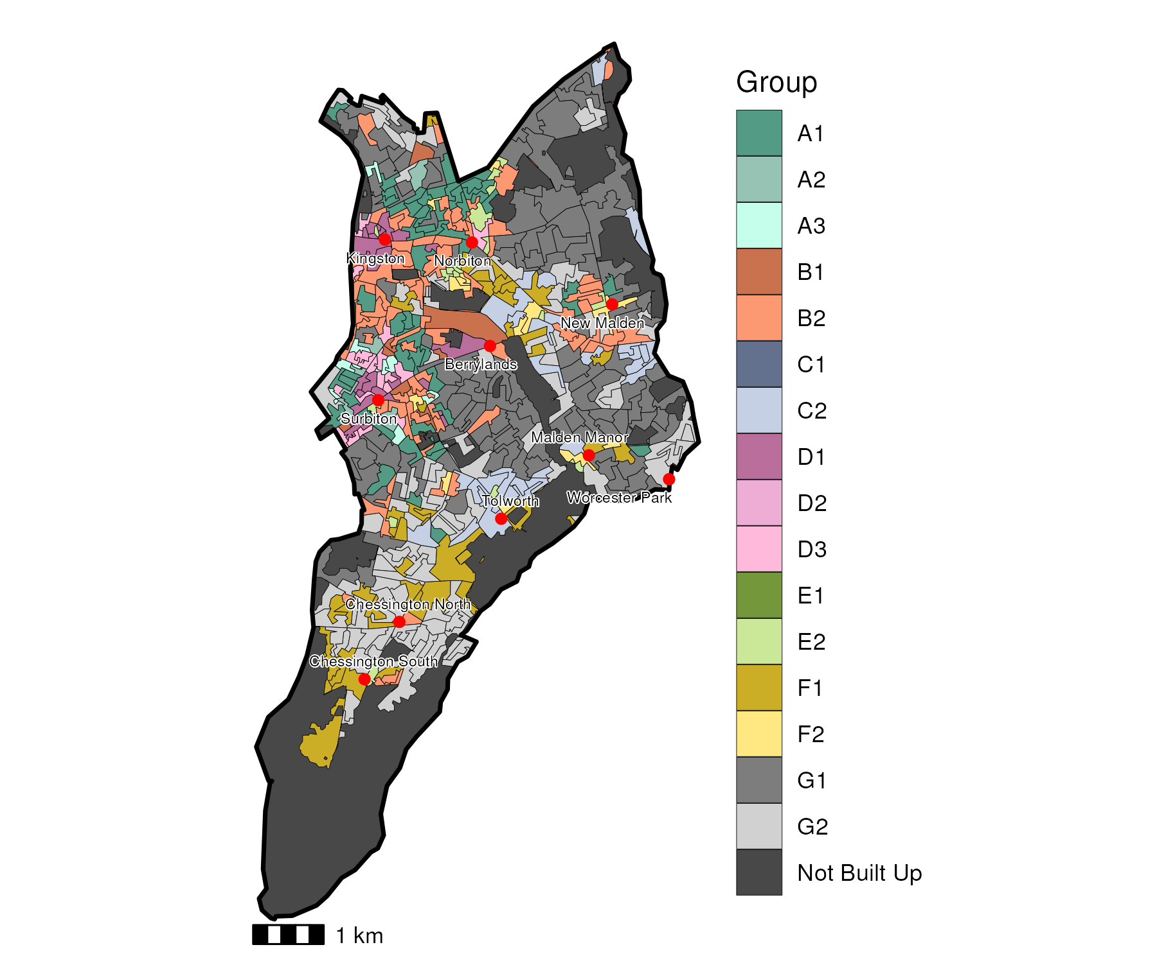

## Index Scores

The distribution of LOAC Groups within Kingston upon Thames relative to the London average can be shown by calculating an index score. If a distribution was the same as the London average the score would be 100. A score of 200 represents double the London average, and 50 a half. Scores that are less than 80 and greater than 120 are typically indicators of an interesting pattern to interpret, and are the thresholds used to describe the LOAC Super Groups and Groups. Where LOAC Groups are not present within a borough, the LOAC Group codes are 'greyed out'.

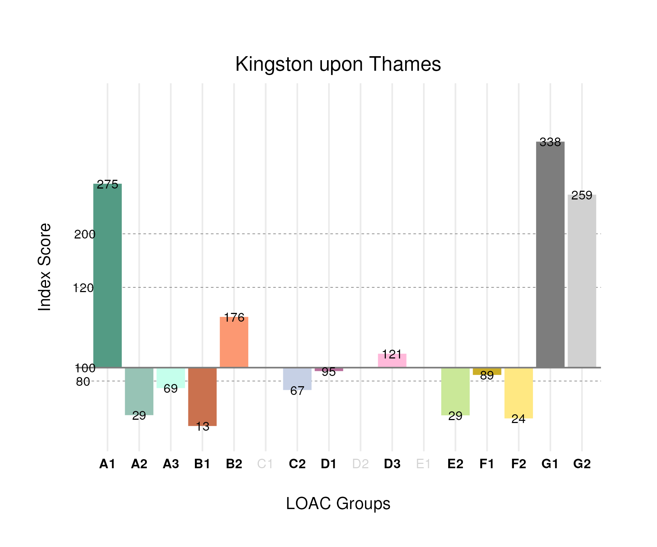

## Population Counts

The distribution of the population by LOAC Groups is shown in the following table.

| Group | Total Population (Census 2021) |
| --- | --- |
| A1 | 17,807 |
| A2 | 1,811 |
| A3 | 2,047 |
| B1 | 1,869 |
| B2 | 23,279 |
| C1 | 0 |
| C2 | 11,032 |
| D1 | 6,424 |
| D2 | 0 |
| D3 | 5,046 |
| E1 | 0 |
| E2 | 5,226 |
| F1 | 13,178 |
| F2 | 4,669 |
| G1 | 40,359 |
| G2 | 35,332 |

# Kensington and Chelsea

## Spatial Distribution

The following map shows the spatial distribution of LOAC Groups across the London borough of Kensington and Chelsea.

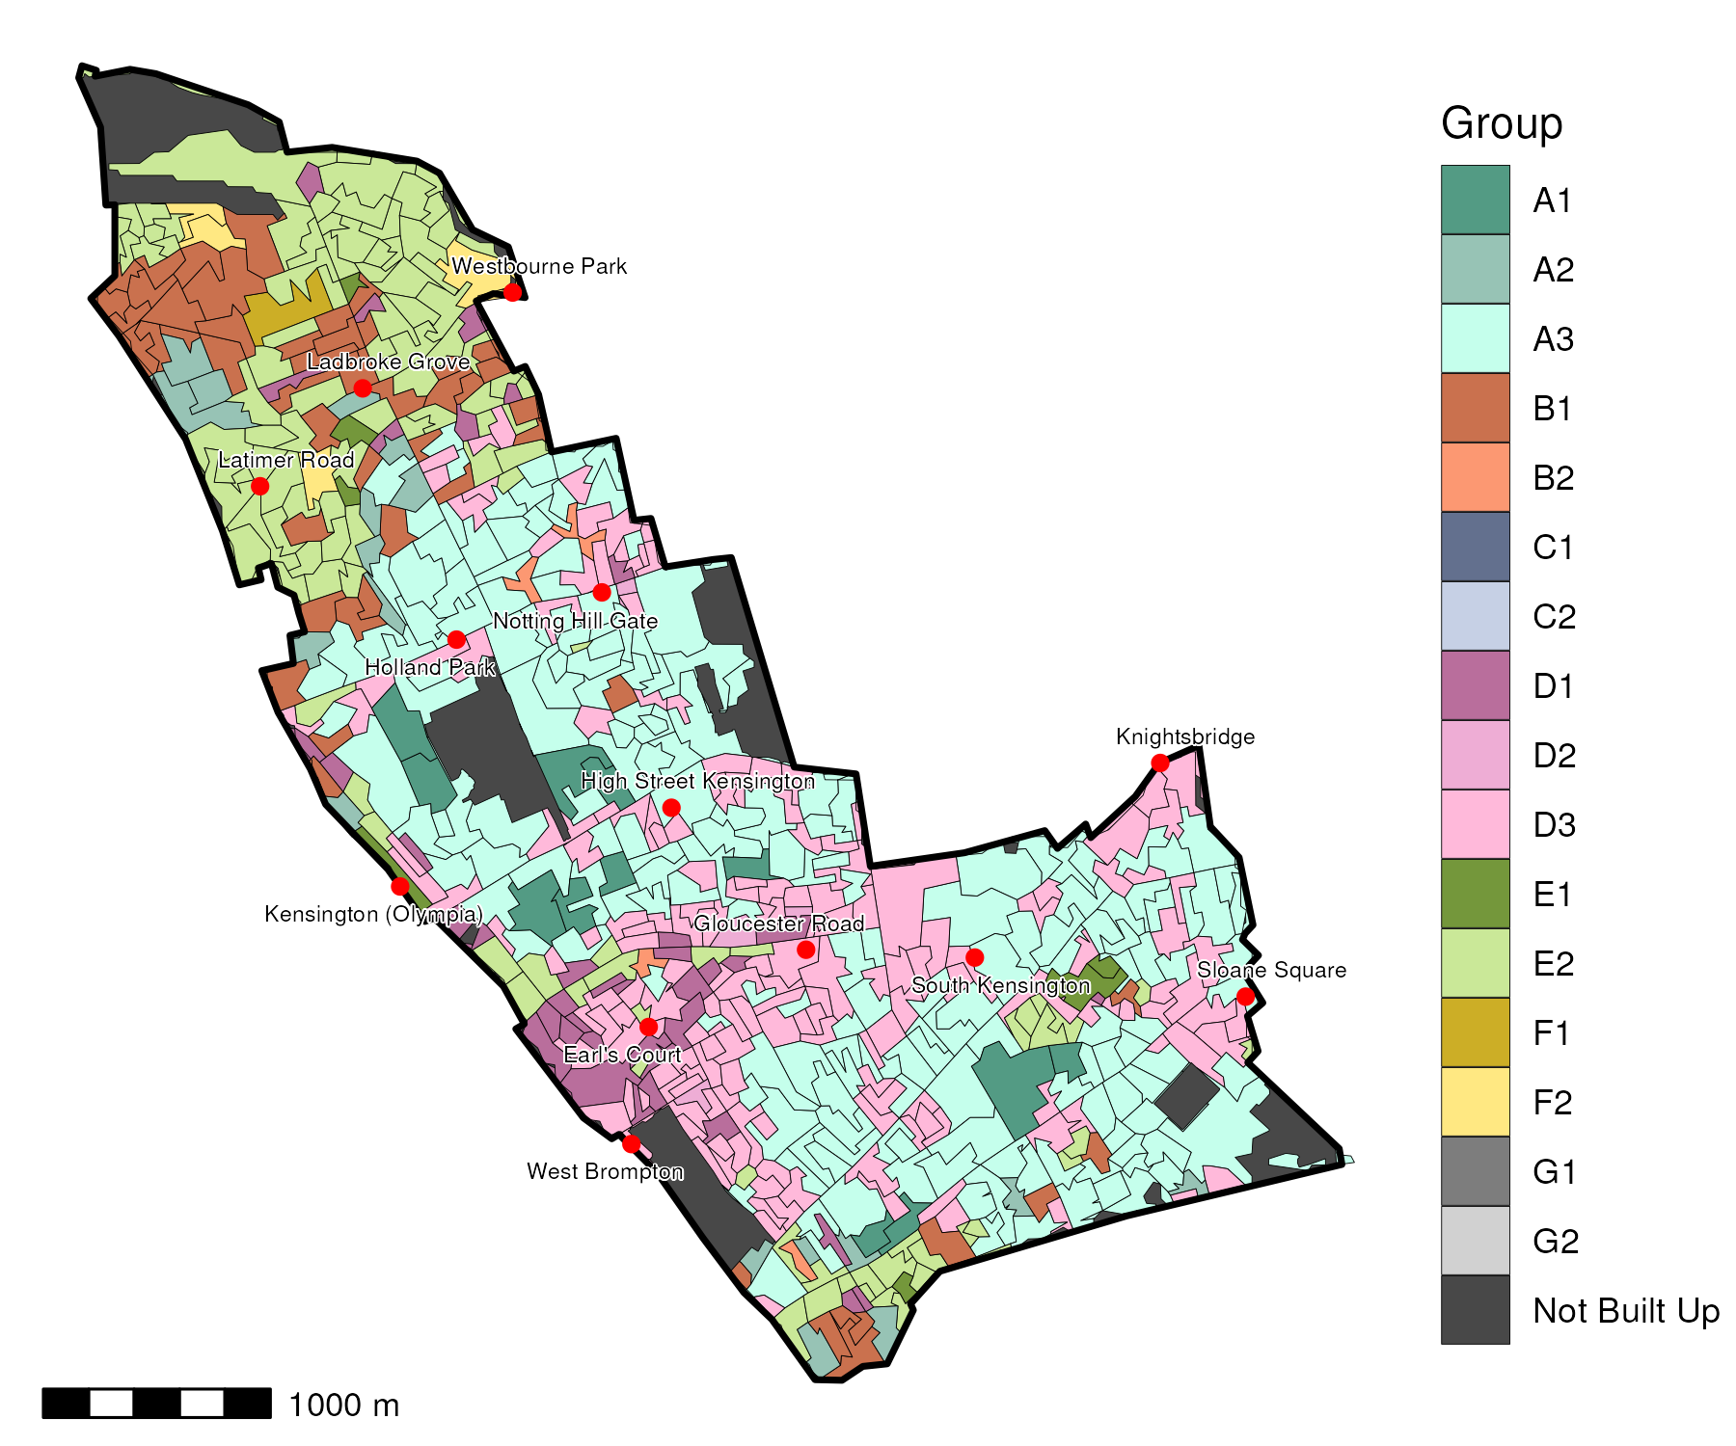

## Index Scores

The distribution of LOAC Groups within Kensington and Chelsea relative to the London average can be shown by calculating an index score. If a distribution was the same as the London average the score would be 100. A score of 200 represents double the London average, and 50 a half. Scores that are less than 80 and greater than 120 are typically indicators of an interesting pattern to interpret, and are the thresholds used to describe the LOAC Super Groups and Groups. Where LOAC Groups are not present within a borough, the LOAC Group codes are 'greyed out'.

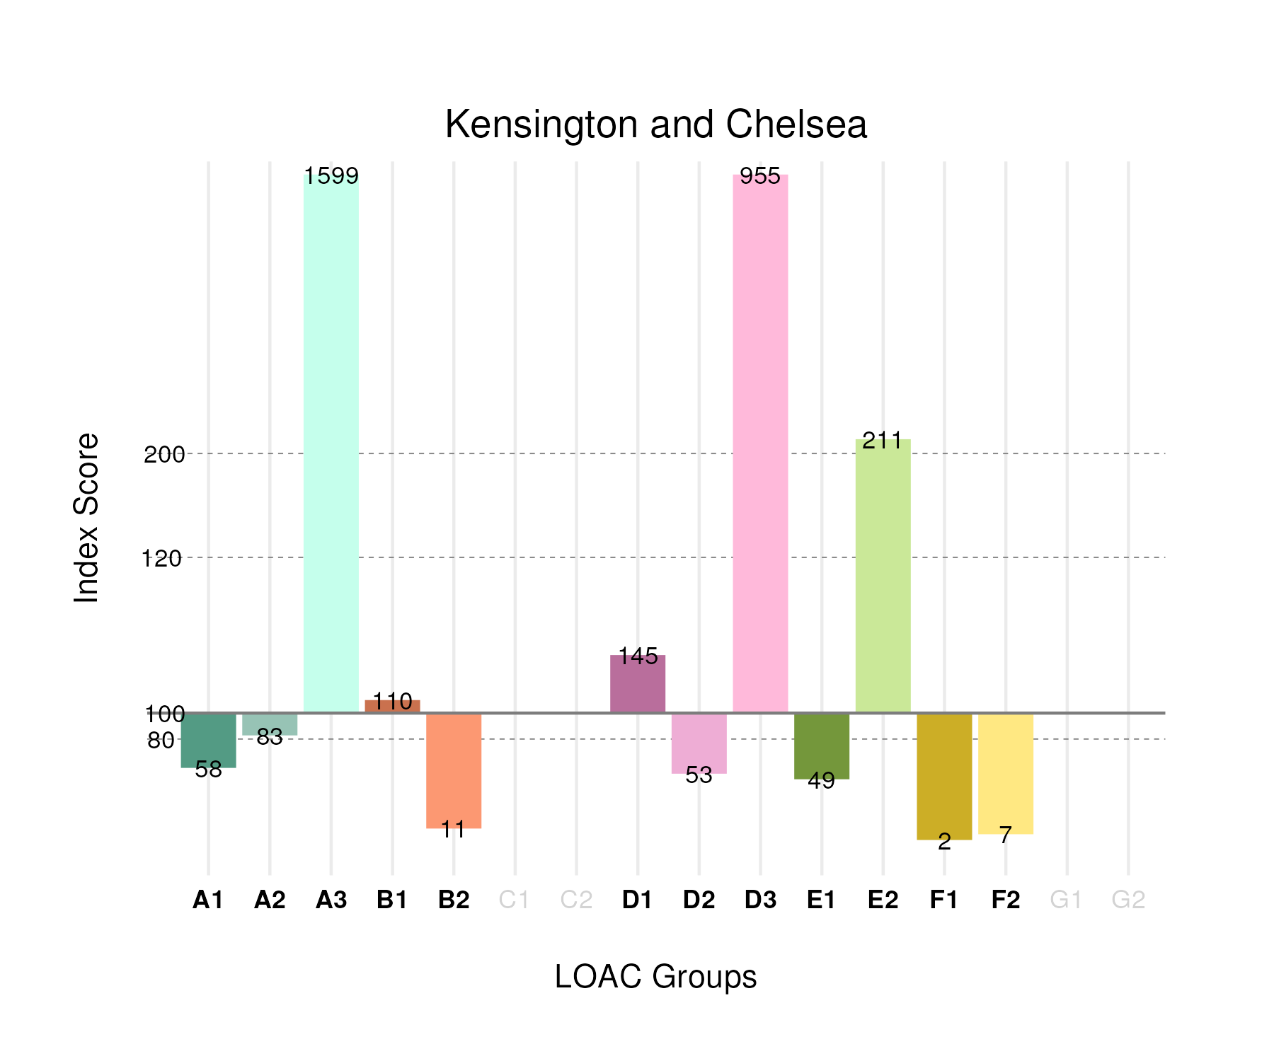

## Population Counts

The distribution of the population by LOAC Groups is shown in the following table.

| Group | Total Population (Census 2021) |
| --- | --- |
| A1 | 3,191 |
| A2 | 4,408 |
| A3 | 40,218 |
| B1 | 13,730 |
| B2 | 1,246 |
| C1 | 0 |
| C2 | 0 |
| D1 | 8,357 |
| D2 | 1,401 |
| D3 | 34,011 |
| E1 | 2,569 |
| E2 | 32,805 |
| F1 | 279 |
| F2 | 1,097 |
| G1 | 0 |
| G2 | 0 |

# Islington

## Spatial Distribution

The following map shows the spatial distribution of LOAC Groups across the London borough of Islington.

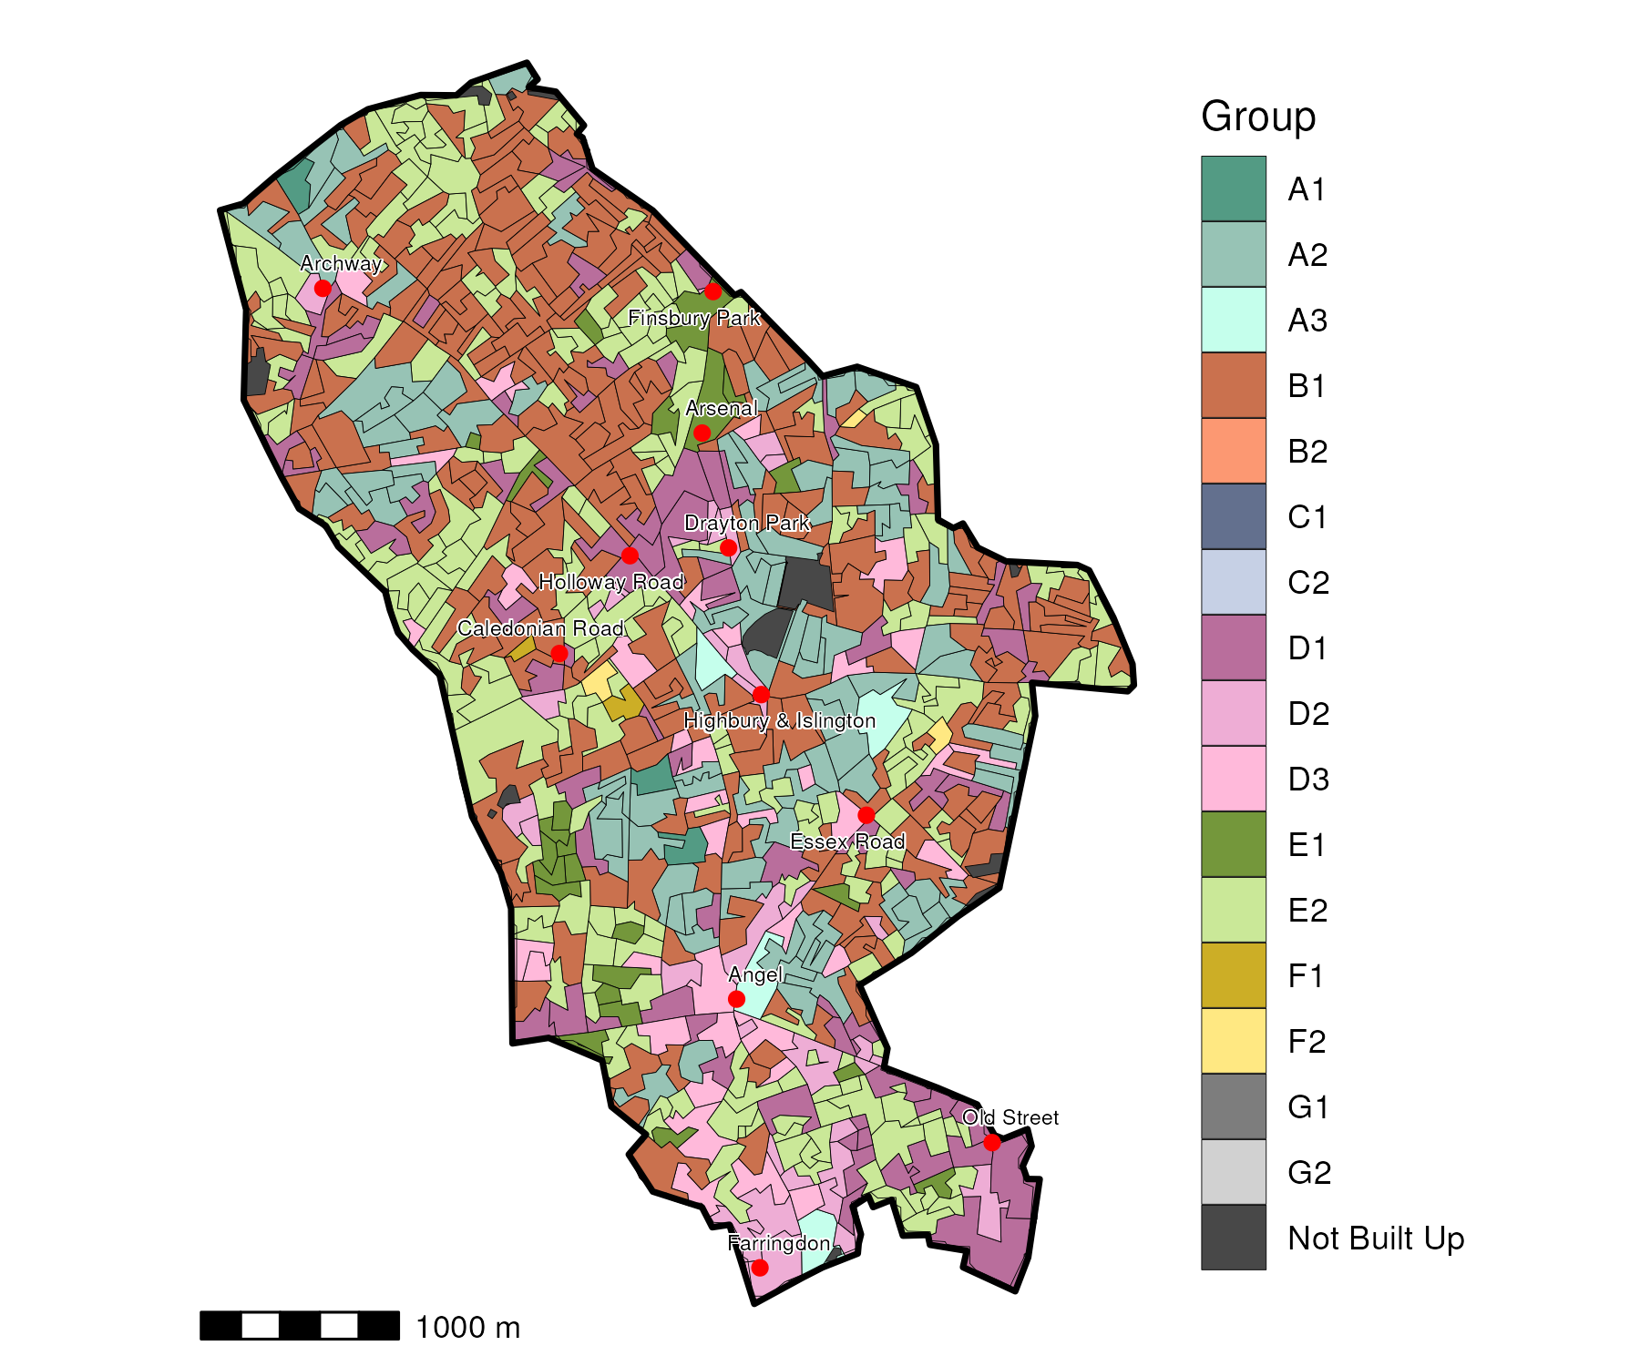

## Index Scores

The distribution of LOAC Groups within Islington relative to the London average can be shown by calculating an index score. If a distribution was the same as the London average the score would be 100. A score of 200 represents double the London average, and 50 a half. Scores that are less than 80 and greater than 120 are typically indicators of an interesting pattern to interpret, and are the thresholds used to describe the LOAC Super Groups and Groups. Where LOAC Groups are not present within a borough, the LOAC Group codes are 'greyed out'.

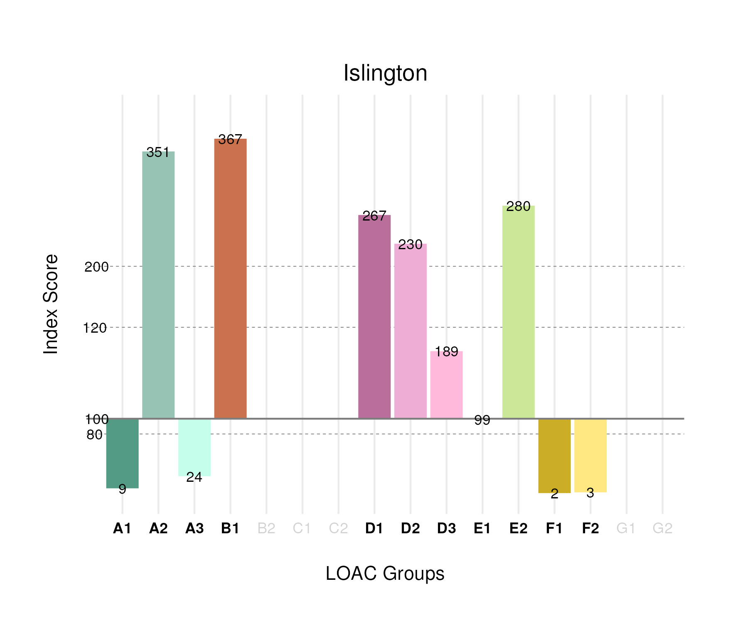

## Population Counts

The distribution of the population by LOAC Groups is shown in the following table.

| Group | Total Population (Census 2021) |
| --- | --- |
| A1 | 721 |
| A2 | 28,192 |
| A3 | 929 |
| B1 | 69,228 |
| B2 | 0 |
| C1 | 0 |
| C2 | 0 |
| D1 | 23,314 |
| D2 | 9,114 |
| D3 | 10,145 |
| E1 | 7,846 |
| E2 | 65,616 |
| F1 | 455 |
| F2 | 838 |
| G1 | 0 |
| G2 | 0 |

# Hounslow

## Spatial Distribution

The following map shows the spatial distribution of LOAC Groups across the London borough of Hounslow.

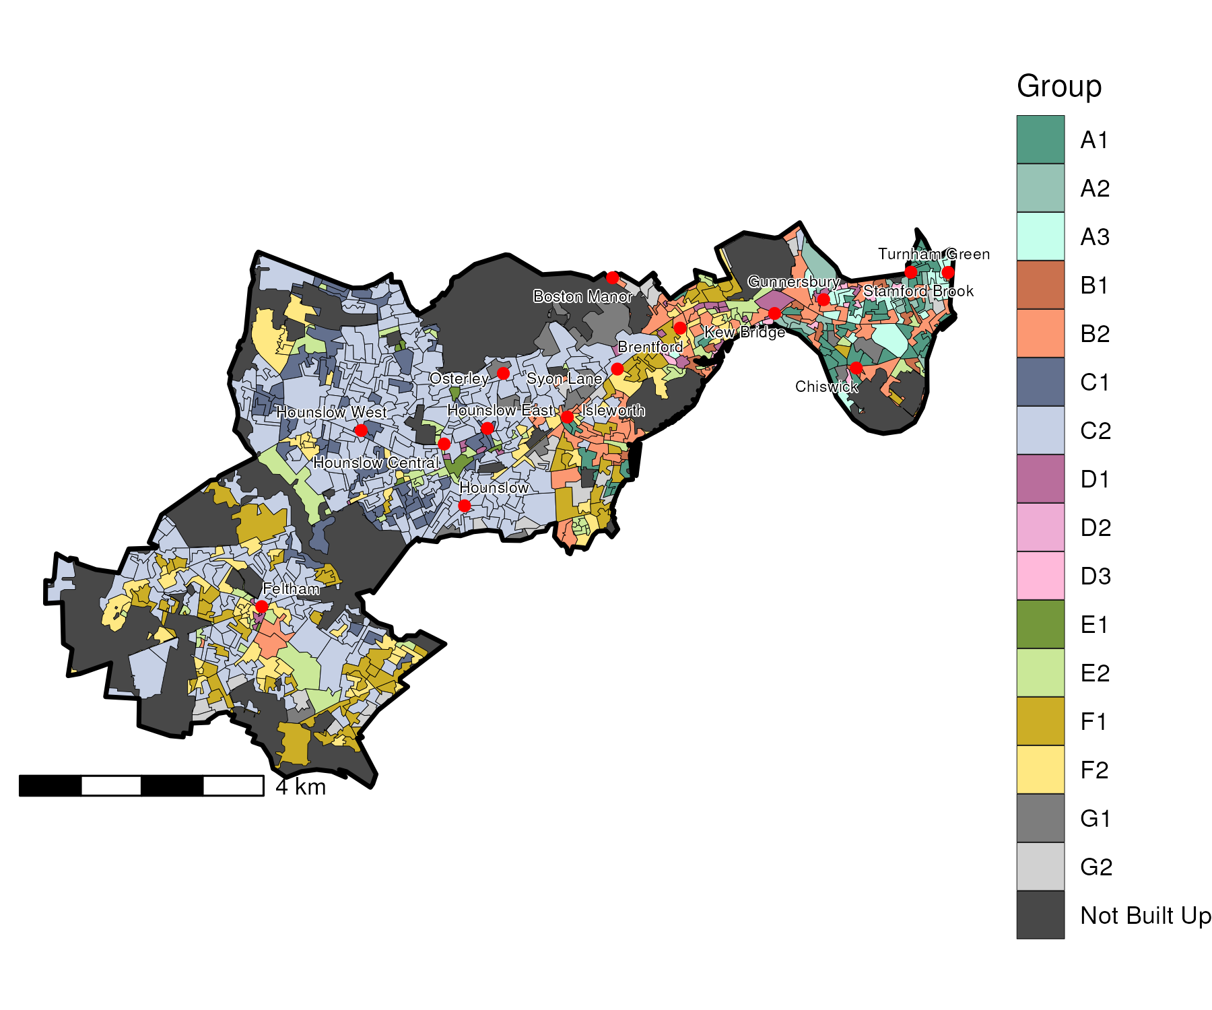

## Index Scores

The distribution of LOAC Groups within Hounslow relative to the London average can be shown by calculating an index score. If a distribution was the same as the London average the score would be 100. A score of 200 represents double the London average, and 50 a half. Scores that are less than 80 and greater than 120 are typically indicators of an interesting pattern to interpret, and are the thresholds used to describe the LOAC Super Groups and Groups. Where LOAC Groups are not present within a borough, the LOAC Group codes are 'greyed out'.

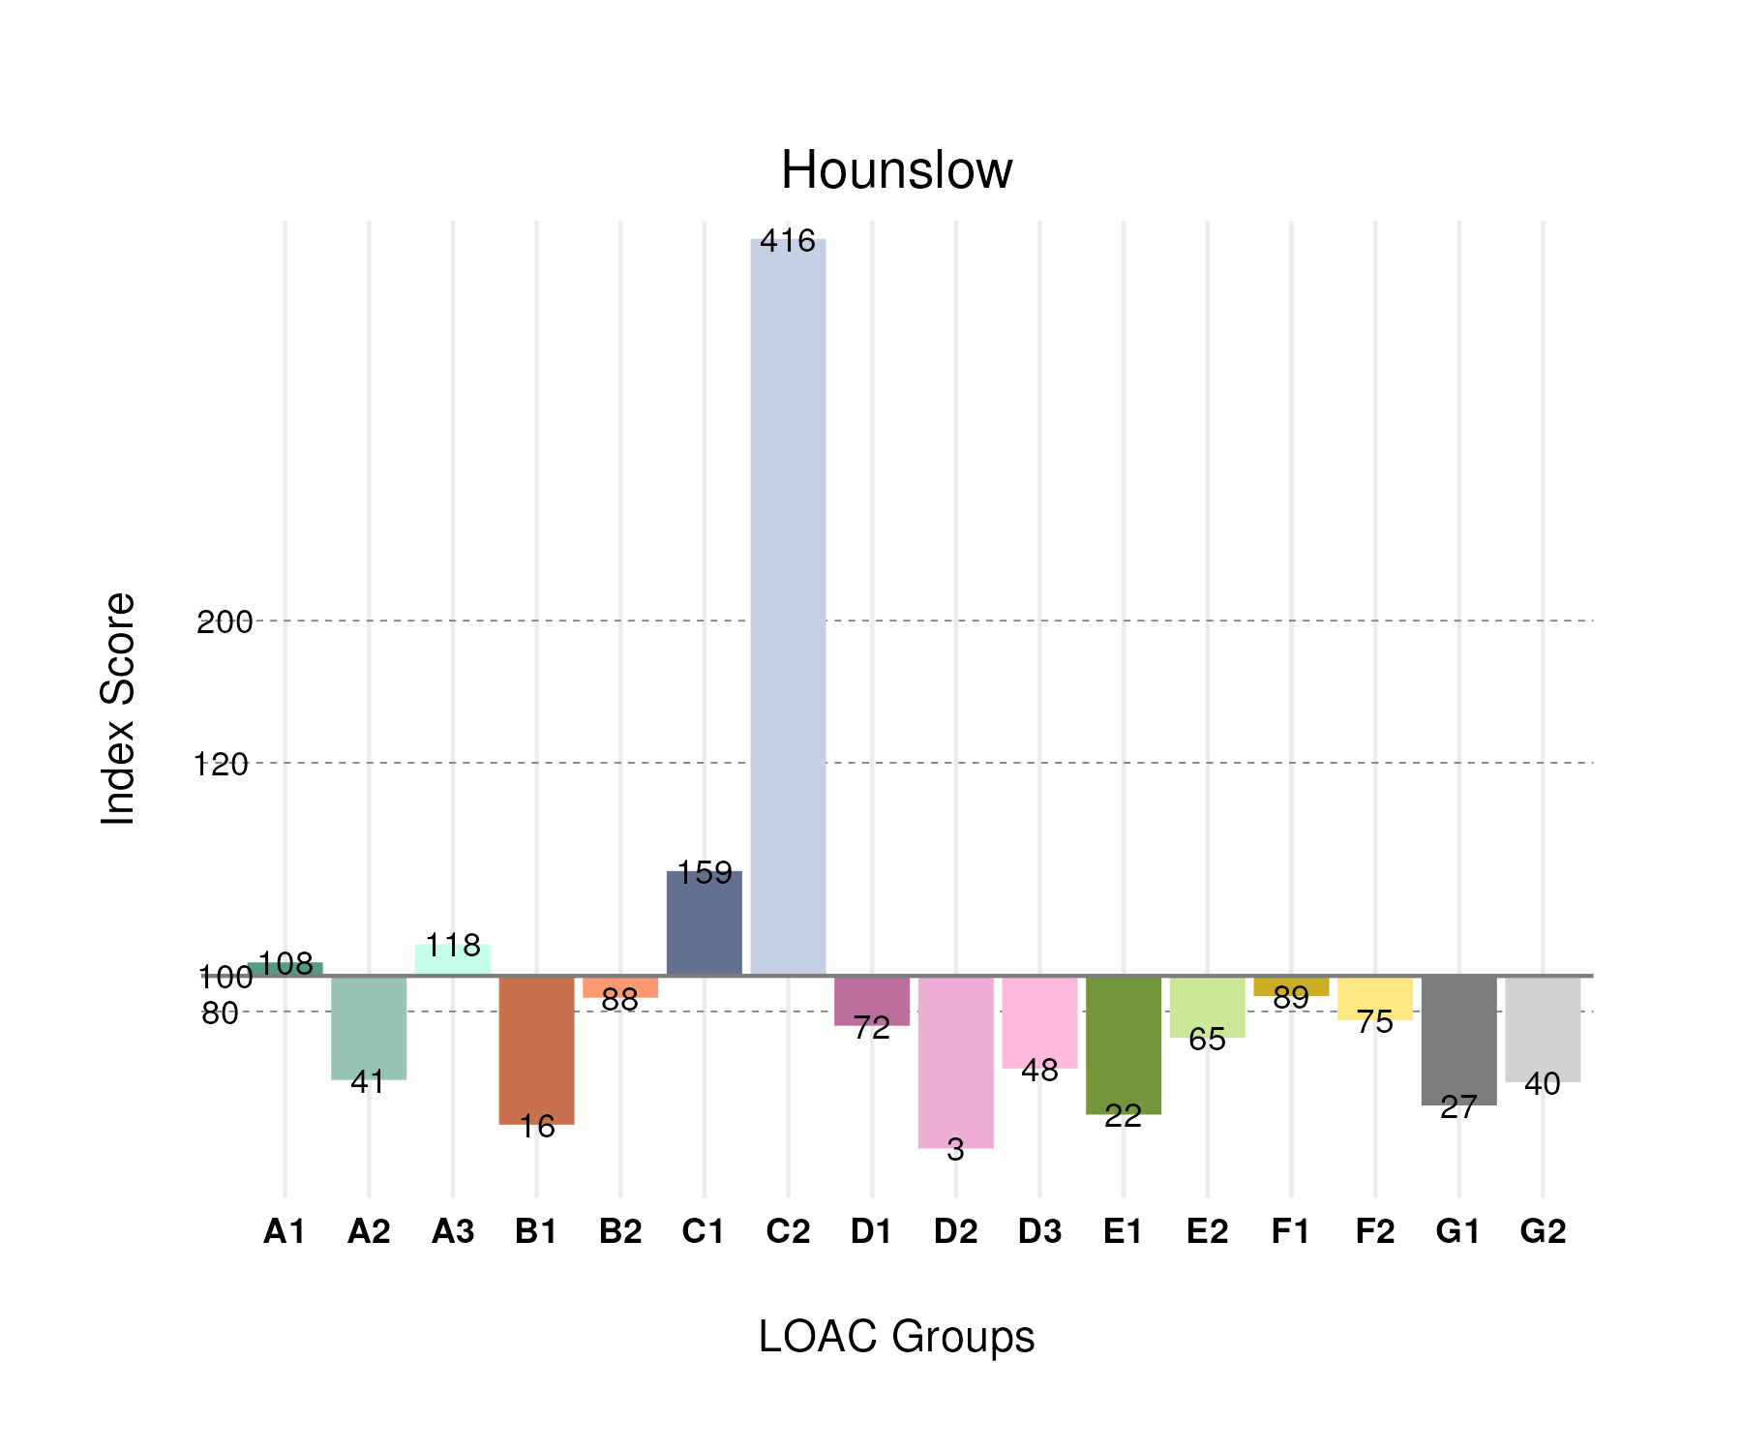

## Population Counts

The distribution of the population by LOAC Groups is shown in the following table.

| Group | Total Population (Census 2021) |
| --- | --- |
| A1 | 11,951 |
| A2 | 4,434 |
| A3 | 5,960 |
| B1 | 4,067 |
| B2 | 19,907 |
| C1 | 26,697 |
| C2 | 118,278 |
| D1 | 8,352 |
| D2 | 149 |
| D3 | 3,427 |
| E1 | 2,307 |
| E2 | 20,340 |
| F1 | 22,472 |
| F2 | 24,893 |
| G1 | 5,540 |
| G2 | 9,394 |

# Hillingdon

## Spatial Distribution

The following map shows the spatial distribution of LOAC Groups across the London borough of Hillingdon.

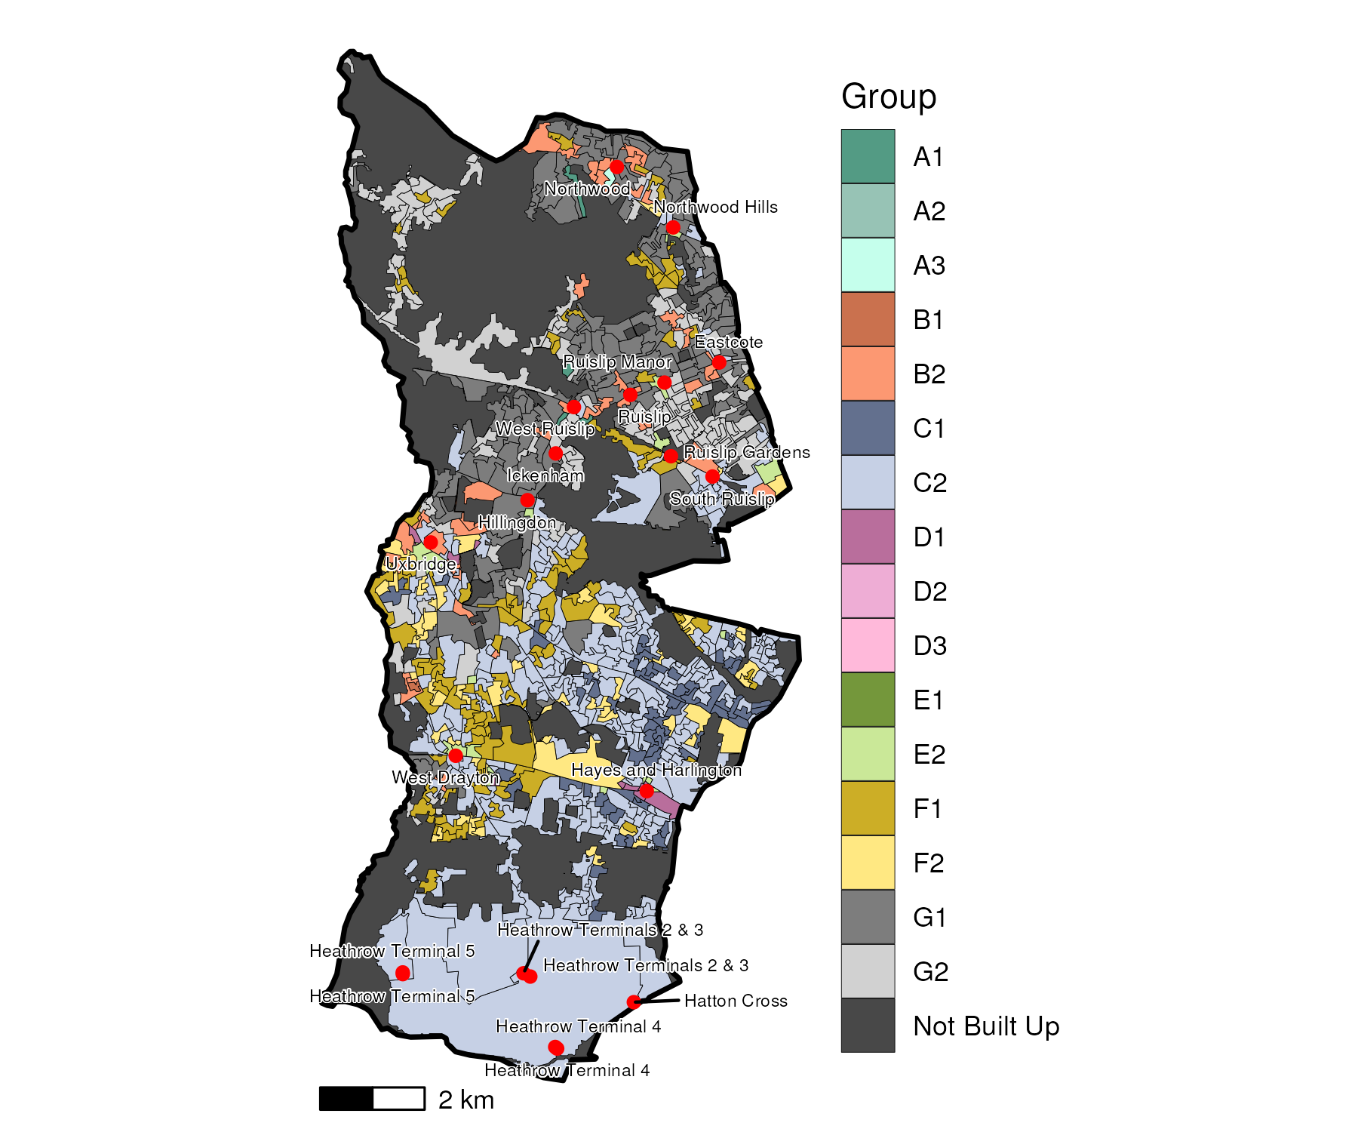

## Index Scores

The distribution of LOAC Groups within Hillingdon relative to the London average can be shown by calculating an index score. If a distribution was the same as the London average the score would be 100. A score of 200 represents double the London average, and 50 a half. Scores that are less than 80 and greater than 120 are typically indicators of an interesting pattern to interpret, and are the thresholds used to describe the LOAC Super Groups and Groups. Where LOAC Groups are not present within a borough, the LOAC Group codes are 'greyed out'.

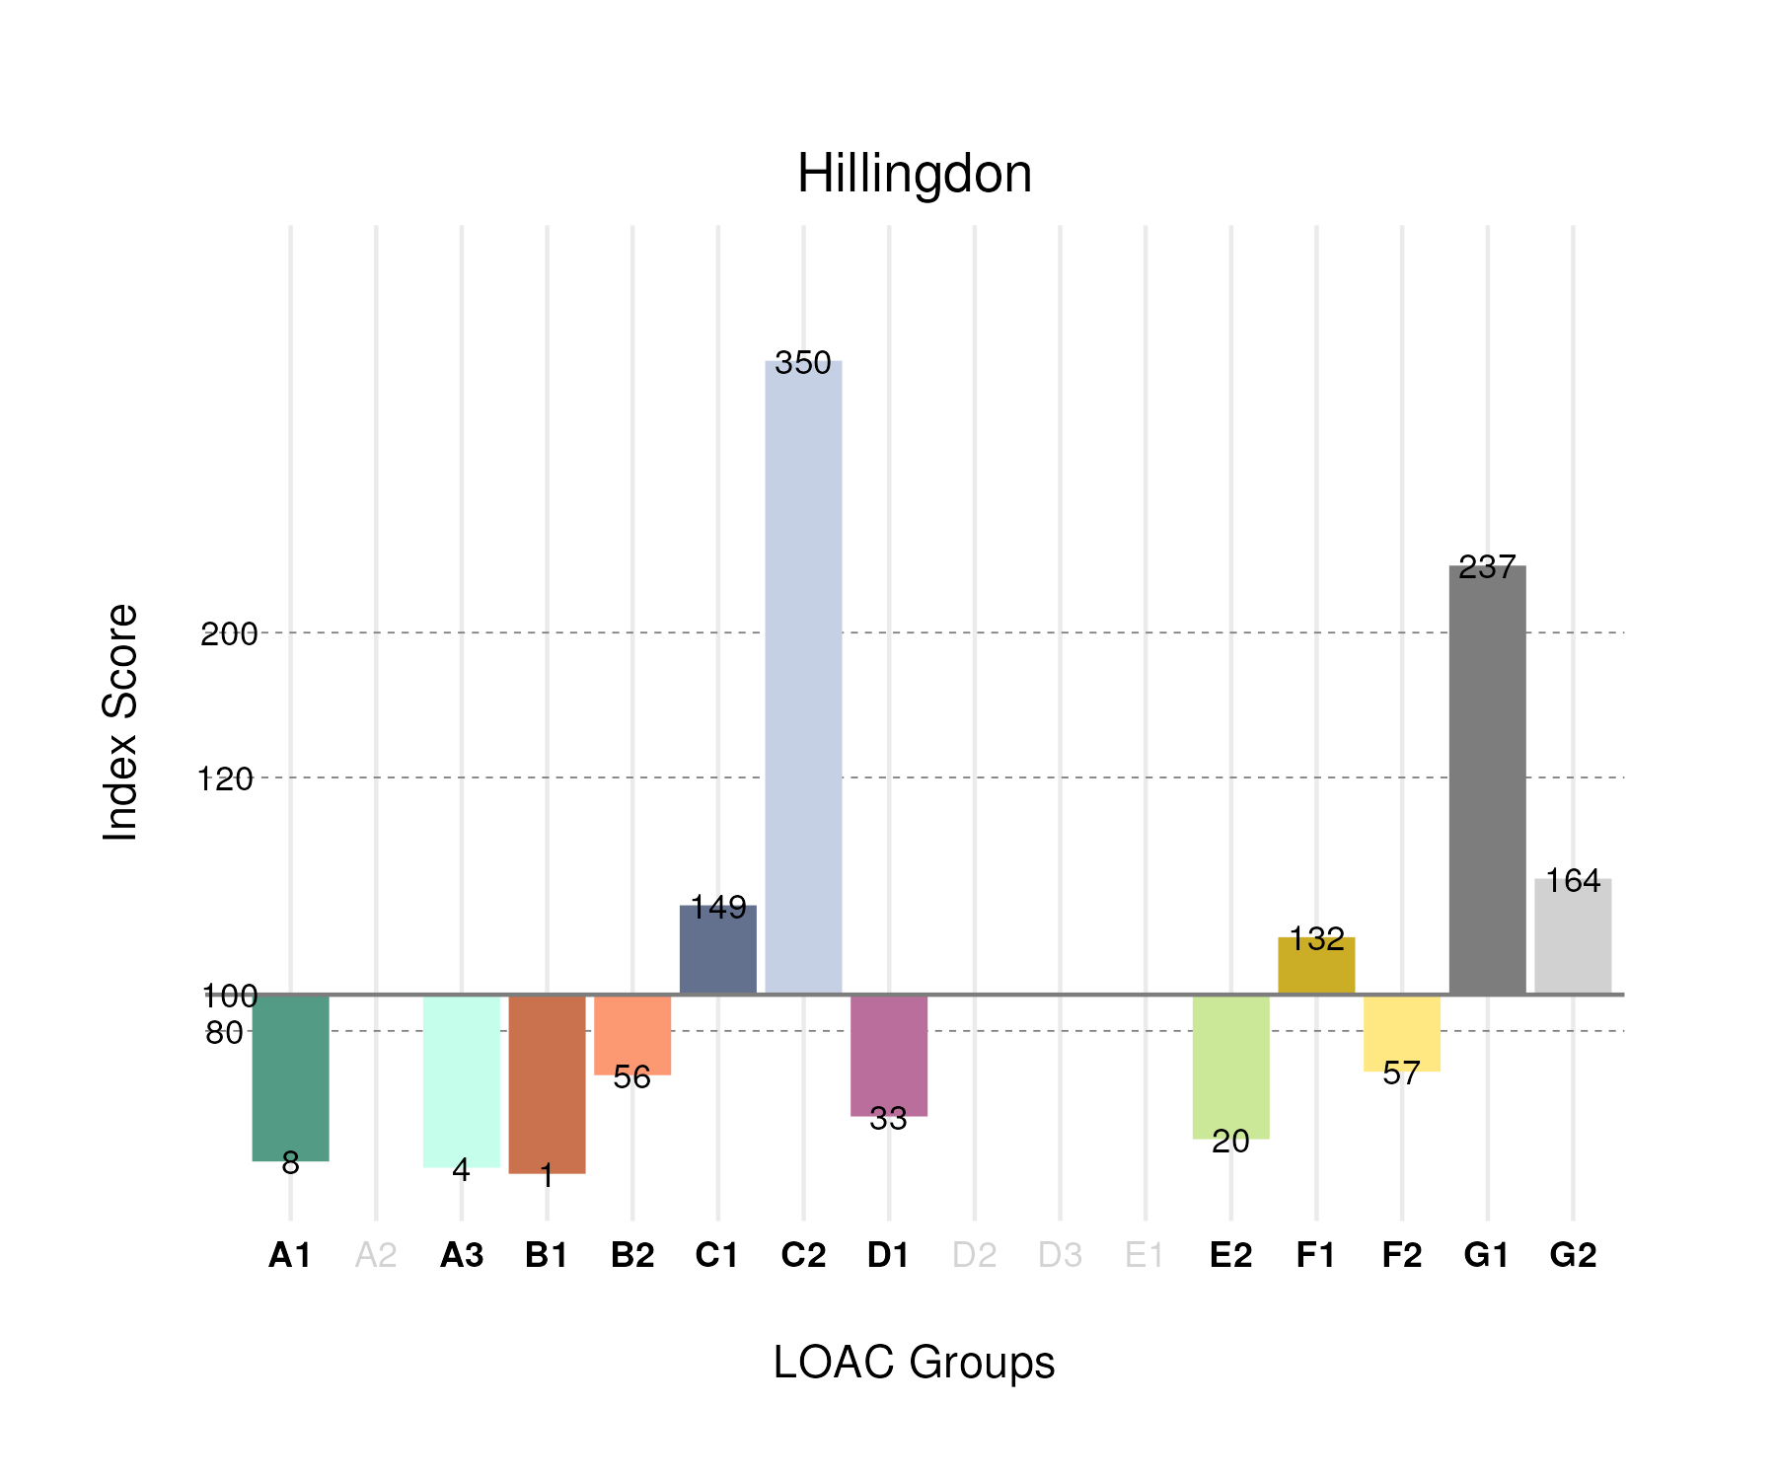

## Population Counts

The distribution of the population by LOAC Groups is shown in the following table.

| Group | Total Population (Census 2021) |
| --- | --- |
| A1 | 928 |
| A2 | 0 |
| A3 | 236 |
| B1 | 281 |
| B2 | 13,388 |
| C1 | 26,626 |
| C2 | 105,683 |
| D1 | 4,037 |
| D2 | 0 |
| D3 | 0 |
| E1 | 0 |
| E2 | 6,696 |
| F1 | 35,480 |
| F2 | 20,255 |
| G1 | 51,563 |
| G2 | 40,838 |

# Havering

## Spatial Distribution

The following map shows the spatial distribution of LOAC Groups across the London borough of Havering.

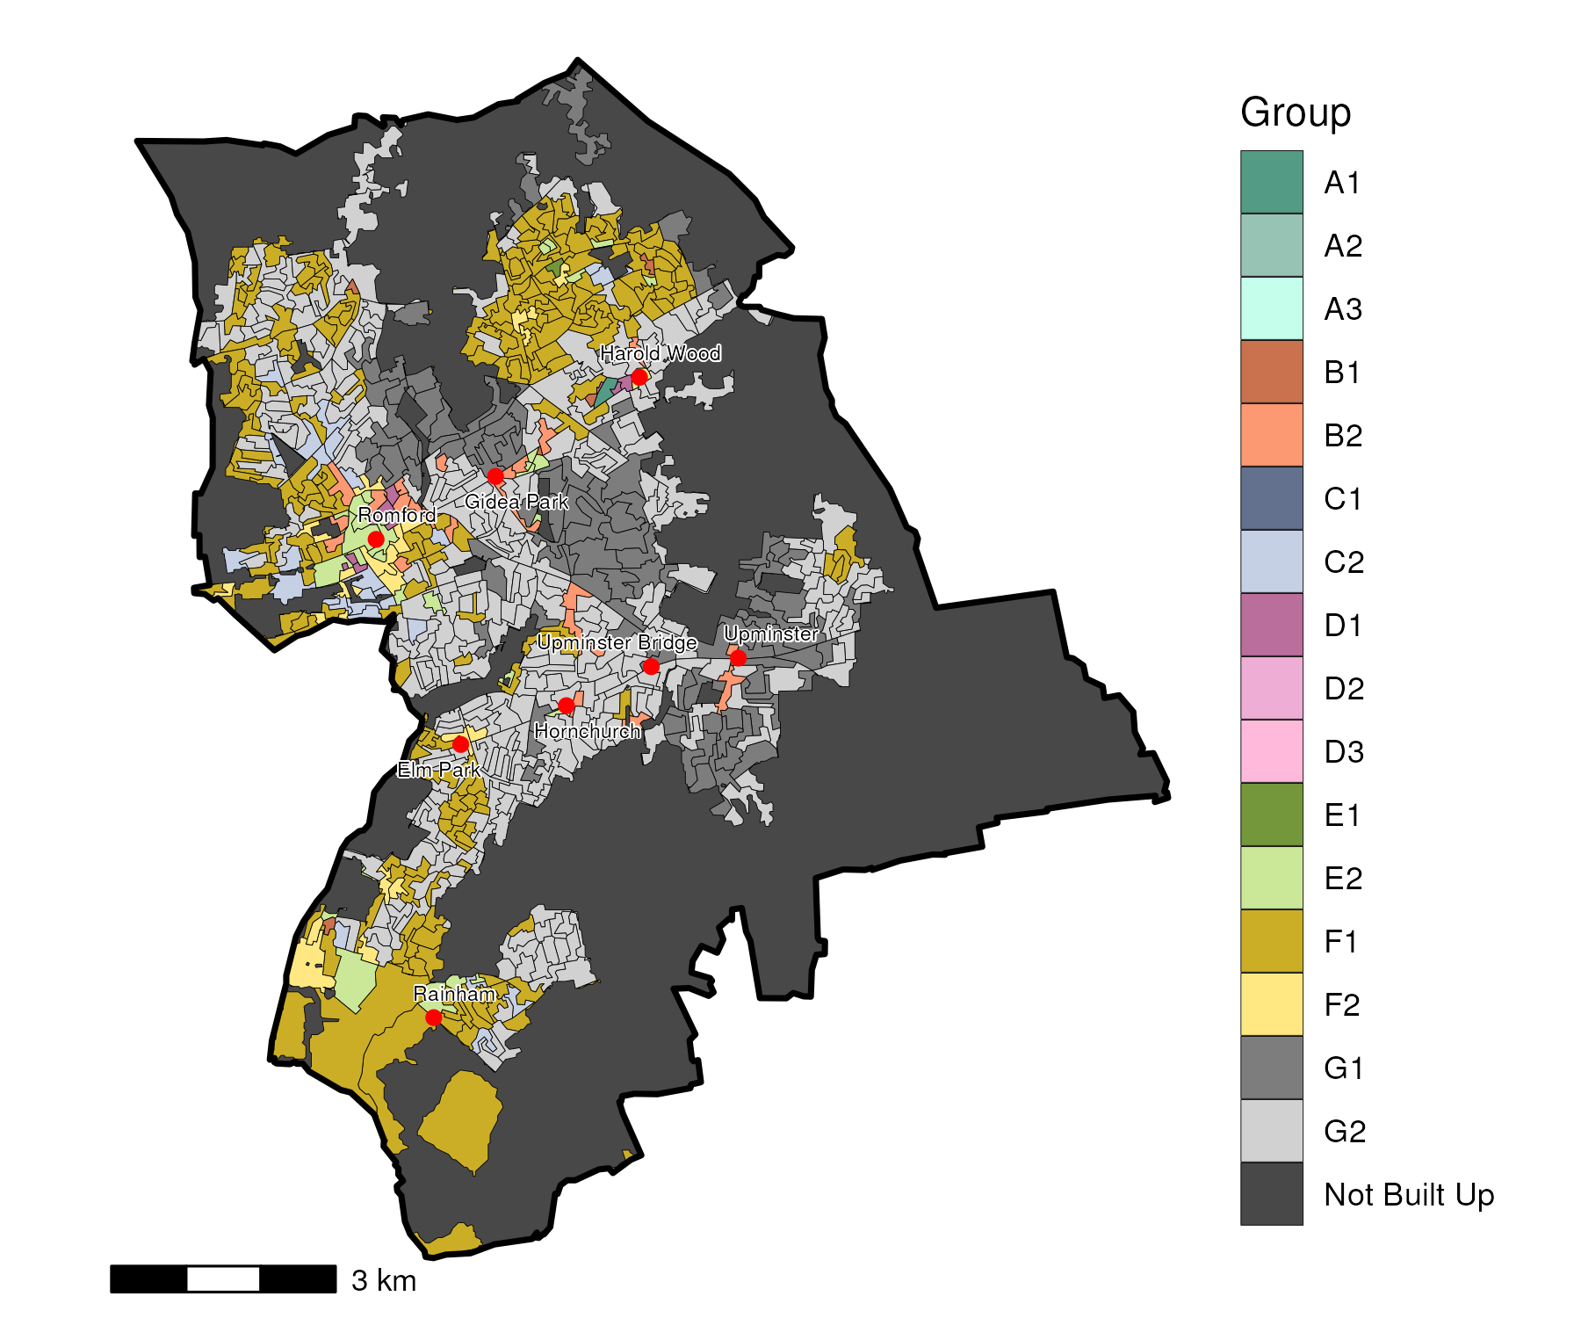

## Index Scores

The distribution of LOAC Groups within Havering relative to the London average can be shown by calculating an index score. If a distribution was the same as the London average the score would be 100. A score of 200 represents double the London average, and 50 a half. Scores that are less than 80 and greater than 120 are typically indicators of an interesting pattern to interpret, and are the thresholds used to describe the LOAC Super Groups and Groups. Where LOAC Groups are not present within a borough, the LOAC Group codes are 'greyed out'.

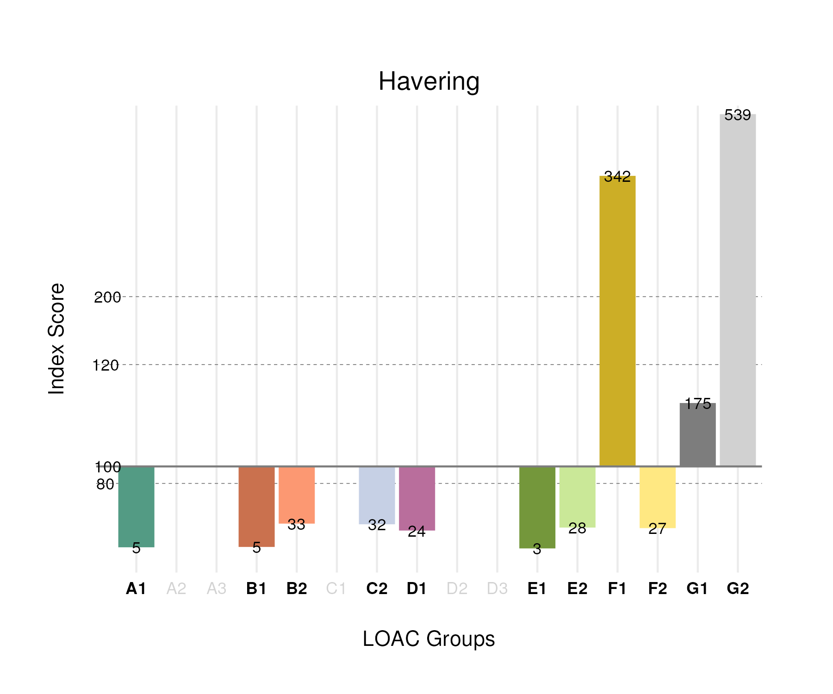

## Population Counts

The distribution of the population by LOAC Groups is shown in the following table.

| Group | Total Population (Census 2021) |
| --- | --- |
| A1 | 479 |
| A2 | 0 |
| A3 | 0 |
| B1 | 1,176 |
| B2 | 6,735 |
| C1 | 0 |
| C2 | 8,235 |
| D1 | 2,586 |
| D2 | 0 |
| D3 | 0 |
| E1 | 328 |
| E2 | 7,952 |
| F1 | 78,939 |
| F2 | 8,243 |
| G1 | 32,546 |
| G2 | 114,860 |

# Harrow

## Spatial Distribution

The following map shows the spatial distribution of LOAC Groups across the London borough of Harrow.

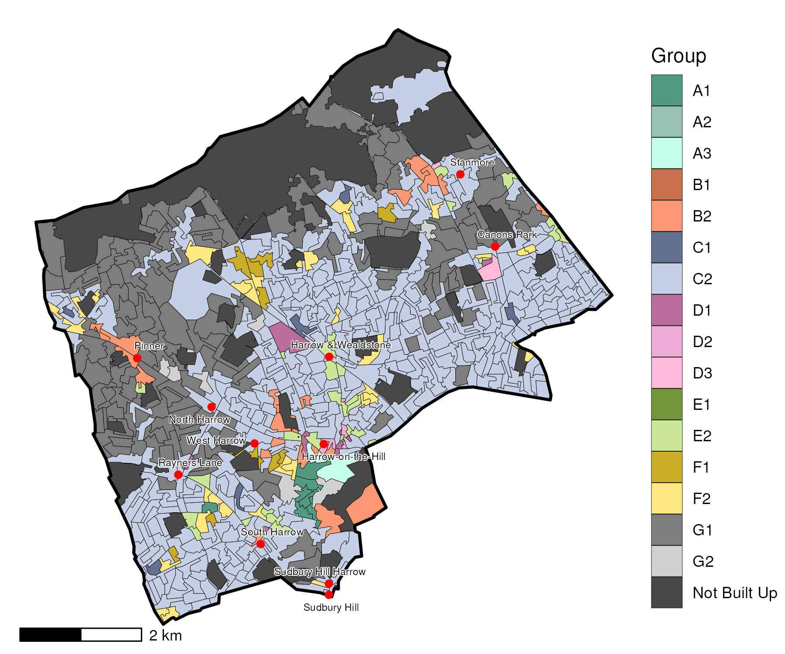

## Index Scores

The distribution of LOAC Groups within Harrow relative to the London average can be shown by calculating an index score. If a distribution was the same as the London average the score would be 100. A score of 200 represents double the London average, and 50 a half. Scores that are less than 80 and greater than 120 are typically indicators of an interesting pattern to interpret, and are the thresholds used to describe the LOAC Super Groups and Groups. Where LOAC Groups are not present within a borough, the LOAC Group codes are 'greyed out'.

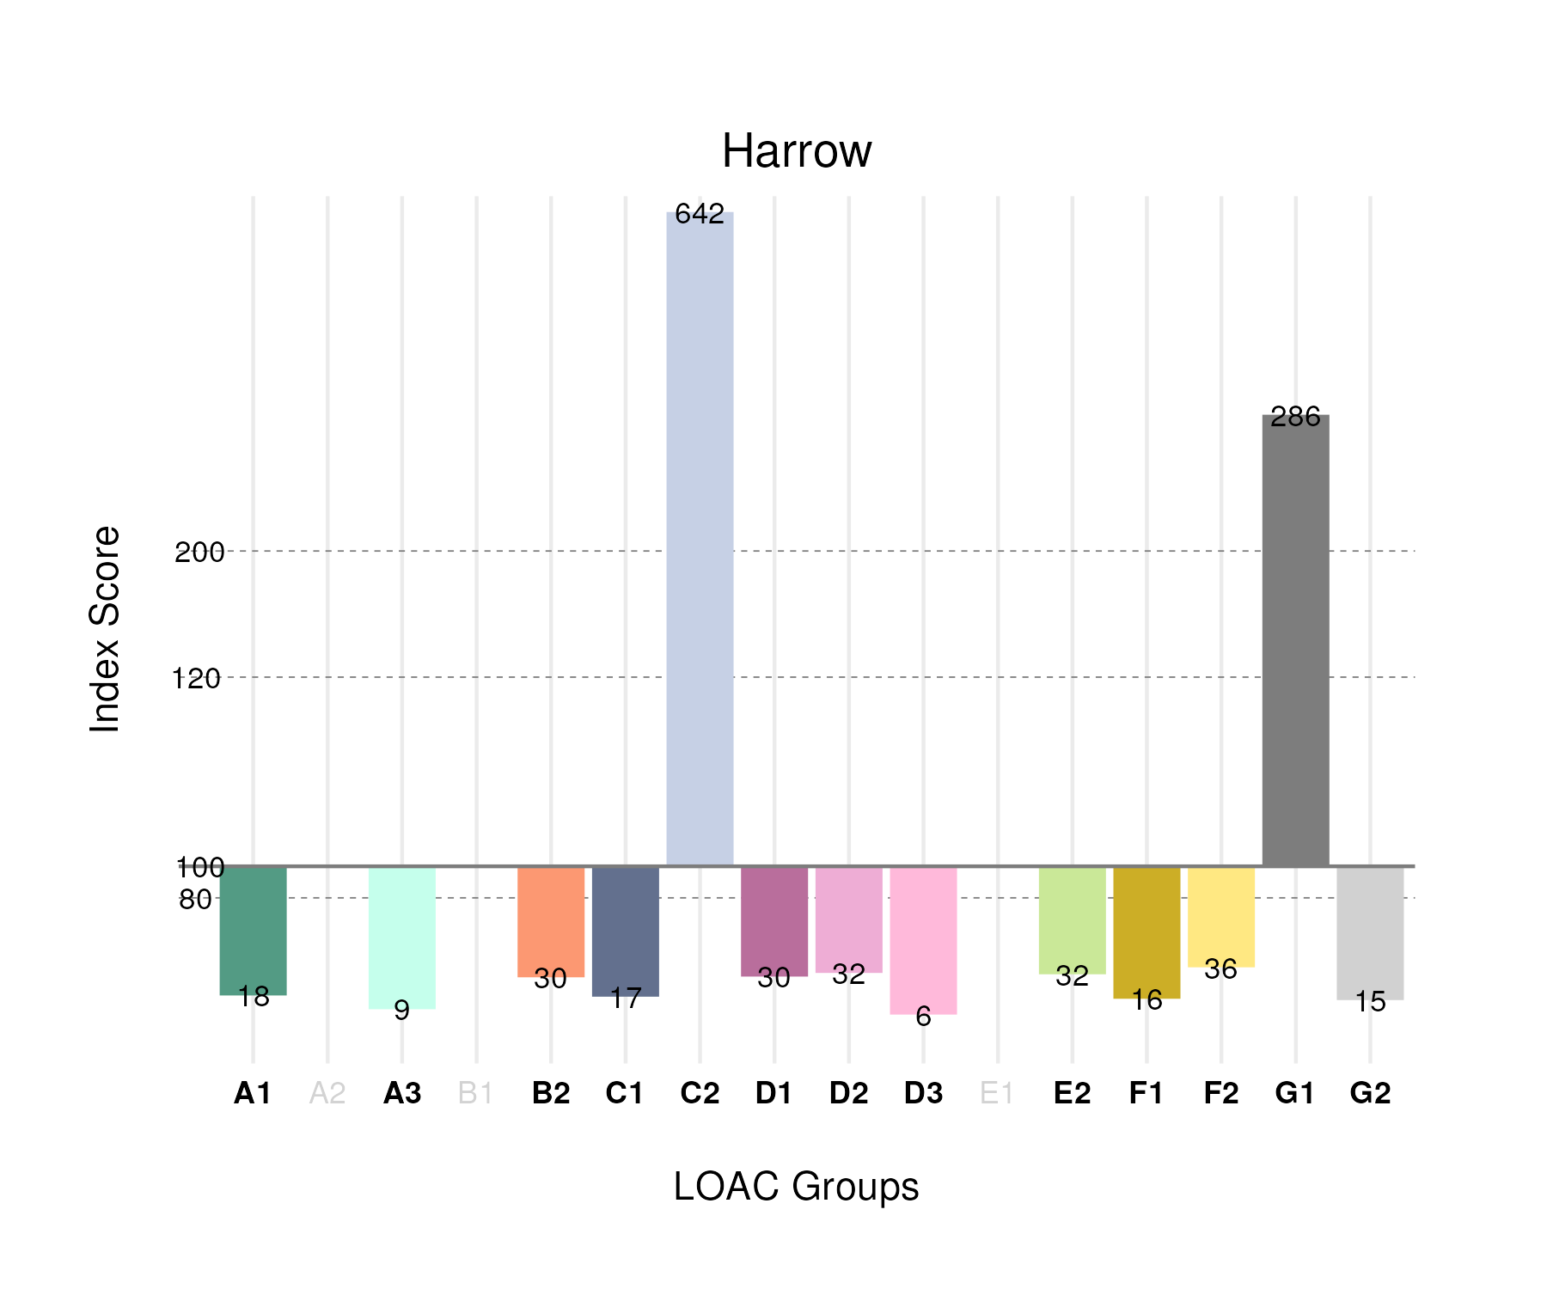

## Population Counts

The distribution of the population by LOAC Groups is shown in the following table.

| Group | Total Population (Census 2021) |
| --- | --- |
| A1 | 1,821 |
| A2 | 0 |
| A3 | 430 |
| B1 | 0 |
| B2 | 6,090 |
| C1 | 2,635 |
| C2 | 165,257 |
| D1 | 3,166 |
| D2 | 1,551 |
| D3 | 388 |
| E1 | 0 |
| E2 | 8,933 |
| F1 | 3,679 |
| F2 | 10,814 |
| G1 | 53,177 |
| G2 | 3,223 |

# Haringey

## Spatial Distribution

The following map shows the spatial distribution of LOAC Groups across the London borough of Haringey.

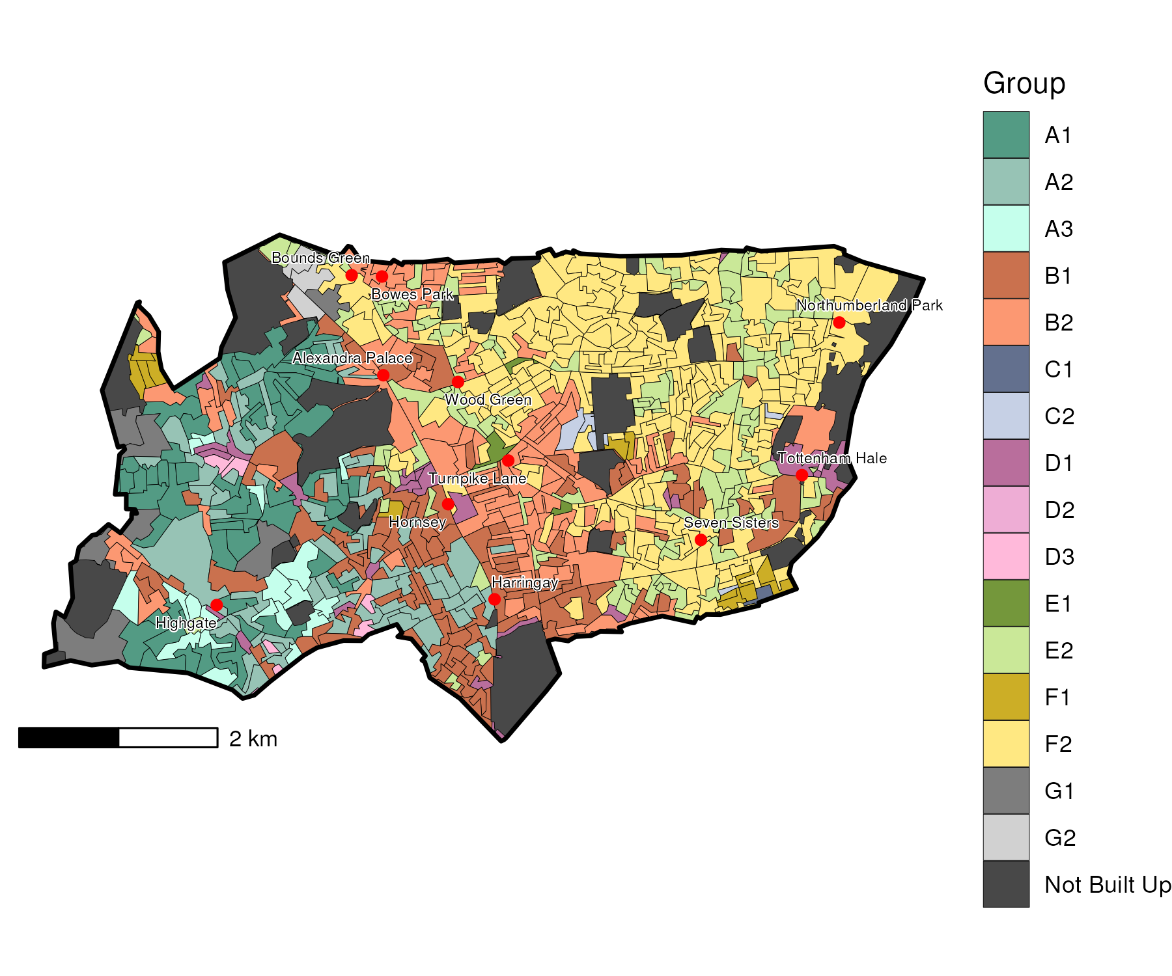

## Index Scores

The distribution of LOAC Groups within Haringey relative to the London average can be shown by calculating an index score. If a distribution was the same as the London average the score would be 100. A score of 200 represents double the London average, and 50 a half. Scores that are less than 80 and greater than 120 are typically indicators of an interesting pattern to interpret, and are the thresholds used to describe the LOAC Super Groups and Groups. Where LOAC Groups are not present within a borough, the LOAC Group codes are 'greyed out'.

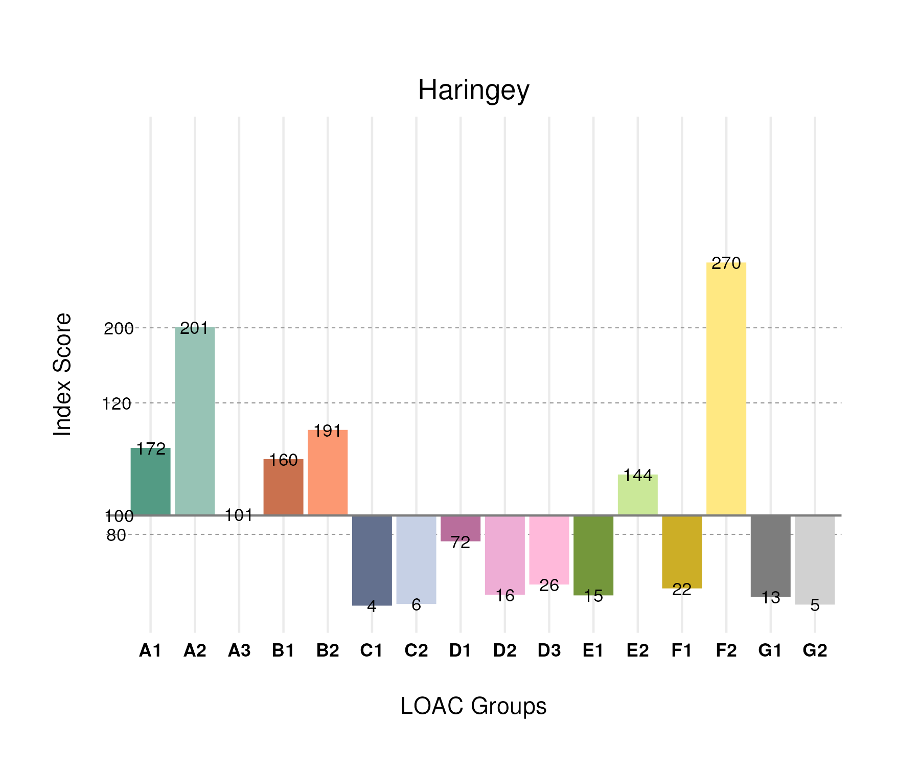

## Population Counts

The distribution of the population by LOAC Groups is shown in the following table.

| Group | Total Population (Census 2021) |
| --- | --- |
| A1 | 17,517 |
| A2 | 19,709 |
| A3 | 4,687 |
| B1 | 36,820 |
| B2 | 39,783 |
| C1 | 598 |
| C2 | 1,482 |
| D1 | 7,716 |
| D2 | 756 |
| D3 | 1,734 |
| E1 | 1,434 |
| E2 | 41,158 |
| F1 | 5,180 |
| F2 | 82,019 |
| G1 | 2,481 |
| G2 | 1,076 |

# Hammersmith and Fulham

## Spatial Distribution

The following map shows the spatial distribution of LOAC Groups across the London borough of Hammersmith and Fulham.

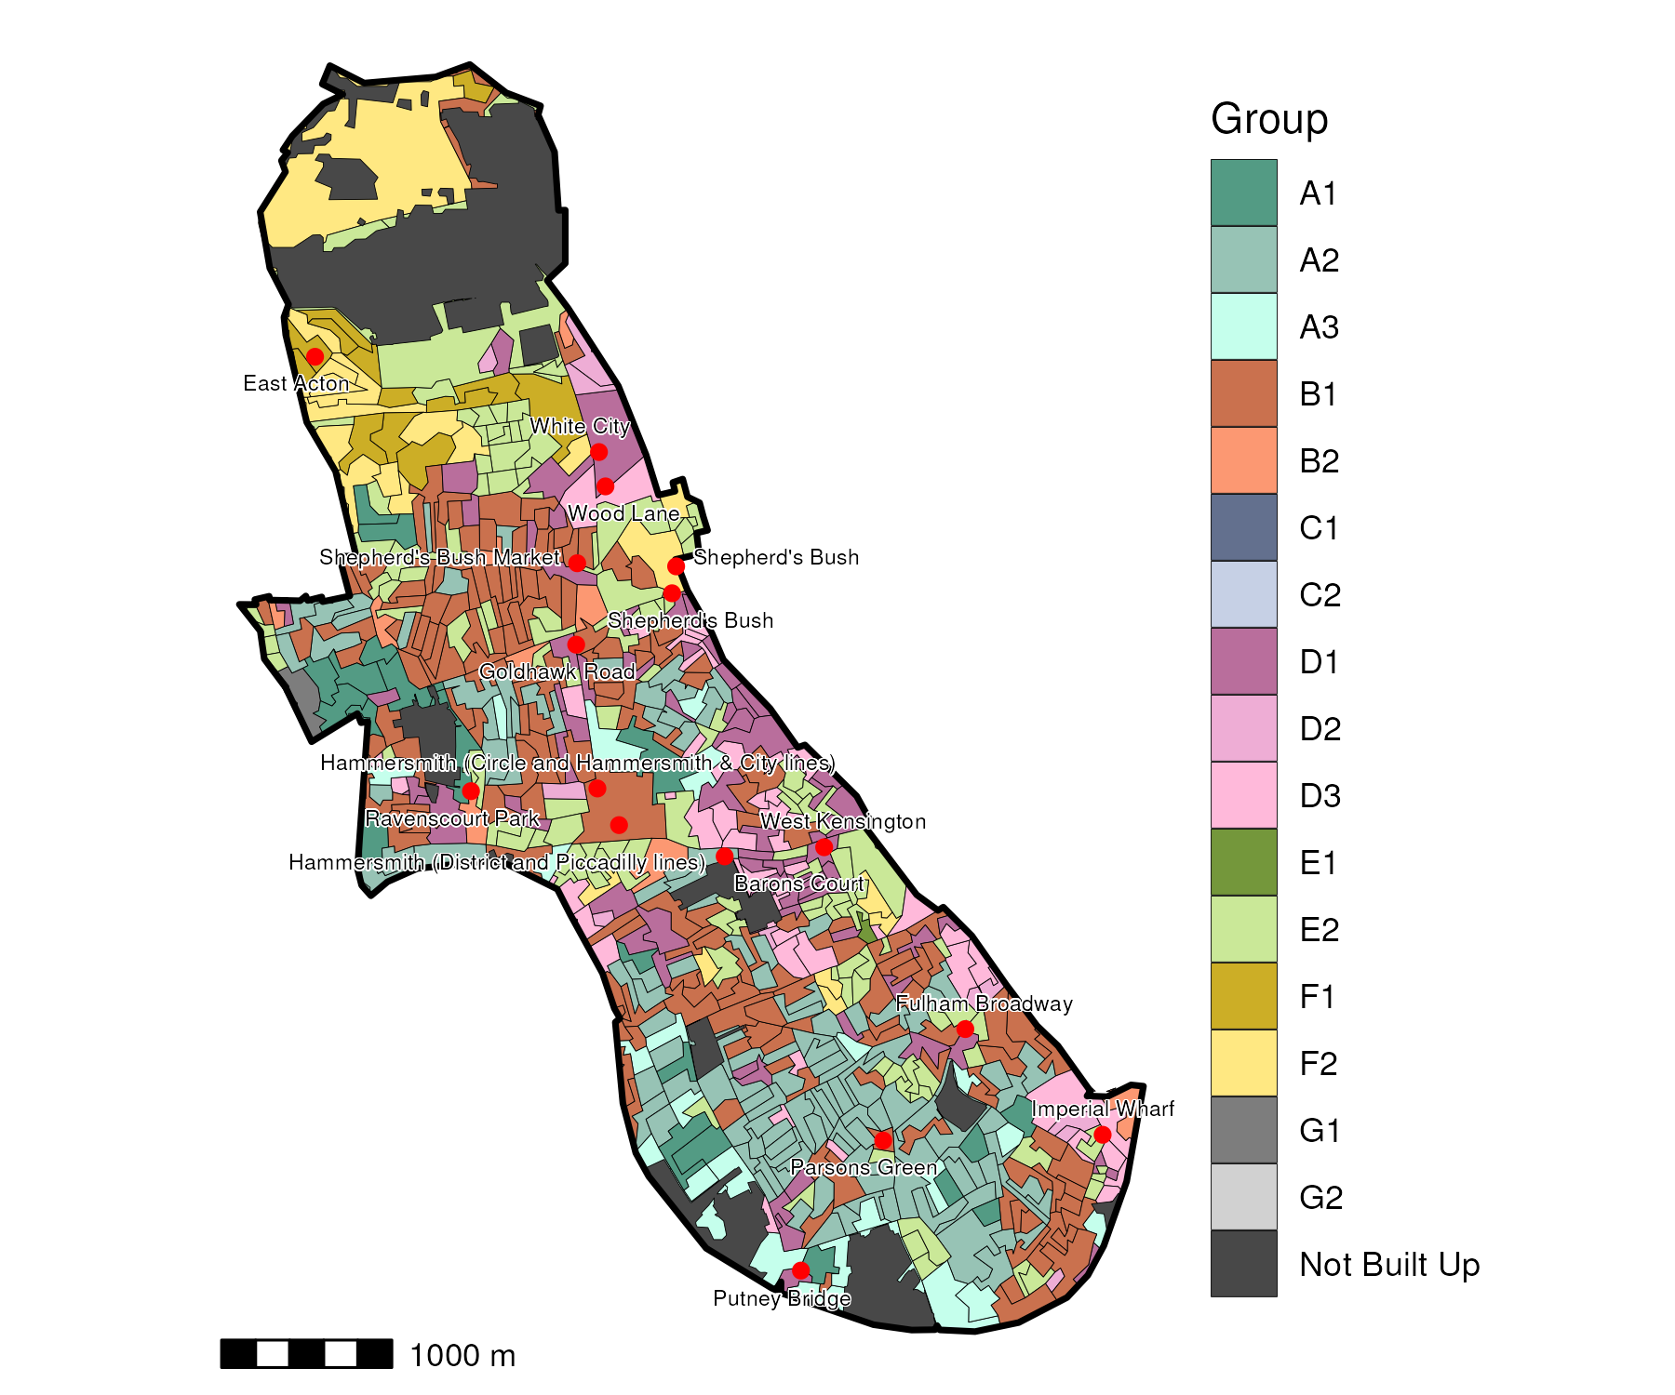

## Index Scores

The distribution of LOAC Groups within Hammersmith and Fulham relative to the London average can be shown by calculating an index score. If a distribution was the same as the London average the score would be 100. A score of 200 represents double the London average, and 50 a half. Scores that are less than 80 and greater than 120 are typically indicators of an interesting pattern to interpret, and are the thresholds used to describe the LOAC Super Groups and Groups. Where LOAC Groups are not present within a borough, the LOAC Group codes are 'greyed out'.

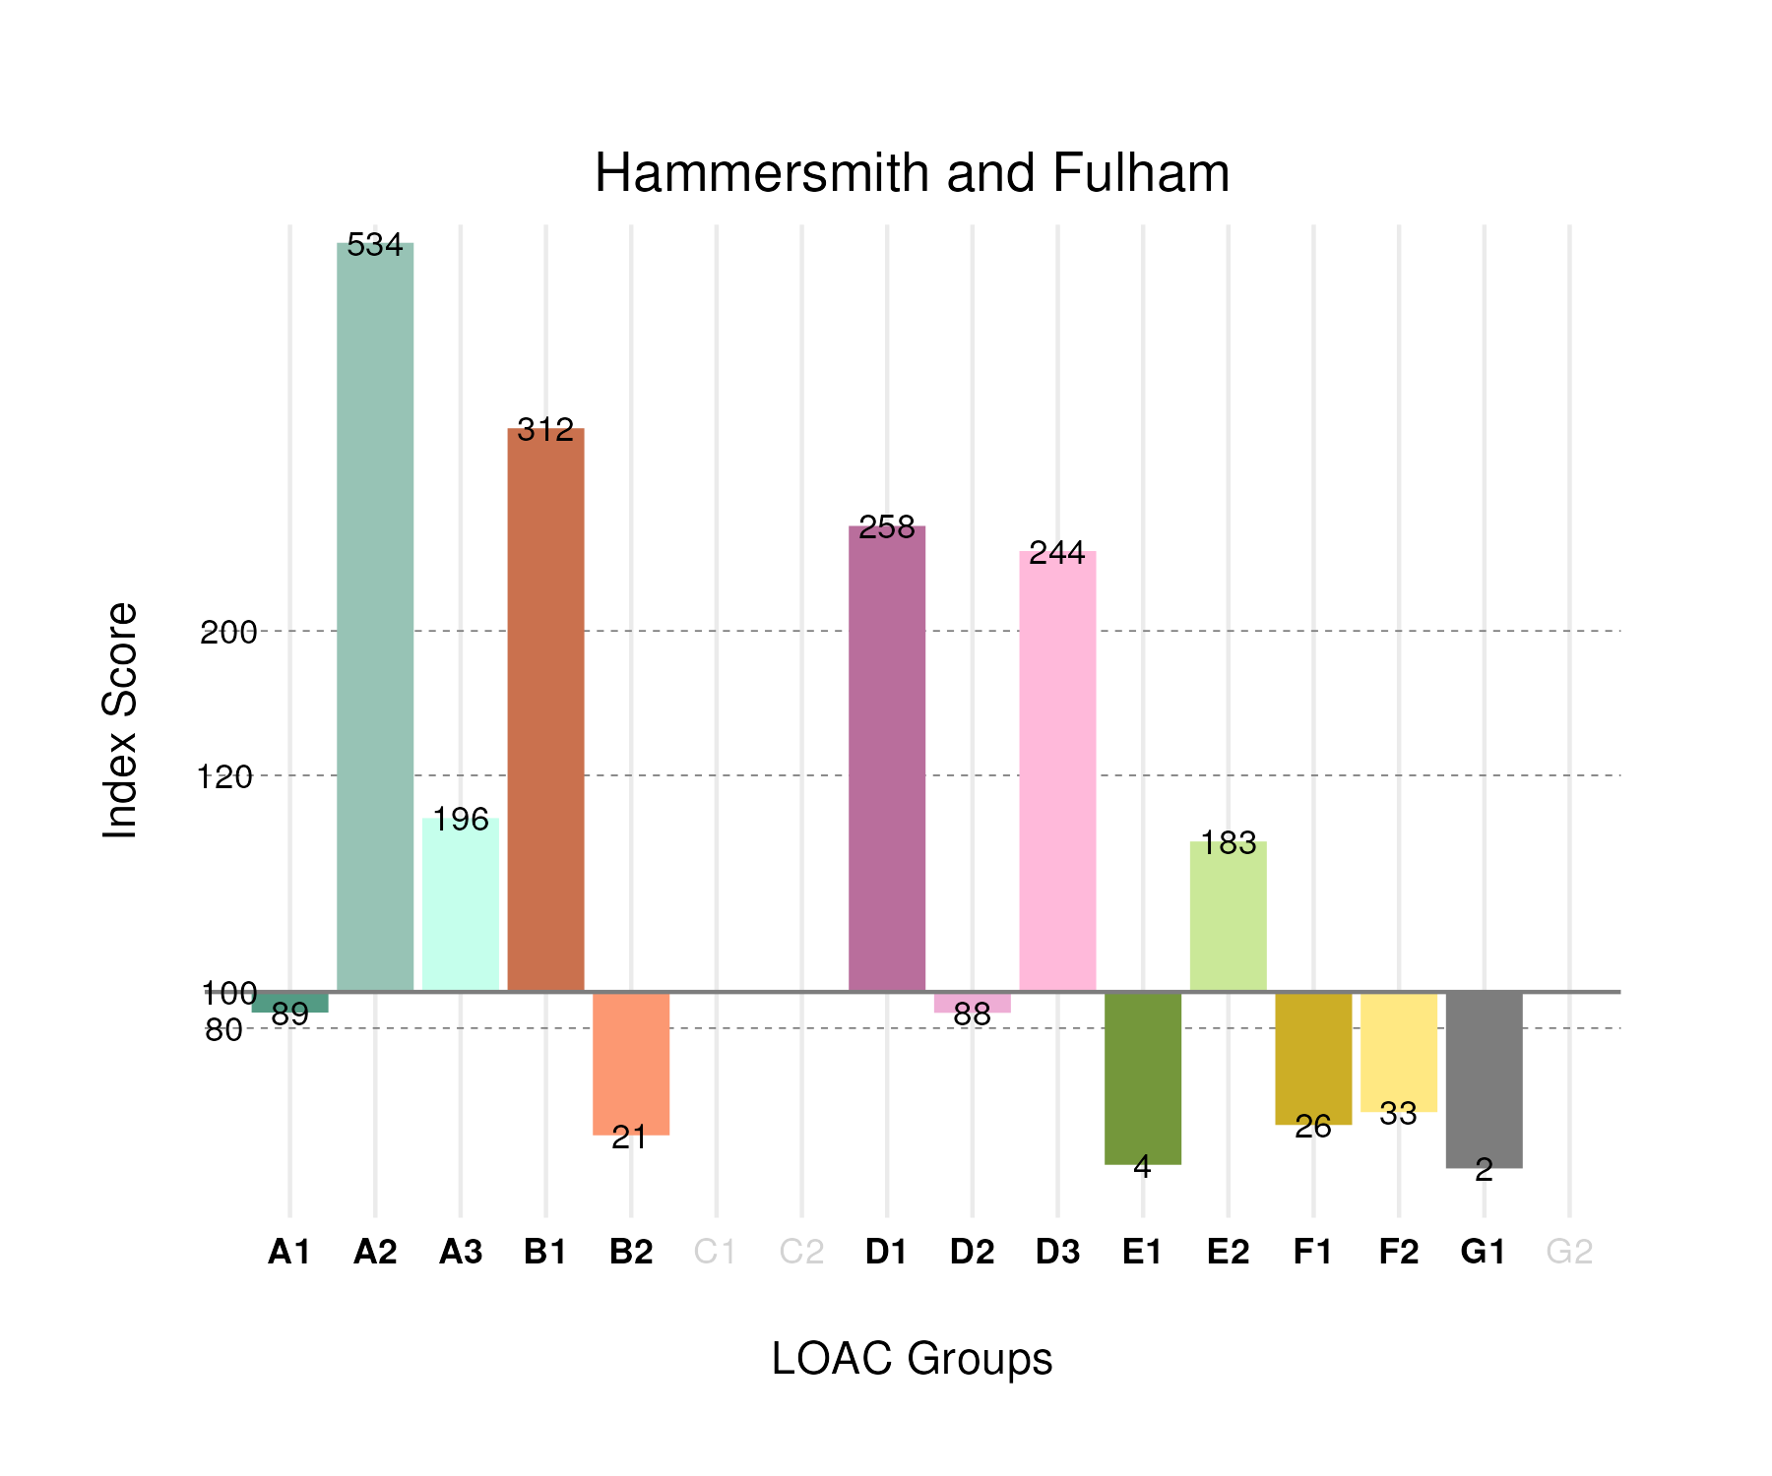

## Population Counts

The distribution of the population by LOAC Groups is shown in the following table.

| Group | Total Population (Census 2021) |
| --- | --- |
| A1 | 6,254 |
| A2 | 36,354 |
| A3 | 6,309 |
| B1 | 49,791 |
| B2 | 2,975 |
| C1 | 0 |
| C2 | 0 |
| D1 | 19,053 |
| D2 | 2,972 |
| D3 | 11,116 |
| E1 | 288 |
| E2 | 36,427 |
| F1 | 4,246 |
| F2 | 7,054 |
| G1 | 297 |
| G2 | 0 |

# Hackney

## Spatial Distribution

The following map shows the spatial distribution of LOAC Groups across the London borough of Hackney.

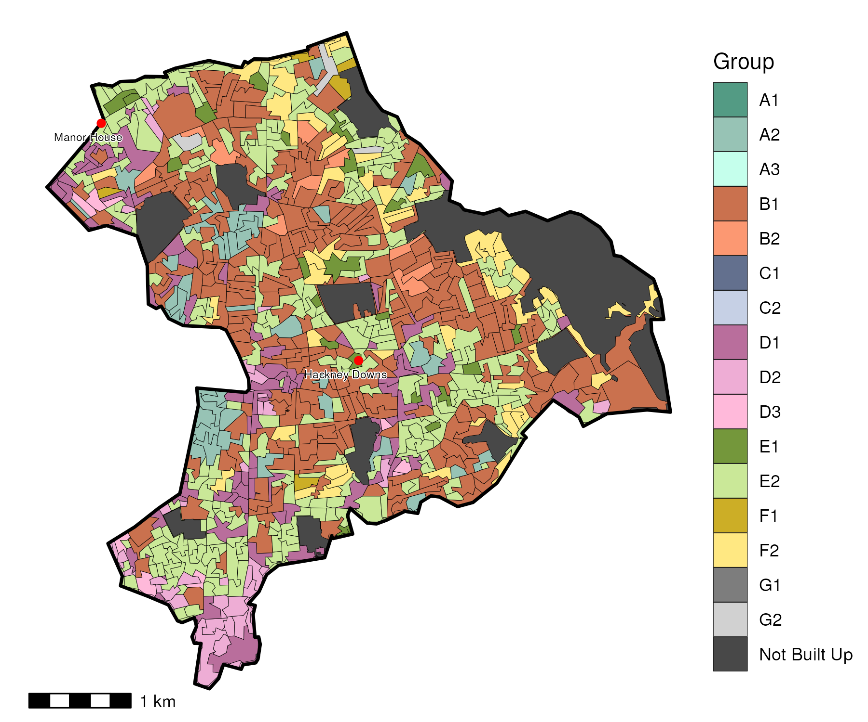

## Index Scores

The distribution of LOAC Groups within Hackney relative to the London average can be shown by calculating an index score. If a distribution was the same as the London average the score would be 100. A score of 200 represents double the London average, and 50 a half. Scores that are less than 80 and greater than 120 are typically indicators of an interesting pattern to interpret, and are the thresholds used to describe the LOAC Super Groups and Groups. Where LOAC Groups are not present within a borough, the LOAC Group codes are 'greyed out'.

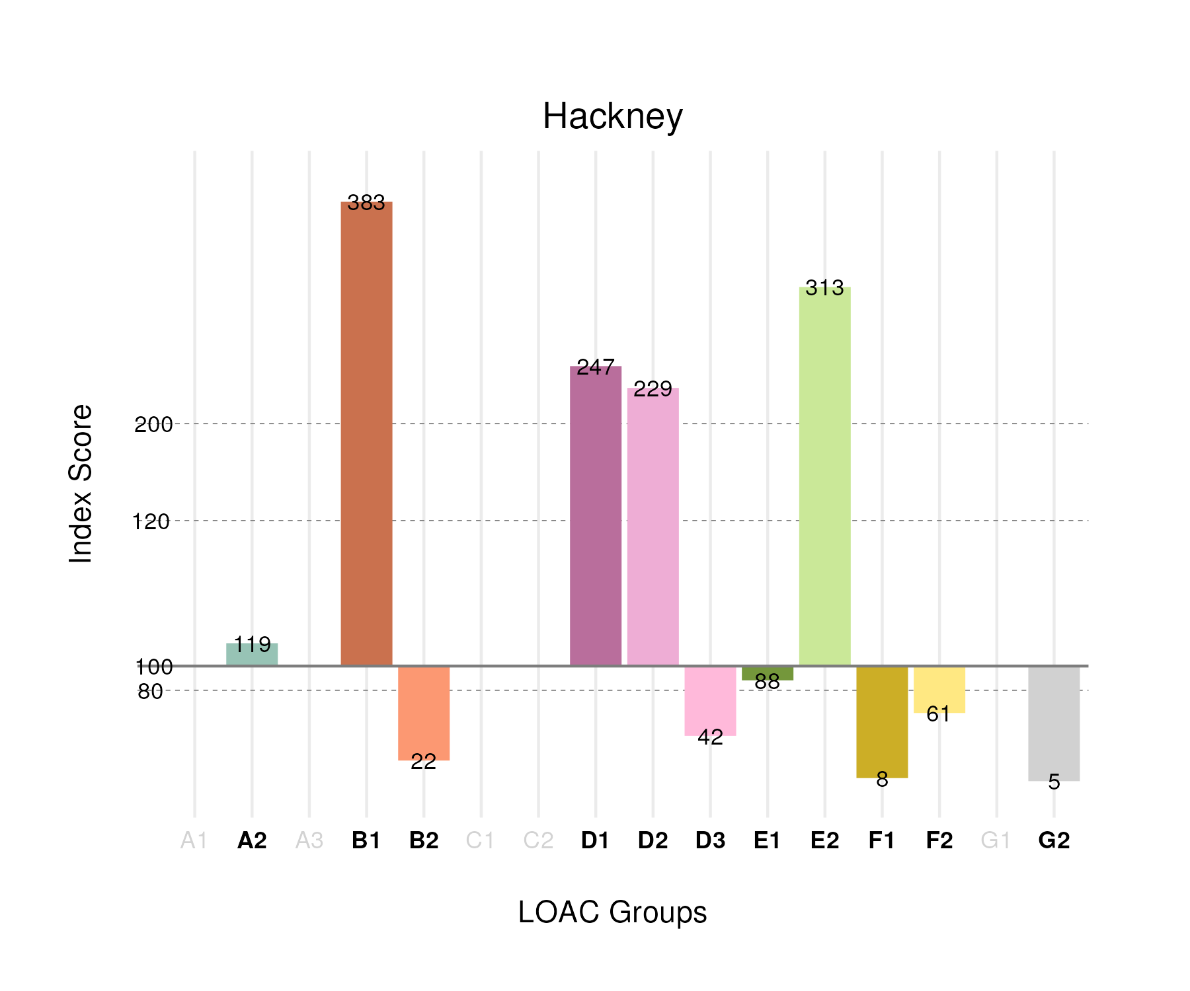

## Population Counts

The distribution of the population by LOAC Groups is shown in the following table.

| Group | Total Population (Census 2021) |
| --- | --- |
| A1 | 0 |
| A2 | 11,438 |
| A3 | 0 |
| B1 | 86,396 |
| B2 | 4,497 |
| C1 | 0 |
| C2 | 0 |
| D1 | 25,828 |
| D2 | 10,903 |
| D3 | 2,729 |
| E1 | 8,358 |
| E2 | 87,881 |
| F1 | 1,723 |
| F2 | 18,271 |
| G1 | 0 |
| G2 | 1,064 |

# Greenwich

## Spatial Distribution

The following map shows the spatial distribution of LOAC Groups across the London borough of Greenwich.

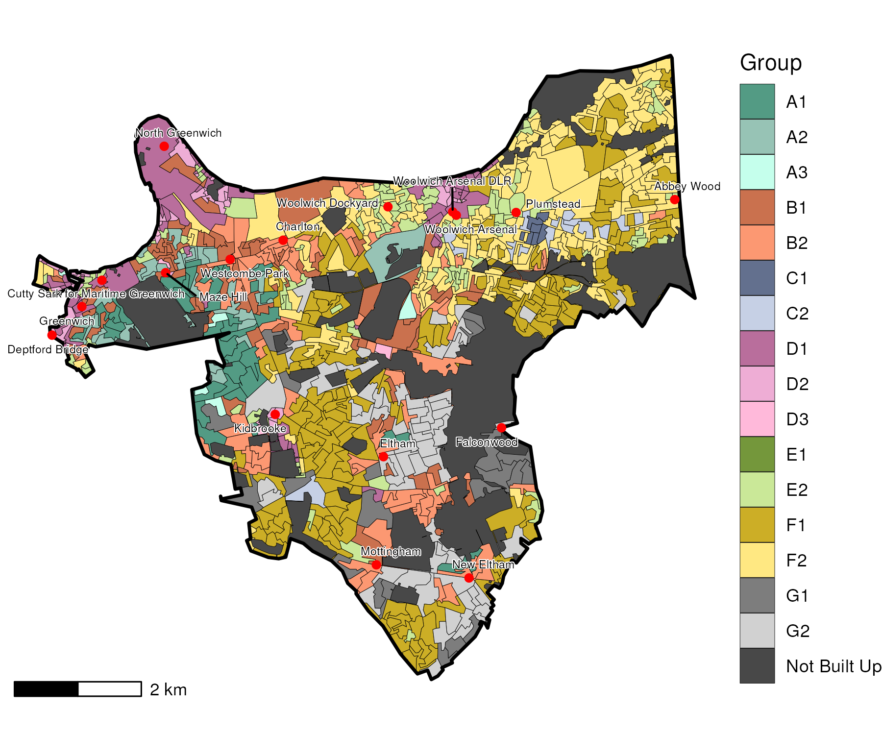

## Index Scores

The distribution of LOAC Groups within Greenwich relative to the London average can be shown by calculating an index score. If a distribution was the same as the London average the score would be 100. A score of 200 represents double the London average, and 50 a half. Scores that are less than 80 and greater than 120 are typically indicators of an interesting pattern to interpret, and are the thresholds used to describe the LOAC Super Groups and Groups. Where LOAC Groups are not present within a borough, the LOAC Group codes are 'greyed out'.

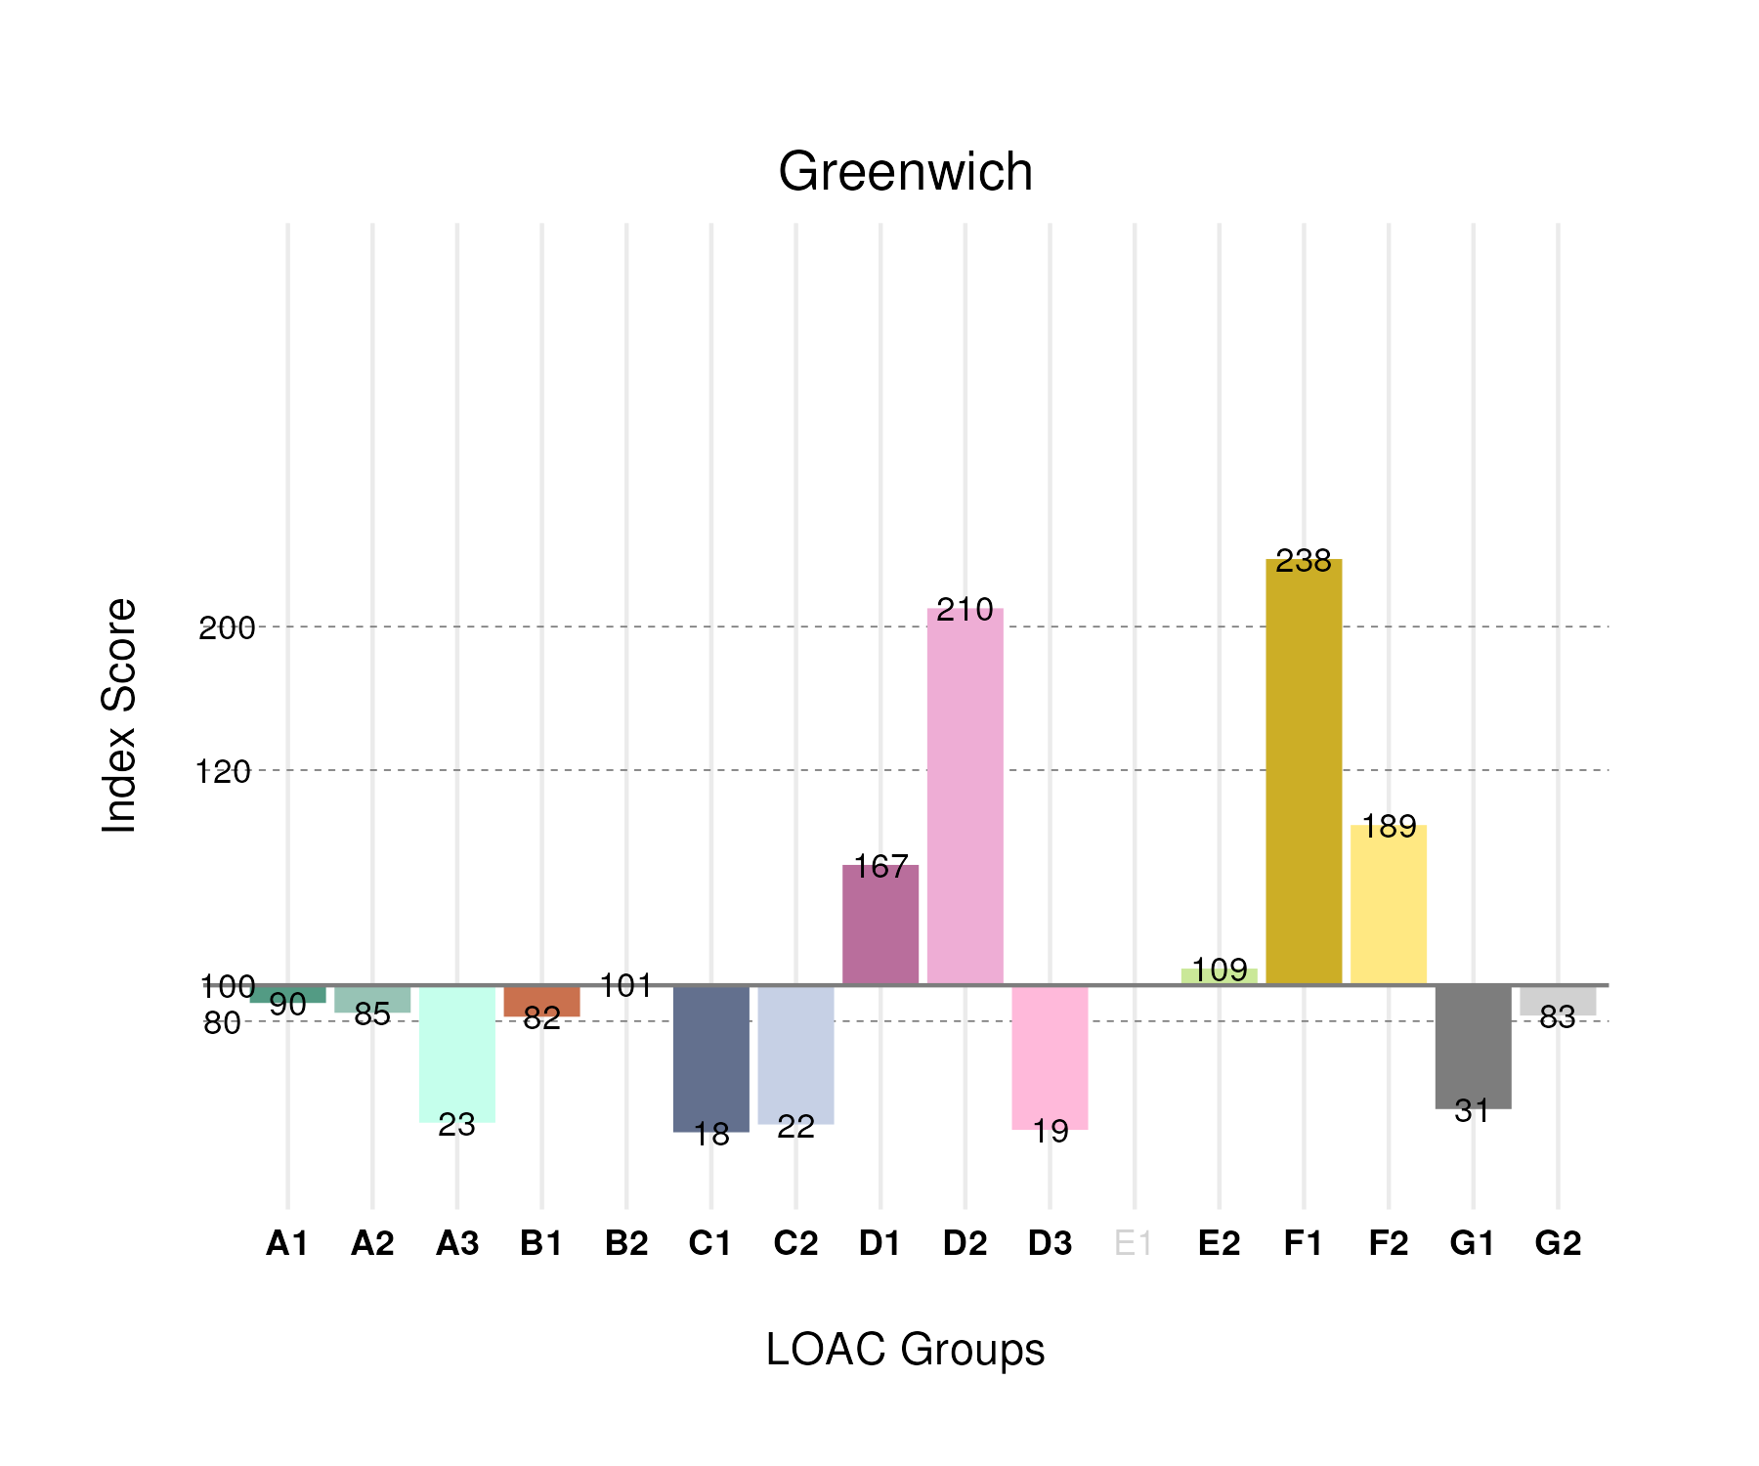

## Population Counts

The distribution of the population by LOAC Groups is shown in the following table.

| Group | Total Population (Census 2021) |
| --- | --- |
| A1 | 10,046 |
| A2 | 9,094 |
| A3 | 1,186 |
| B1 | 20,763 |
| B2 | 22,907 |
| C1 | 3,036 |
| C2 | 6,382 |
| D1 | 19,476 |
| D2 | 11,151 |
| D3 | 1,392 |
| E1 | 0 |
| E2 | 34,285 |
| F1 | 60,489 |
| F2 | 63,047 |
| G1 | 6,367 |
| G2 | 19,546 |

# Enfield

## Spatial Distribution

The following map shows the spatial distribution of LOAC Groups across the London borough of Enfield.

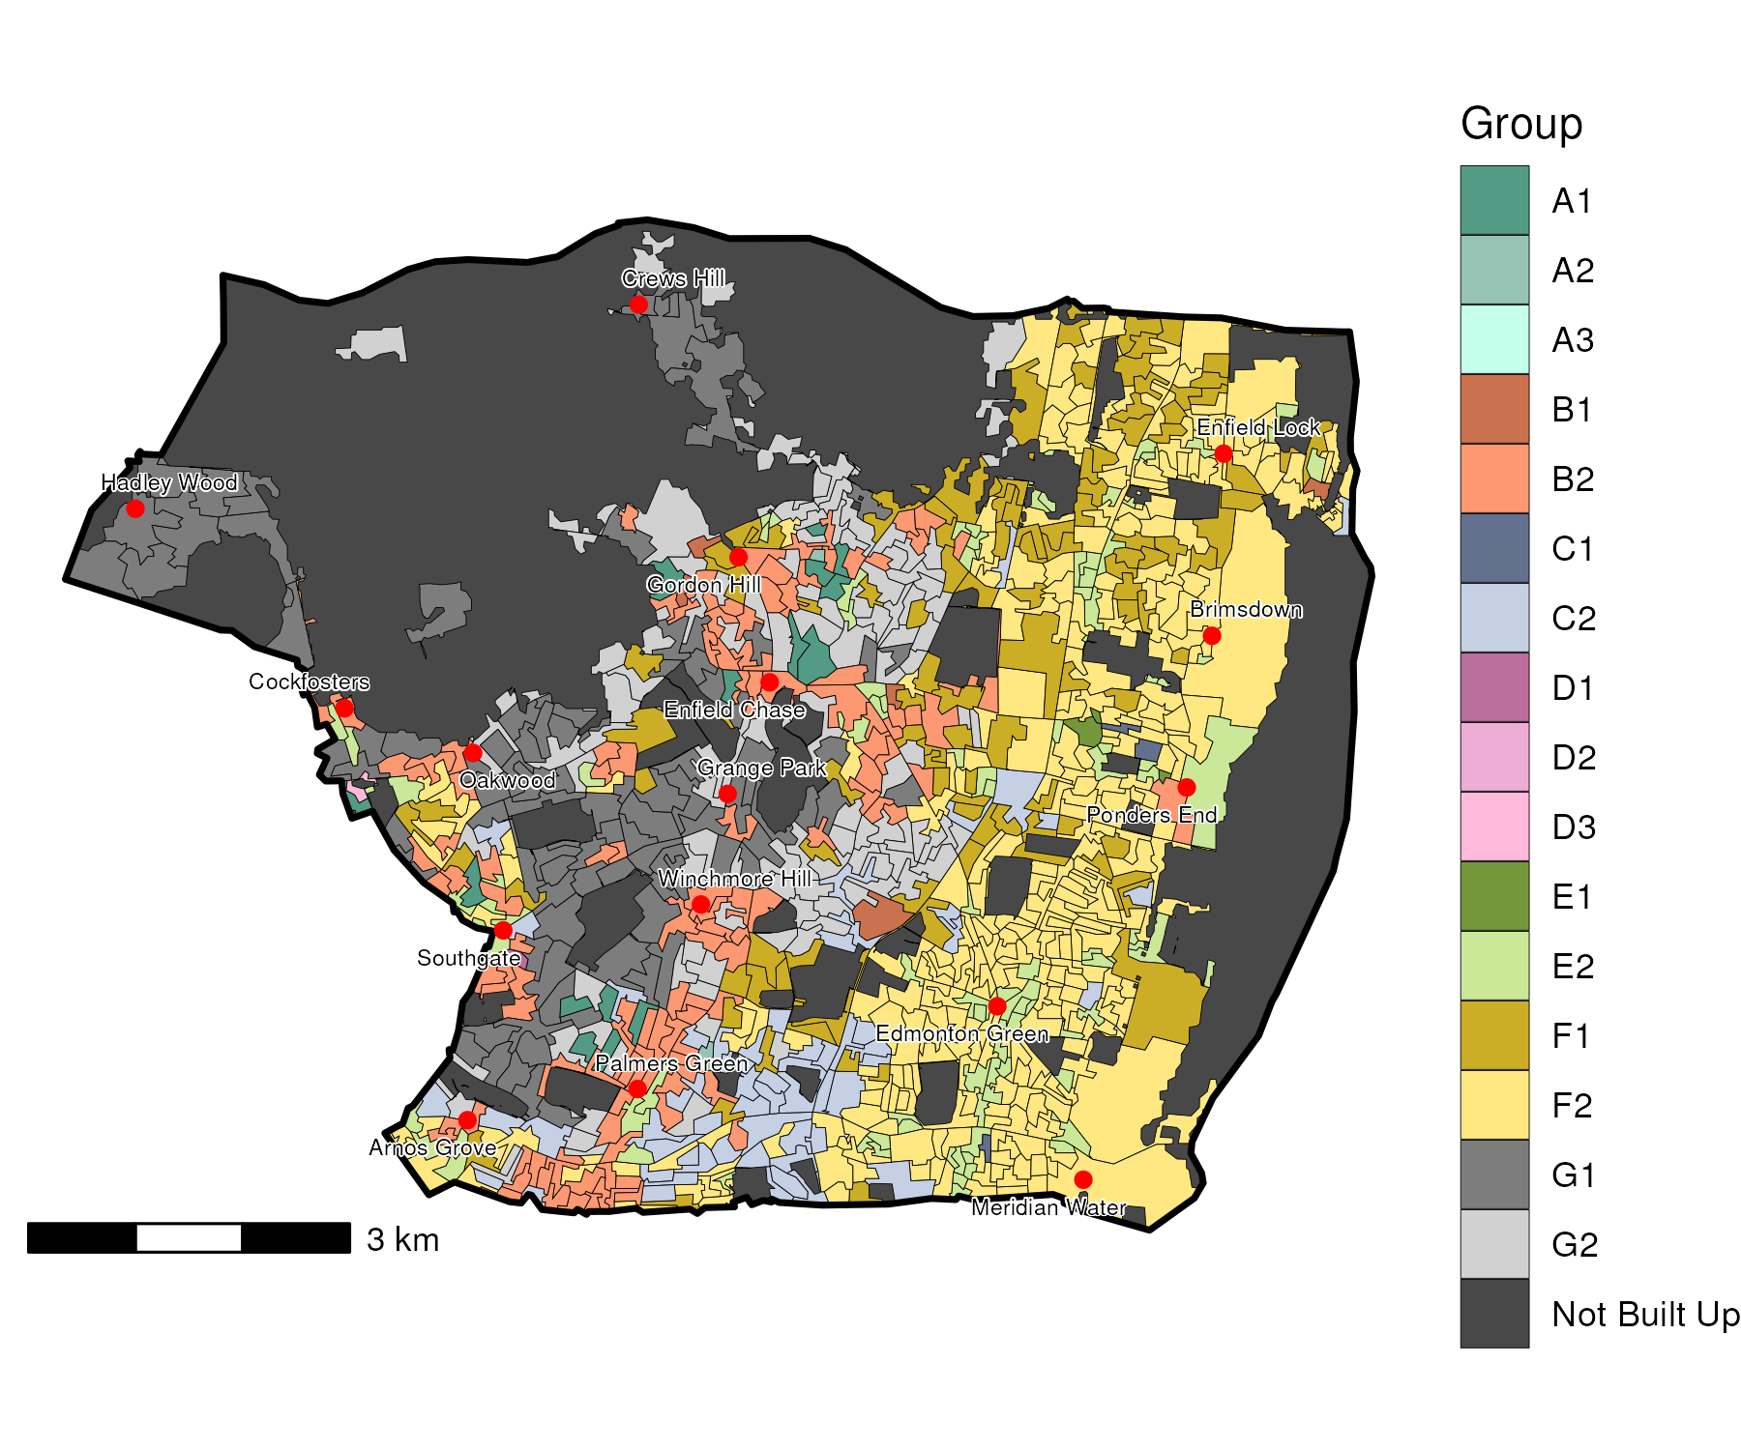

## Index Scores

The distribution of LOAC Groups within Enfield relative to the London average can be shown by calculating an index score. If a distribution was the same as the London average the score would be 100. A score of 200 represents double the London average, and 50 a half. Scores that are less than 80 and greater than 120 are typically indicators of an interesting pattern to interpret, and are the thresholds used to describe the LOAC Super Groups and Groups. Where LOAC Groups are not present within a borough, the LOAC Group codes are 'greyed out'.

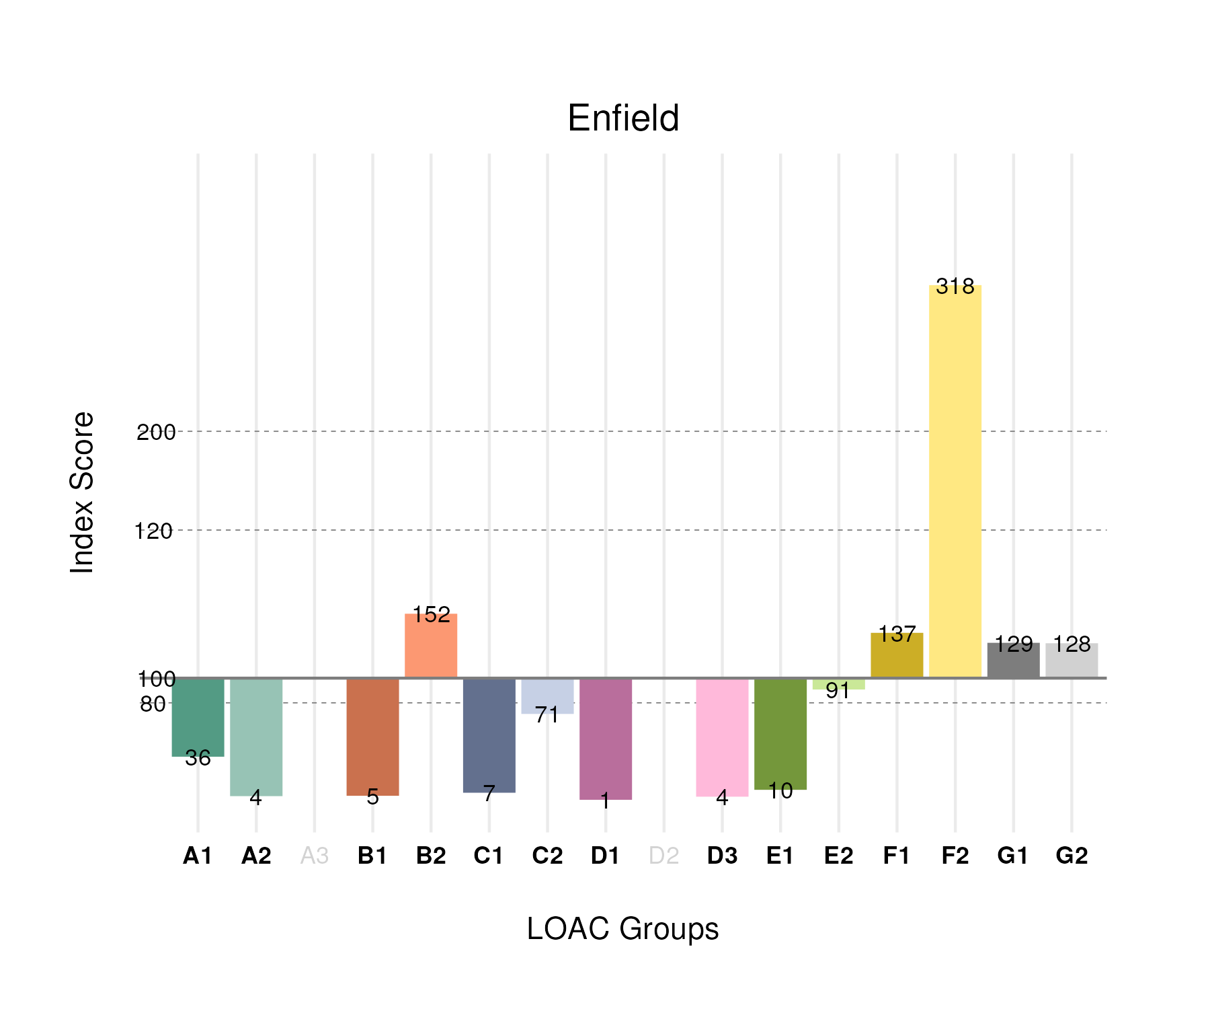

## Population Counts

The distribution of the population by LOAC Groups is shown in the following table.

| Group | Total Population (Census 2021) |
| --- | --- |
| A1 | 4,621 |
| A2 | 538 |
| A3 | 0 |
| B1 | 1,350 |
| B2 | 39,544 |
| C1 | 1,374 |
| C2 | 23,106 |
| D1 | 191 |
| D2 | 0 |
| D3 | 323 |
| E1 | 1,148 |
| E2 | 32,493 |
| F1 | 39,687 |
| F2 | 120,972 |
| G1 | 30,168 |
| G2 | 34,415 |

# Ealing

## Spatial Distribution

The following map shows the spatial distribution of LOAC Groups across the London borough of Ealing.

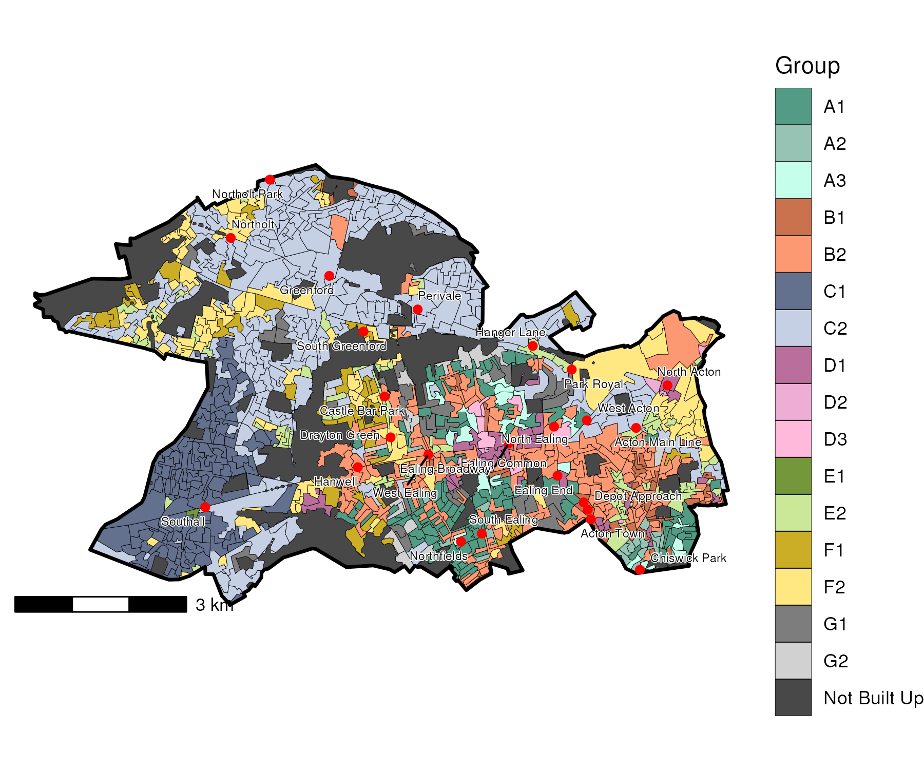

## Index Scores

The distribution of LOAC Groups within Ealing relative to the London average can be shown by calculating an index score. If a distribution was the same as the London average the score would be 100. A score of 200 represents double the London average, and 50 a half. Scores that are less than 80 and greater than 120 are typically indicators of an interesting pattern to interpret, and are the thresholds used to describe the LOAC Super Groups and Groups. Where LOAC Groups are not present within a borough, the LOAC Group codes are 'greyed out'.

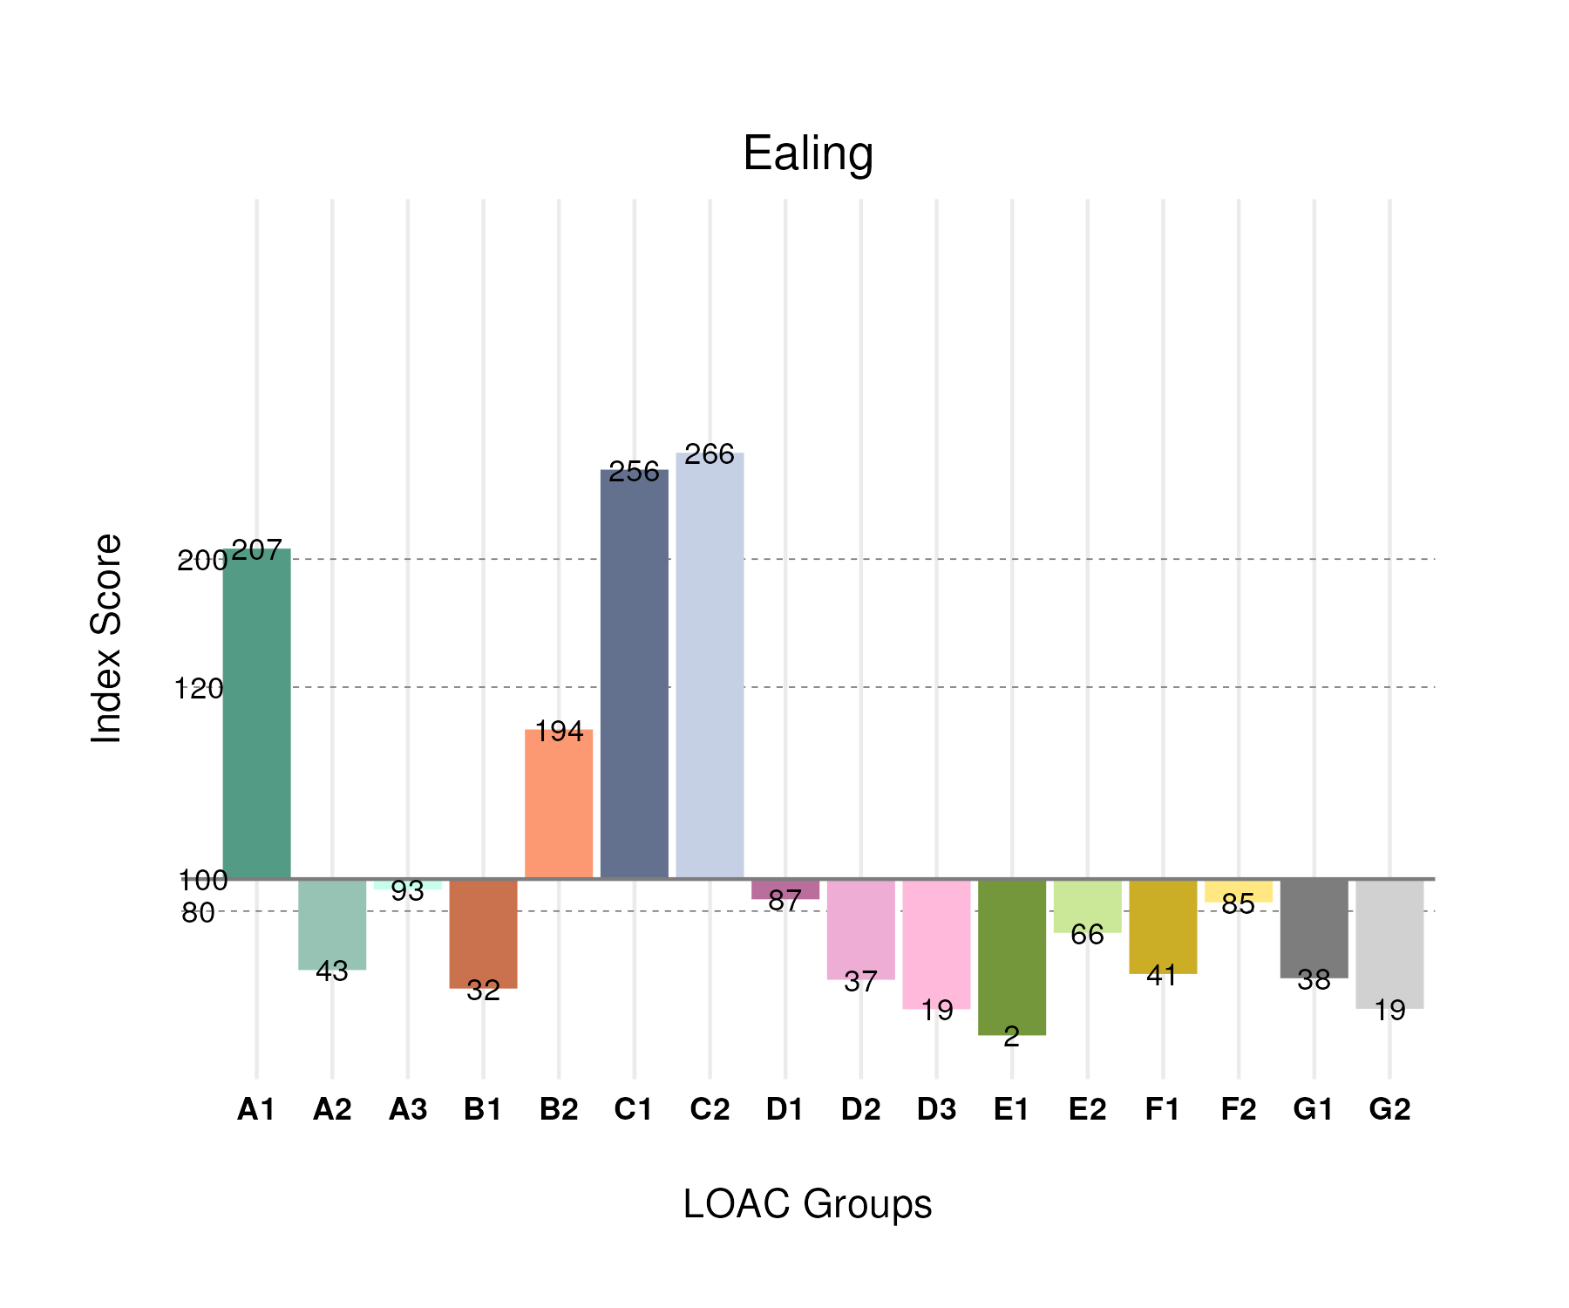

## Population Counts

The distribution of the population by LOAC Groups is shown in the following table.

| Group | Total Population (Census 2021) |
| --- | --- |
| A1 | 29,218 |
| A2 | 5,883 |
| A3 | 6,018 |
| B1 | 10,091 |
| B2 | 55,942 |
| C1 | 54,718 |
| C2 | 96,453 |
| D1 | 12,921 |
| D2 | 2,495 |
| D3 | 1,703 |
| E1 | 307 |
| E2 | 26,440 |
| F1 | 13,150 |
| F2 | 36,121 |
| G1 | 9,924 |
| G2 | 5,653 |

# Croydon

## Spatial Distribution

The following map shows the spatial distribution of LOAC Groups across the London borough of Croydon.

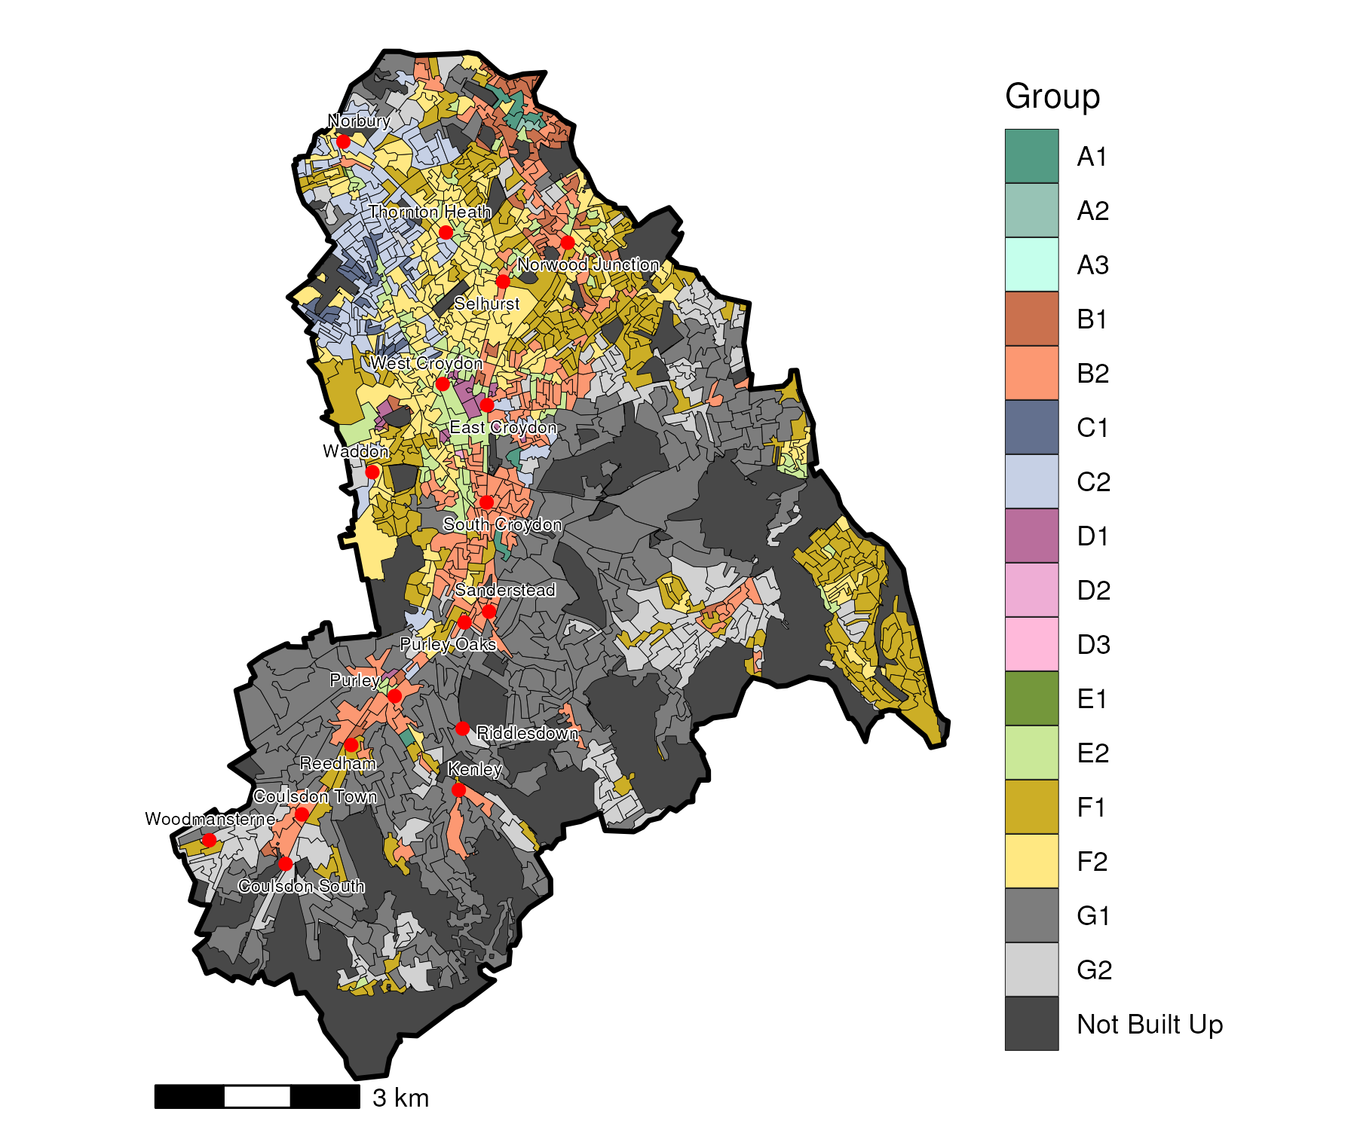

## Index Scores

The distribution of LOAC Groups within Croydon relative to the London average can be shown by calculating an index score. If a distribution was the same as the London average the score would be 100. A score of 200 represents double the London average, and 50 a half. Scores that are less than 80 and greater than 120 are typically indicators of an interesting pattern to interpret, and are the thresholds used to describe the LOAC Super Groups and Groups. Where LOAC Groups are not present within a borough, the LOAC Group codes are 'greyed out'.

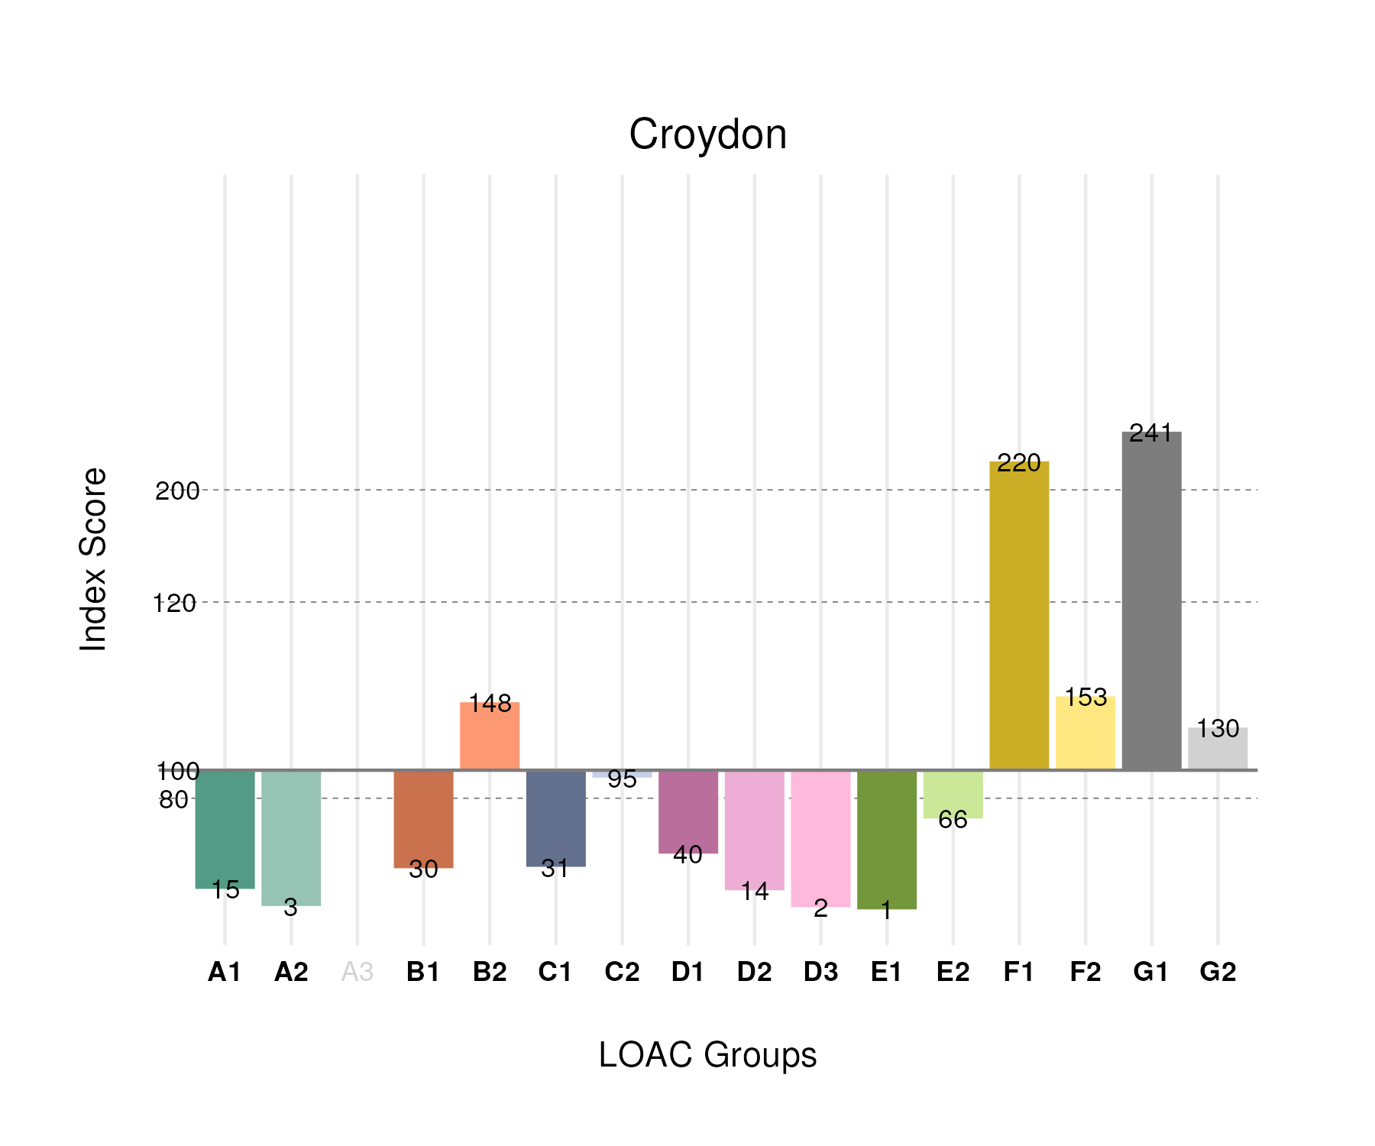

## Population Counts

The distribution of the population by LOAC Groups is shown in the following table.

| Group | Total Population (Census 2021) |
| --- | --- |
| A1 | 2,310 |
| A2 | 456 |
| A3 | 0 |
| B1 | 10,232 |
| B2 | 45,688 |
| C1 | 7,077 |
| C2 | 36,512 |
| D1 | 6,376 |
| D2 | 1,028 |
| D3 | 227 |
| E1 | 103 |
| E2 | 27,785 |
| F1 | 75,725 |
| F2 | 68,684 |
| G1 | 67,063 |
| G2 | 41,420 |

# Camden

## Spatial Distribution

The following map shows the spatial distribution of LOAC Groups across the London borough of Camden.

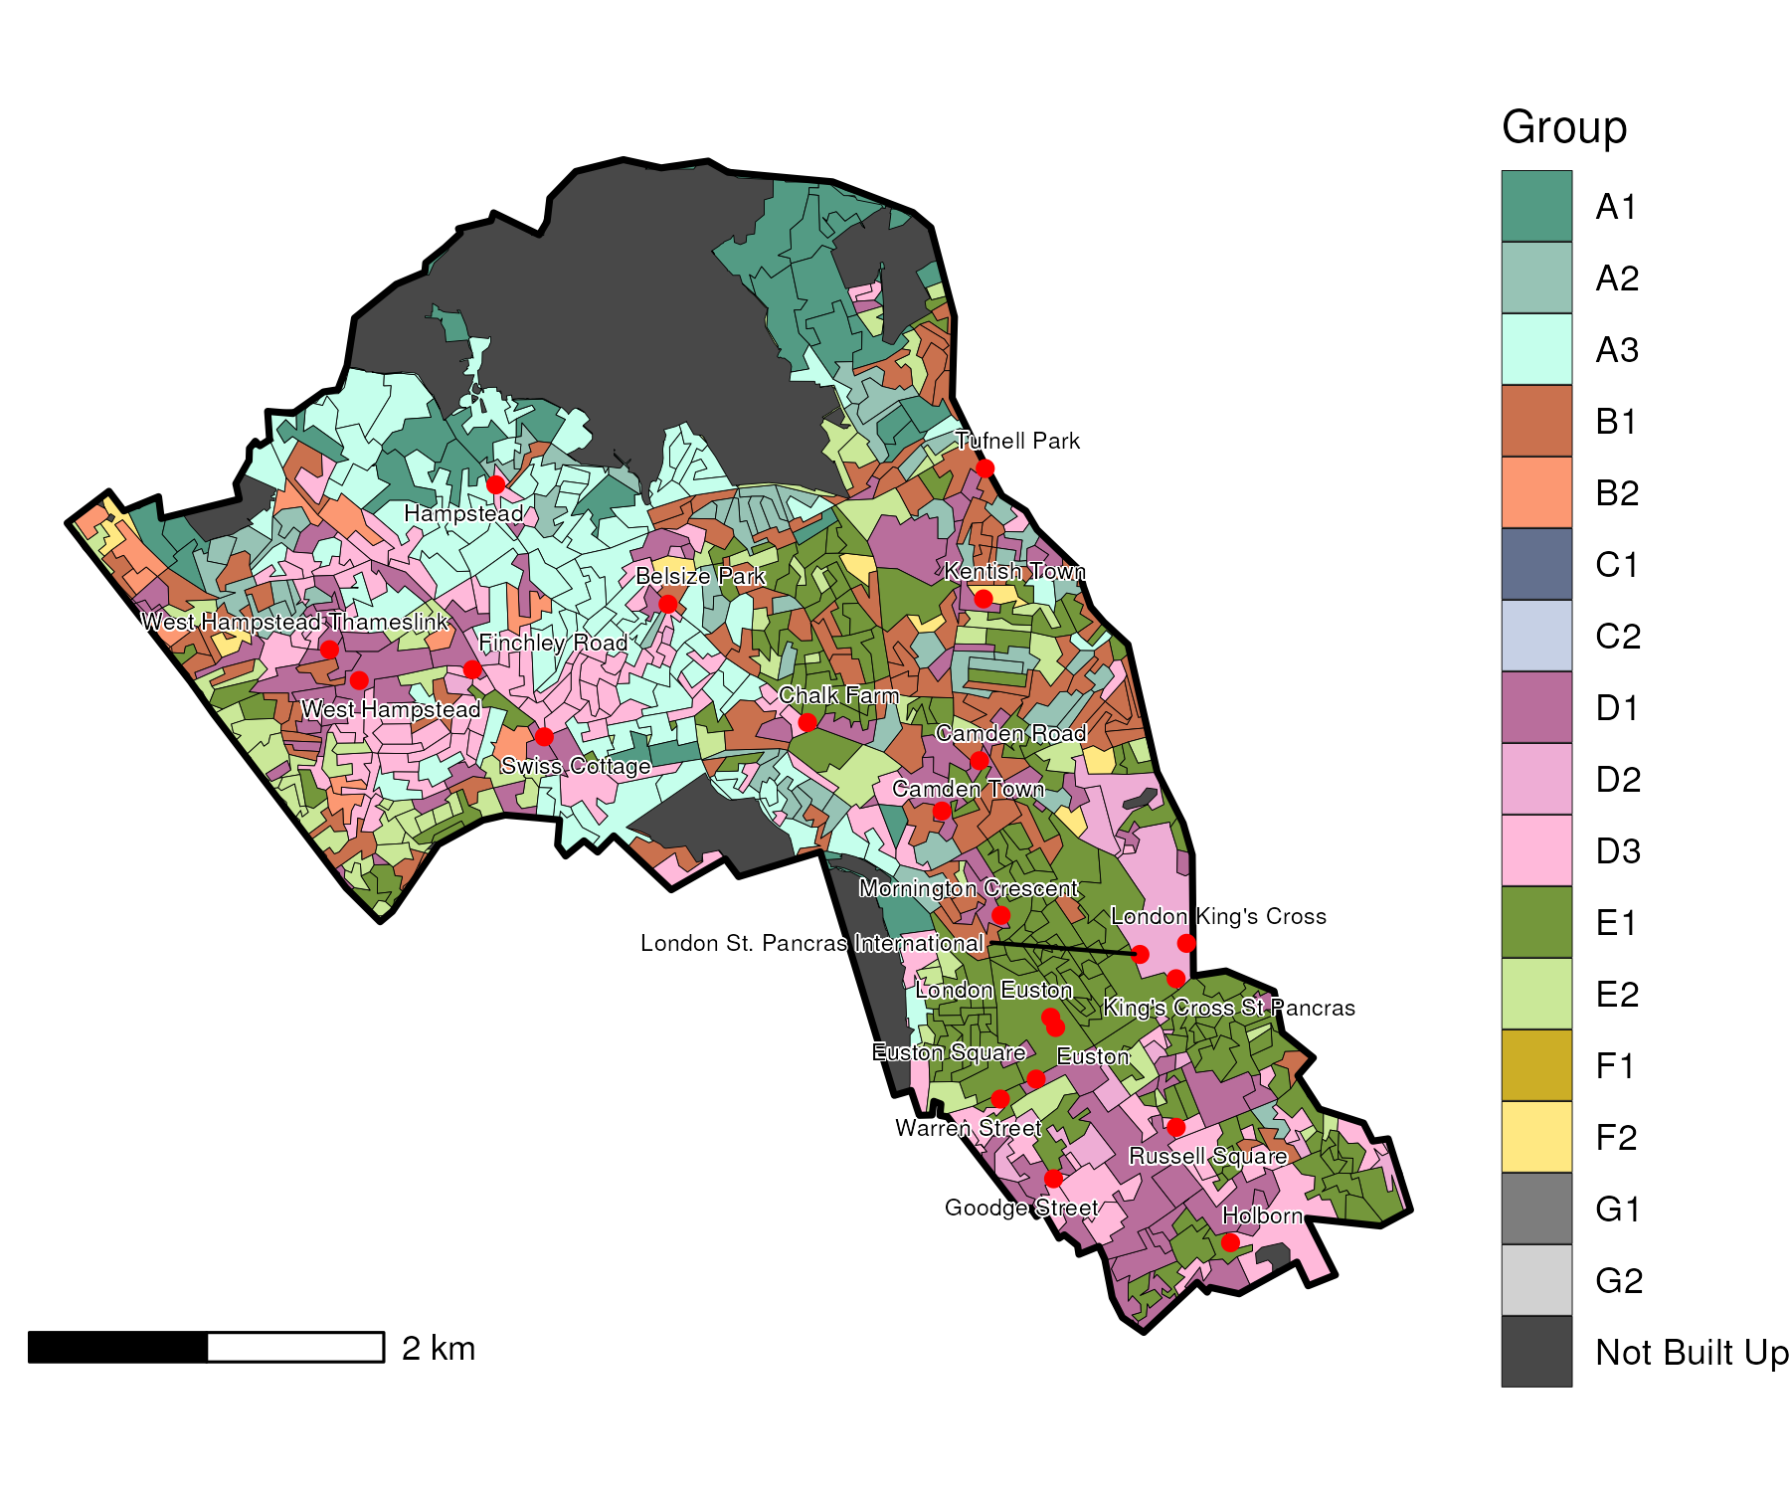

## Index Scores

The distribution of LOAC Groups within Camden relative to the London average can be shown by calculating an index score. If a distribution was the same as the London average the score would be 100. A score of 200 represents double the London average, and 50 a half. Scores that are less than 80 and greater than 120 are typically indicators of an interesting pattern to interpret, and are the thresholds used to describe the LOAC Super Groups and Groups. Where LOAC Groups are not present within a borough, the LOAC Group codes are 'greyed out'.

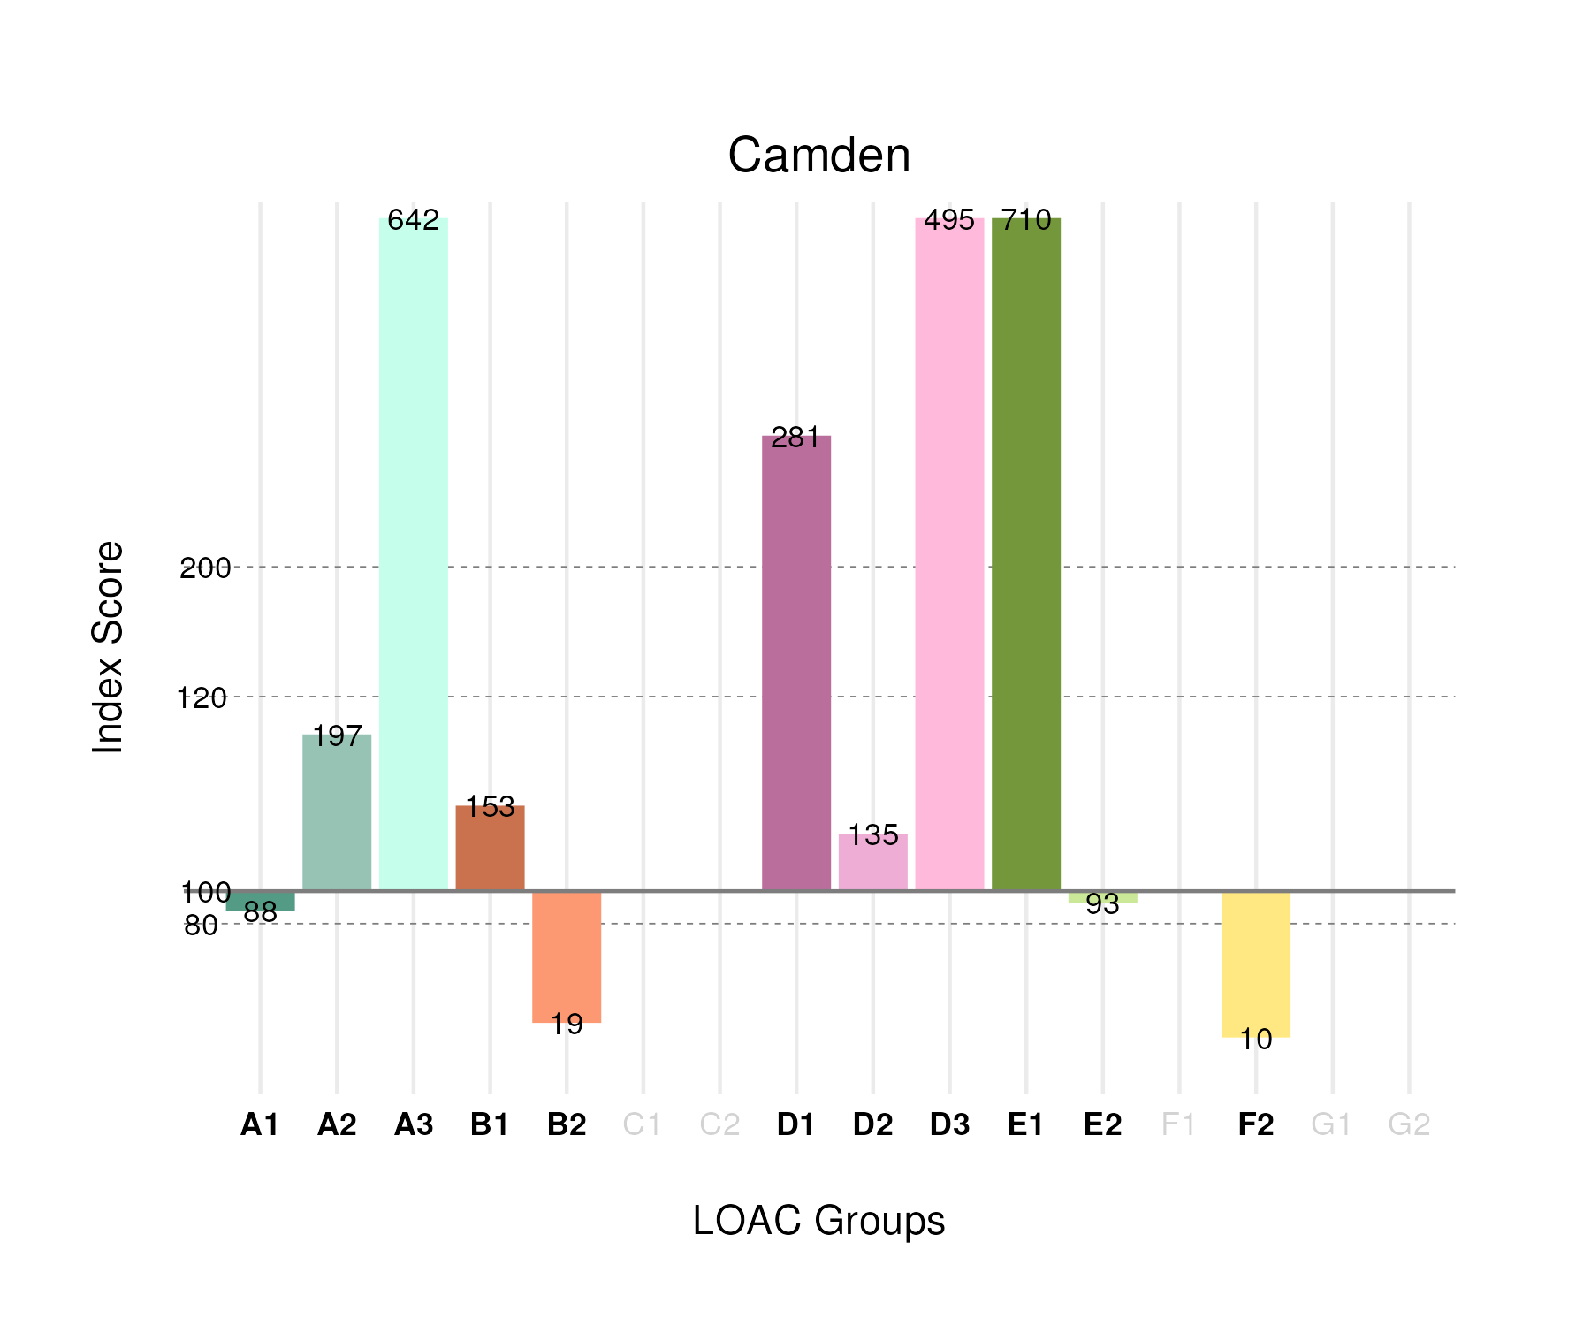

## Population Counts

The distribution of the population by LOAC Groups is shown in the following table.

| Group | Total Population (Census 2021) |
| --- | --- |
| A1 | 7,113 |
| A2 | 15,351 |
| A3 | 23,673 |
| B1 | 27,938 |
| B2 | 3,112 |
| C1 | 0 |
| C2 | 0 |
| D1 | 23,787 |
| D2 | 5,216 |
| D3 | 25,857 |
| E1 | 54,541 |
| E2 | 21,176 |
| F1 | 0 |
| F2 | 2,363 |
| G1 | 0 |
| G2 | 0 |

# Bromley

## Spatial Distribution

The following map shows the spatial distribution of LOAC Groups across the London borough of Bromley.

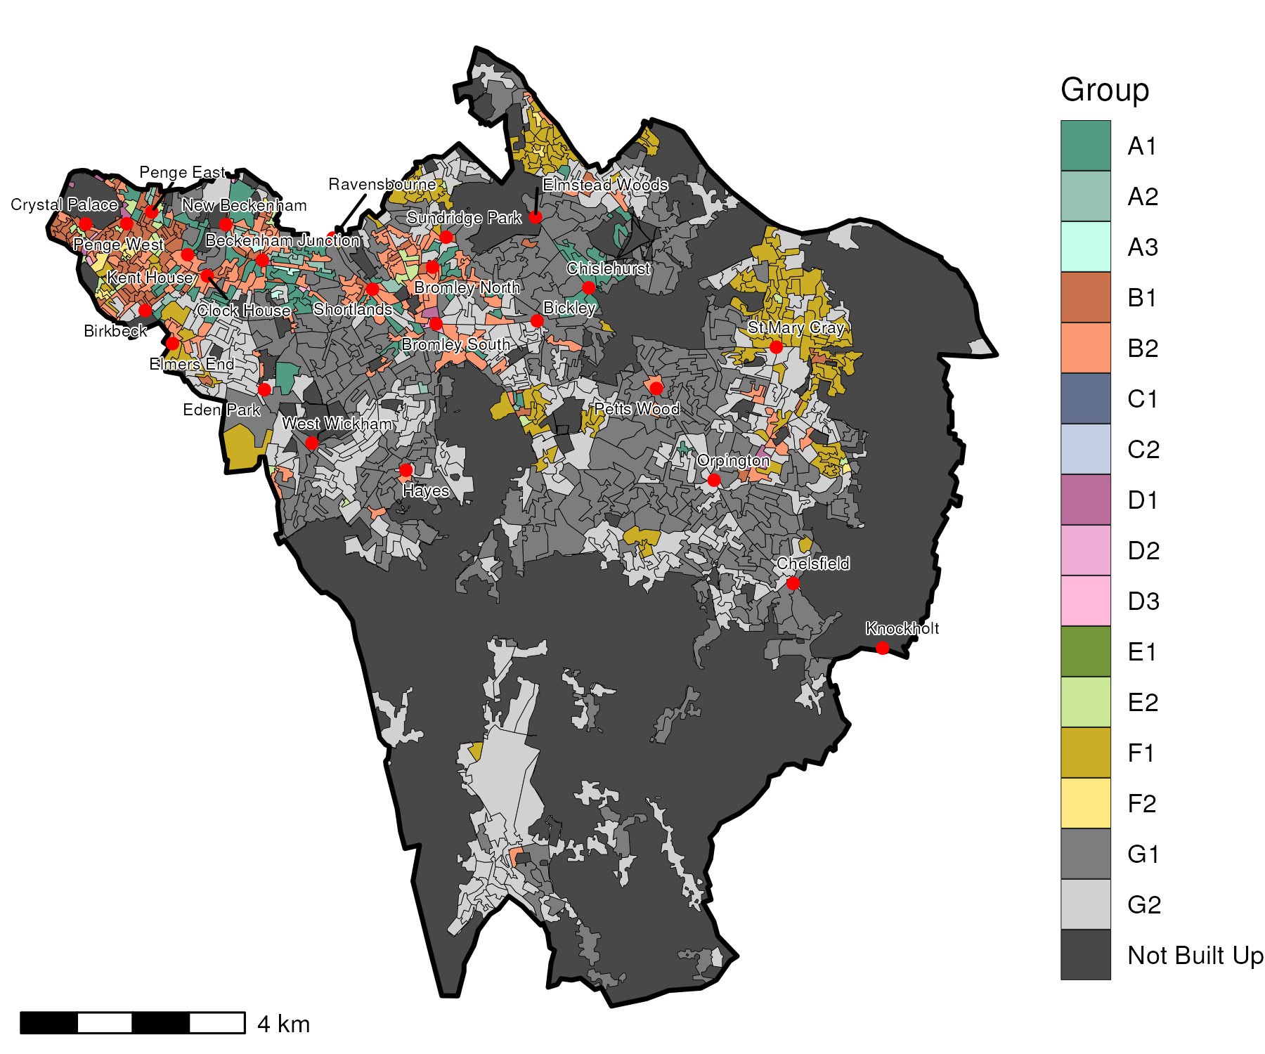

## Index Scores

The distribution of LOAC Groups within Bromley relative to the London average can be shown by calculating an index score. If a distribution was the same as the London average the score would be 100. A score of 200 represents double the London average, and 50 a half. Scores that are less than 80 and greater than 120 are typically indicators of an interesting pattern to interpret, and are the thresholds used to describe the LOAC Super Groups and Groups. Where LOAC Groups are not present within a borough, the LOAC Group codes are 'greyed out'.

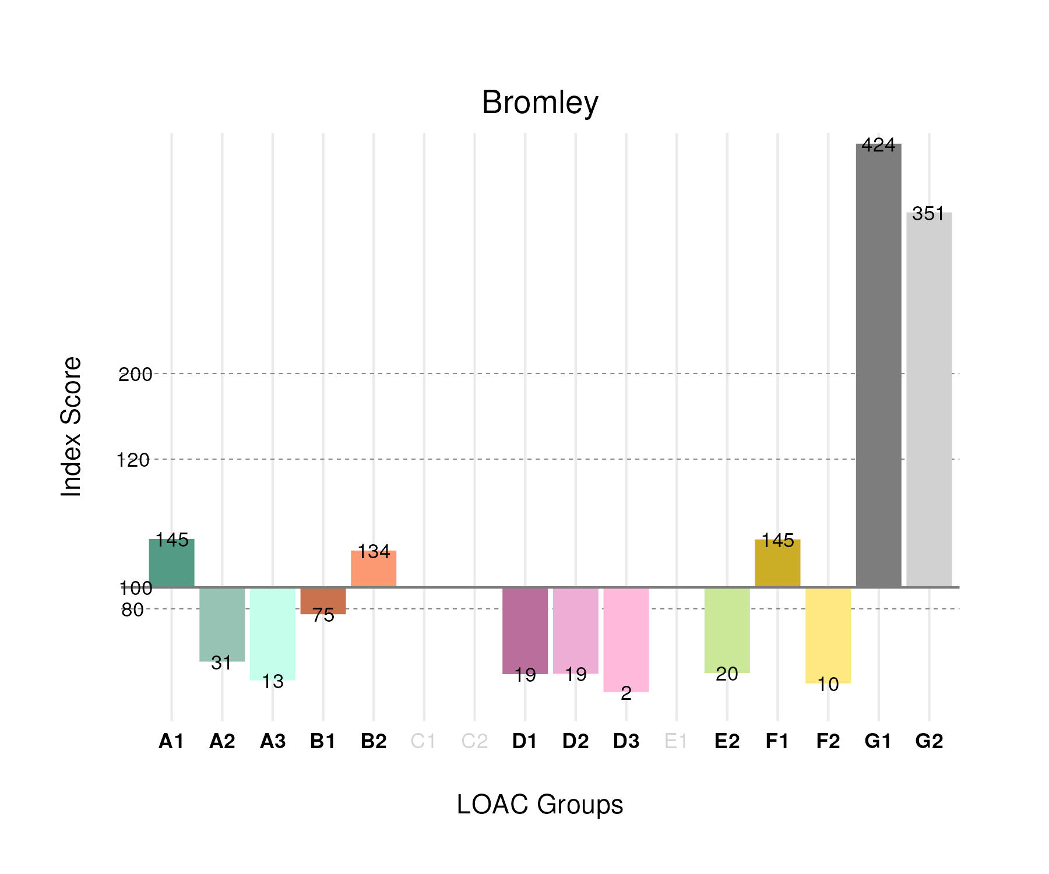

## Population Counts

The distribution of the population by LOAC Groups is shown in the following table.

| Group | Total Population (Census 2021) |
| --- | --- |
| A1 | 18,488 |
| A2 | 3,748 |
| A3 | 756 |
| B1 | 21,524 |
| B2 | 34,951 |
| C1 | 0 |
| C2 | 0 |
| D1 | 2,509 |
| D2 | 1,165 |
| D3 | 175 |
| E1 | 0 |
| E2 | 7,147 |
| F1 | 42,078 |
| F2 | 3,873 |
| G1 | 99,452 |
| G2 | 94,127 |

# Brent

## Spatial Distribution

The following map shows the spatial distribution of LOAC Groups across the London borough of Brent.

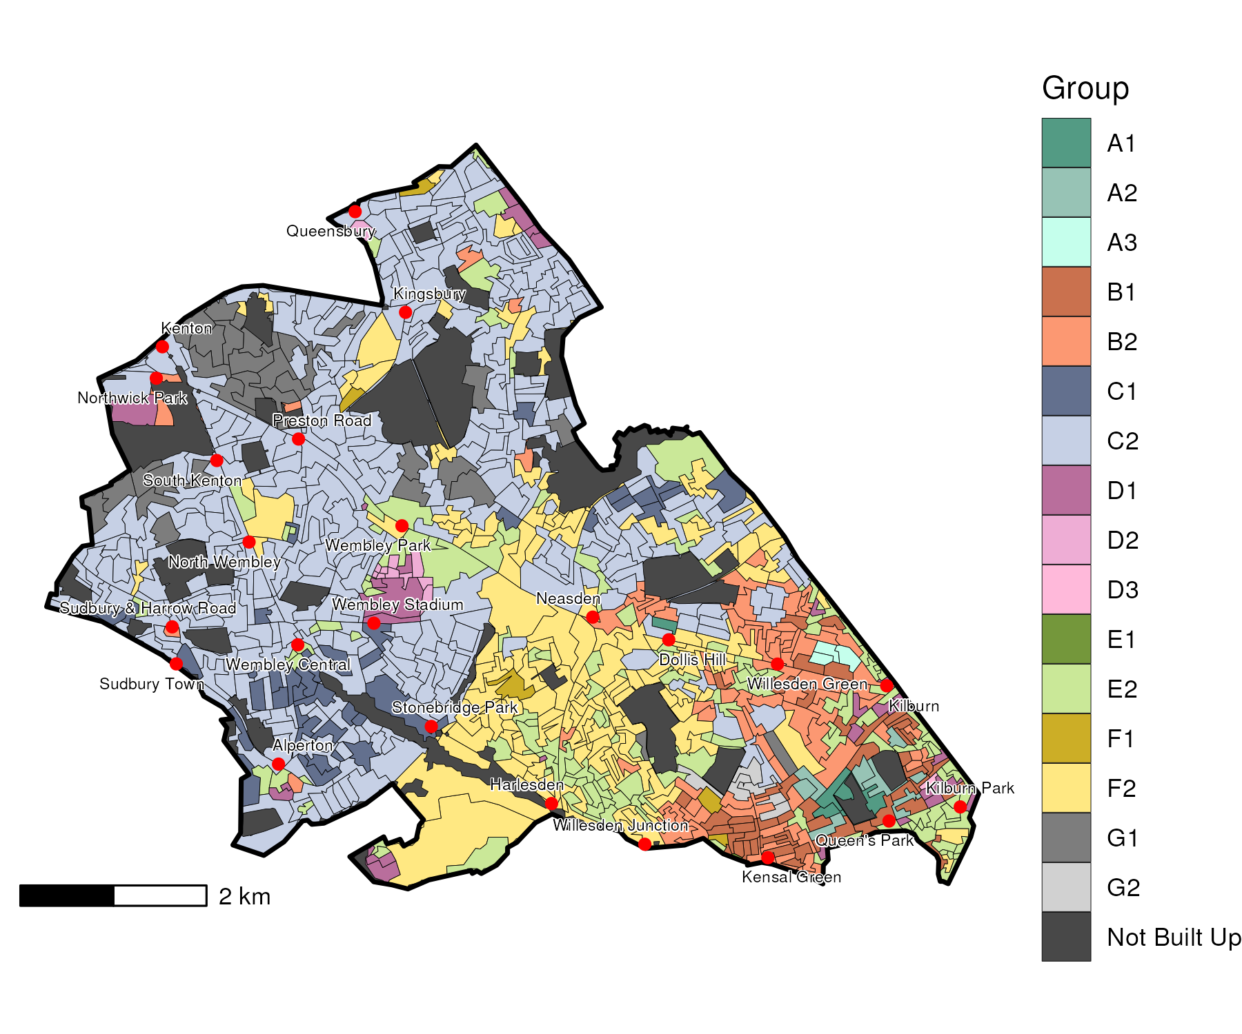

## Index Scores

The distribution of LOAC Groups within Brent relative to the London average can be shown by calculating an index score. If a distribution was the same as the London average the score would be 100. A score of 200 represents double the London average, and 50 a half. Scores that are less than 80 and greater than 120 are typically indicators of an interesting pattern to interpret, and are the thresholds used to describe the LOAC Super Groups and Groups. Where LOAC Groups are not present within a borough, the LOAC Group codes are 'greyed out'.

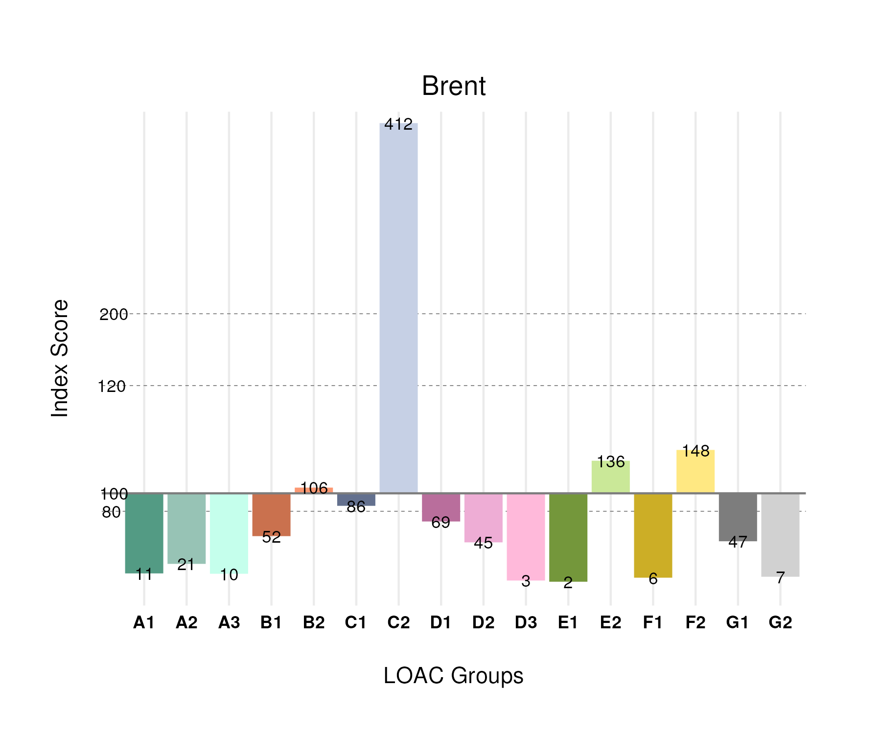

## Population Counts

The distribution of the population by LOAC Groups is shown in the following table.

| Group | Total Population (Census 2021) |
| --- | --- |
| A1 | 1,414 |
| A2 | 2,703 |
| A3 | 620 |
| B1 | 15,476 |
| B2 | 28,459 |
| C1 | 17,036 |
| C2 | 138,179 |
| D1 | 9,397 |
| D2 | 2,828 |
| D3 | 241 |
| E1 | 190 |
| E2 | 50,224 |
| F1 | 1,800 |
| F2 | 58,025 |
| G1 | 11,254 |
| G2 | 1,954 |

# Bexley

## Spatial Distribution

The following map shows the spatial distribution of LOAC Groups across the London borough of Bexley.

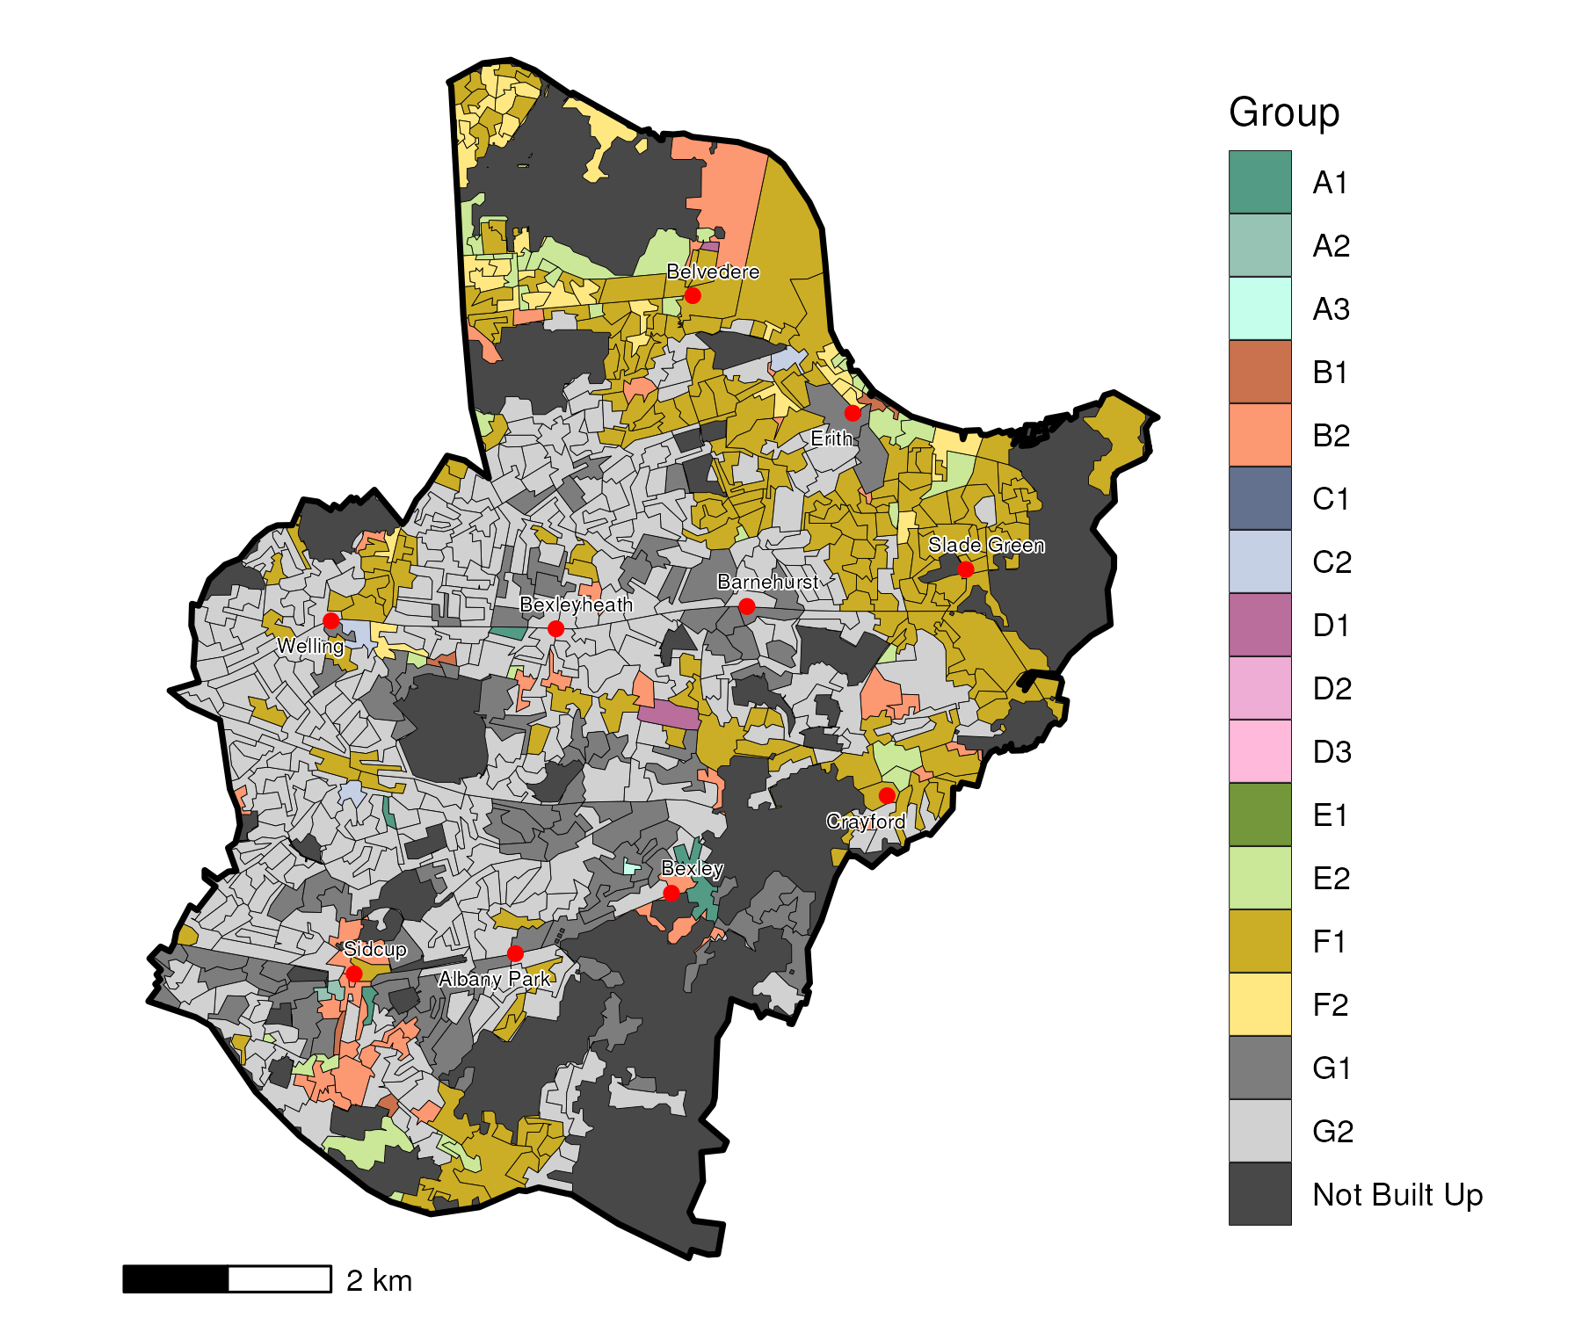

## Index Scores

The distribution of LOAC Groups within Bexley relative to the London average can be shown by calculating an index score. If a distribution was the same as the London average the score would be 100. A score of 200 represents double the London average, and 50 a half. Scores that are less than 80 and greater than 120 are typically indicators of an interesting pattern to interpret, and are the thresholds used to describe the LOAC Super Groups and Groups. Where LOAC Groups are not present within a borough, the LOAC Group codes are 'greyed out'.

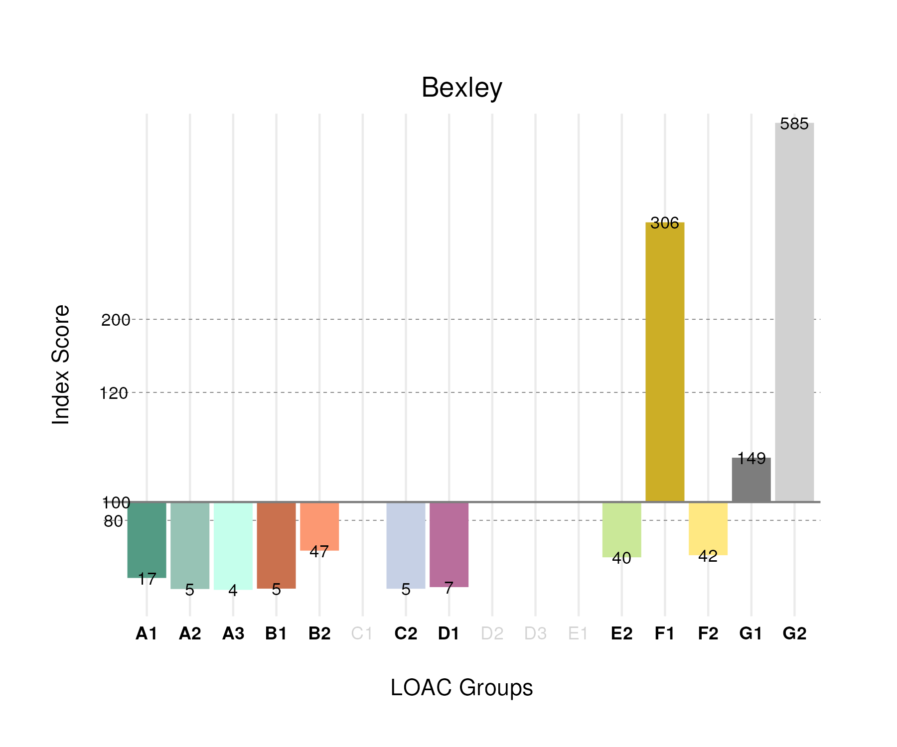

## Population Counts

The distribution of the population by LOAC Groups is shown in the following table.

| Group | Total Population (Census 2021) |
| --- | --- |
| A1 | 1,608 |
| A2 | 443 |
| A3 | 169 |
| B1 | 1,120 |
| B2 | 9,086 |
| C1 | 0 |
| C2 | 1,243 |
| D1 | 686 |
| D2 | 0 |
| D3 | 0 |
| E1 | 0 |
| E2 | 10,559 |
| F1 | 66,378 |
| F2 | 11,863 |
| G1 | 26,023 |
| G2 | 117,226 |

# Barnet

## Spatial Distribution

The following map shows the spatial distribution of LOAC Groups across the London borough of Barnet.

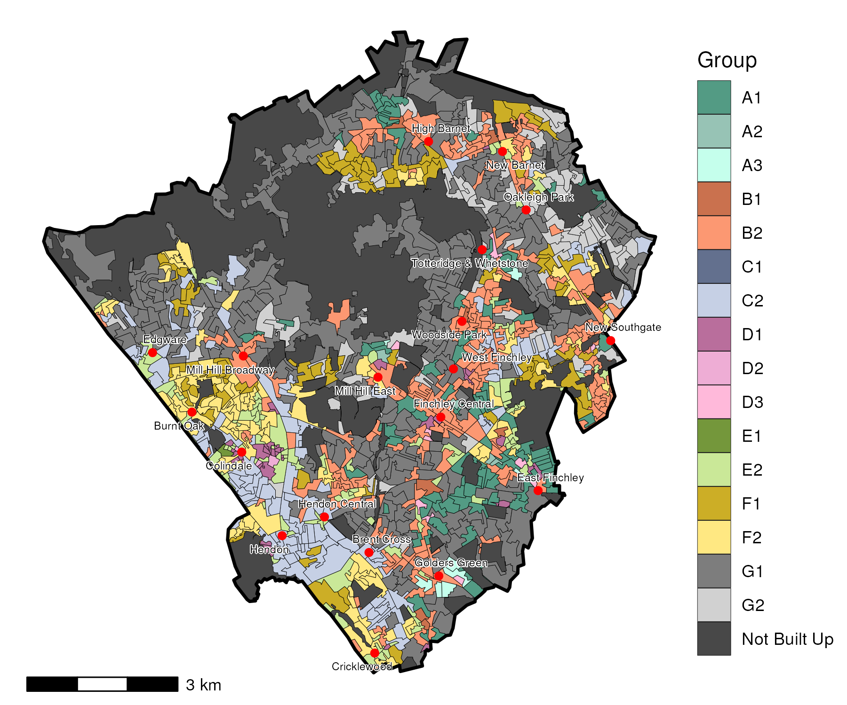

## Index Scores

The distribution of LOAC Groups within Barnet relative to the London average can be shown by calculating an index score. If a distribution was the same as the London average the score would be 100. A score of 200 represents double the London average, and 50 a half. Scores that are less than 80 and greater than 120 are typically indicators of an interesting pattern to interpret, and are the thresholds used to describe the LOAC Super Groups and Groups. Where LOAC Groups are not present within a borough, the LOAC Group codes are 'greyed out'.

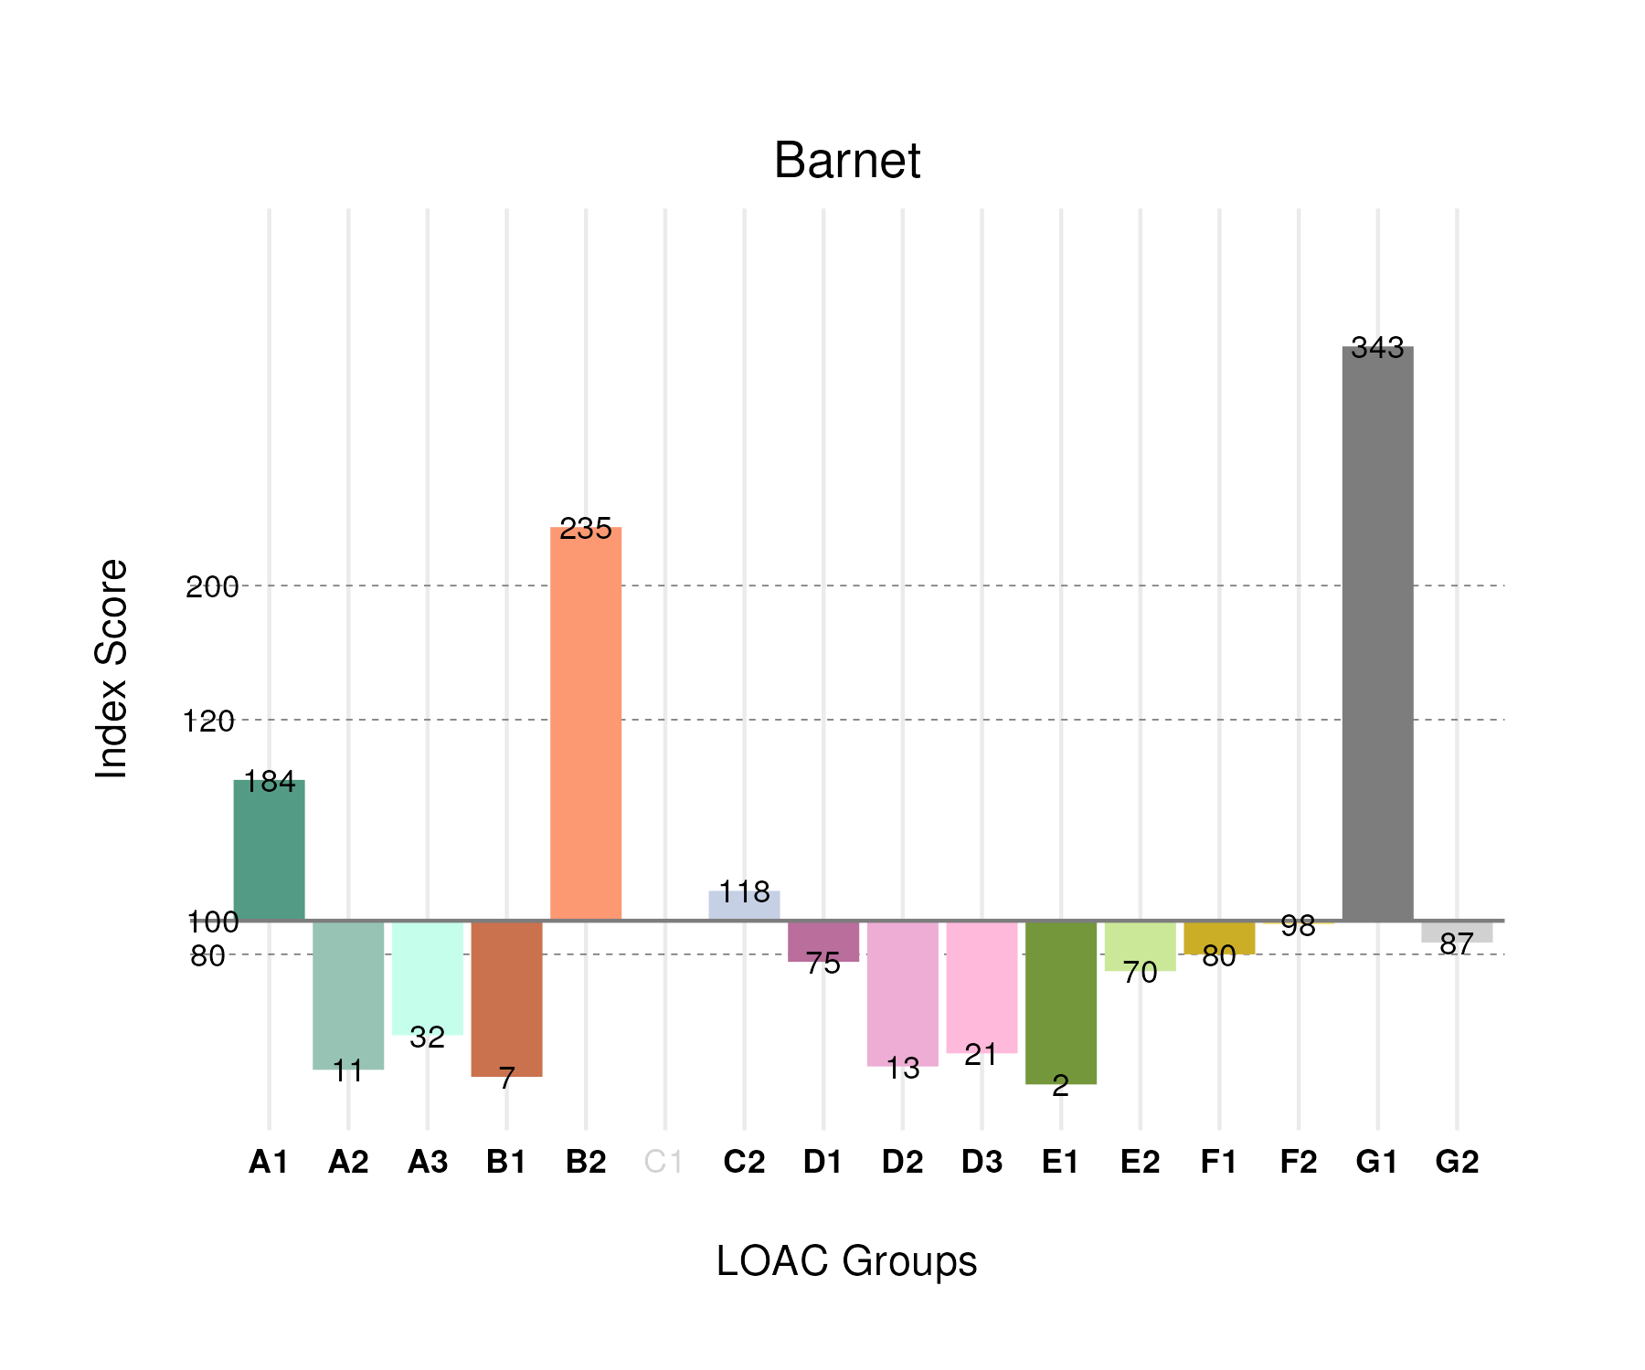

## Population Counts

The distribution of the population by LOAC Groups is shown in the following table.

| Group | Total Population (Census 2021) |
| --- | --- |
| A1 | 27,619 |
| A2 | 1,599 |
| A3 | 2,160 |
| B1 | 2,320 |
| B2 | 72,020 |
| C1 | 0 |
| C2 | 45,240 |
| D1 | 11,843 |
| D2 | 932 |
| D3 | 2,020 |
| E1 | 332 |
| E2 | 29,544 |
| F1 | 27,384 |
| F2 | 43,880 |
| G1 | 94,857 |
| G2 | 27,550 |

# Barking and Dagenham

## Spatial Distribution

The following map shows the spatial distribution of LOAC Groups across the London borough of Barking and Dagenham.

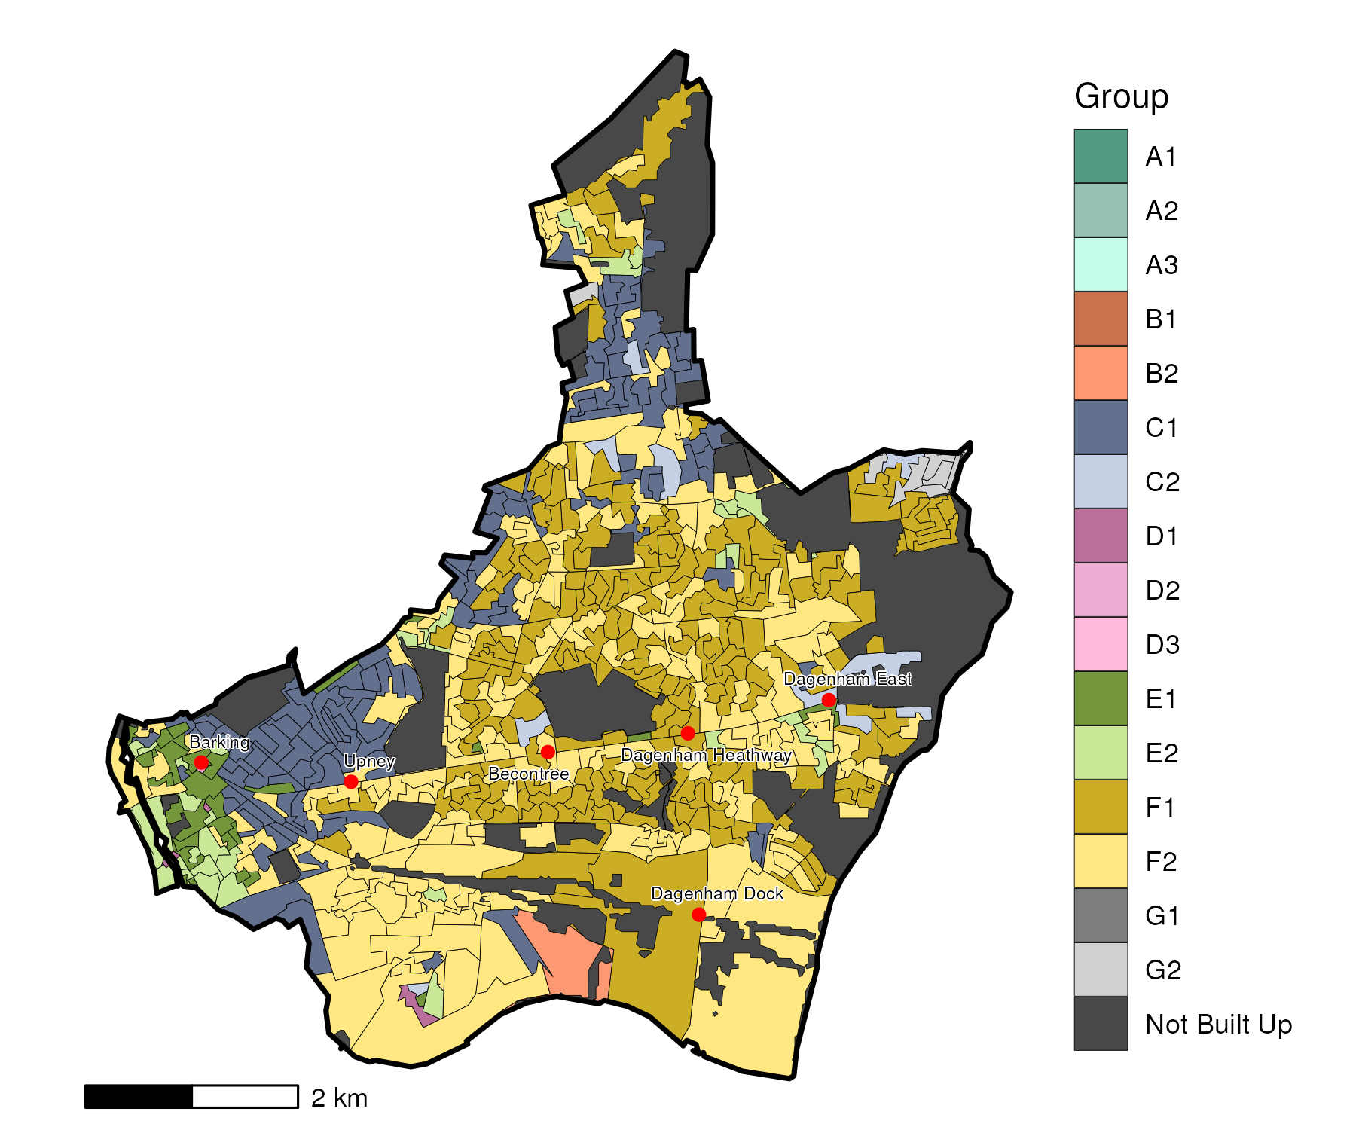

## Index Scores

The distribution of LOAC Groups within Barking and Dagenham relative to the London average can be shown by calculating an index score. If a distribution was the same as the London average the score would be 100. A score of 200 represents double the London average, and 50 a half. Scores that are less than 80 and greater than 120 are typically indicators of an interesting pattern to interpret, and are the thresholds used to describe the LOAC Super Groups and Groups. Where LOAC Groups are not present within a borough, the LOAC Group codes are 'greyed out'.

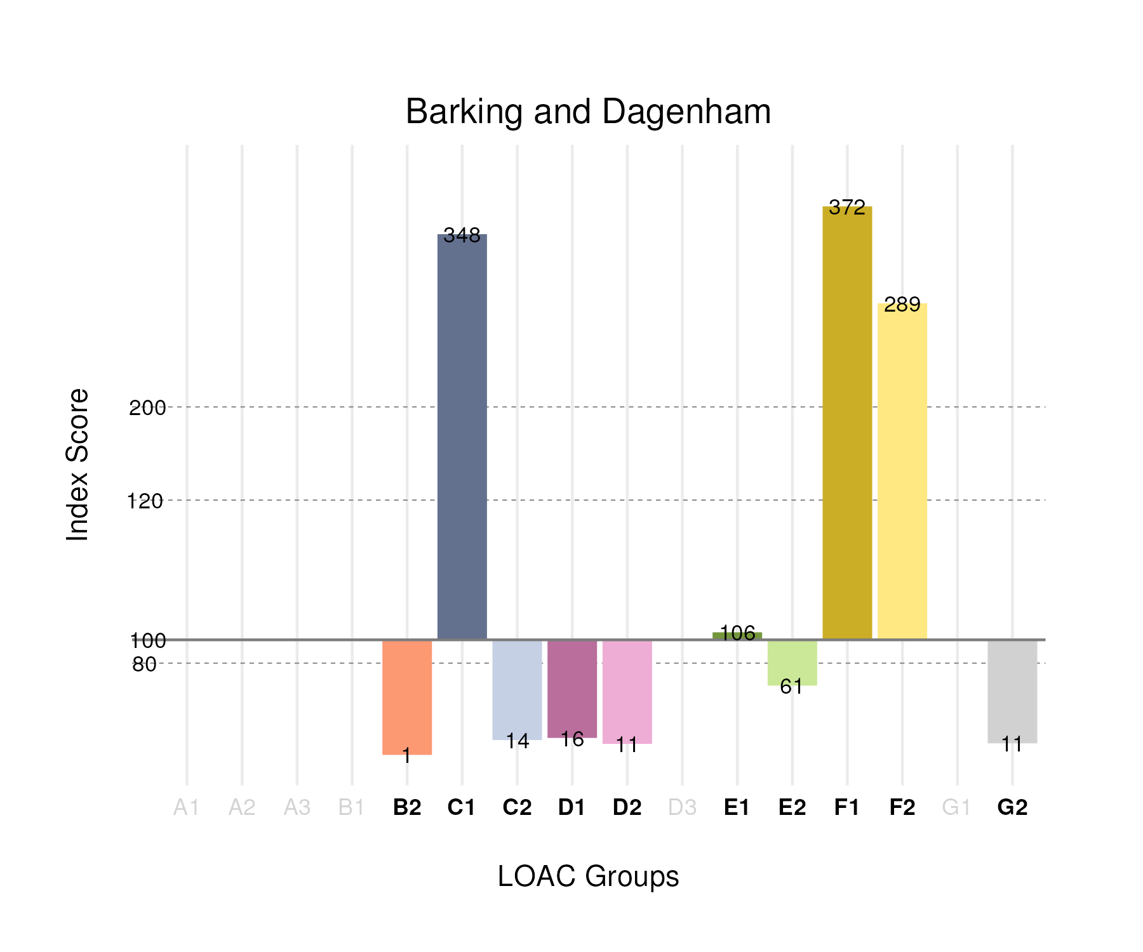

## Population Counts

The distribution of the population by LOAC Groups is shown in the following table.

| Group | Total Population (Census 2021) |
| --- | --- |
| A1 | 0 |
| A2 | 0 |
| A3 | 0 |
| B1 | 0 |
| B2 | 207 |
| C1 | 44,404 |
| C2 | 3,000 |
| D1 | 1,391 |
| D2 | 426 |
| D3 | 0 |
| E1 | 8,518 |
| E2 | 14,404 |
| F1 | 71,670 |
| F2 | 72,819 |
| G1 | 0 |
| G2 | 1,977 |

# City of London

## Spatial Distribution

The following map shows the spatial distribution of LOAC Groups across the London borough of City of London.

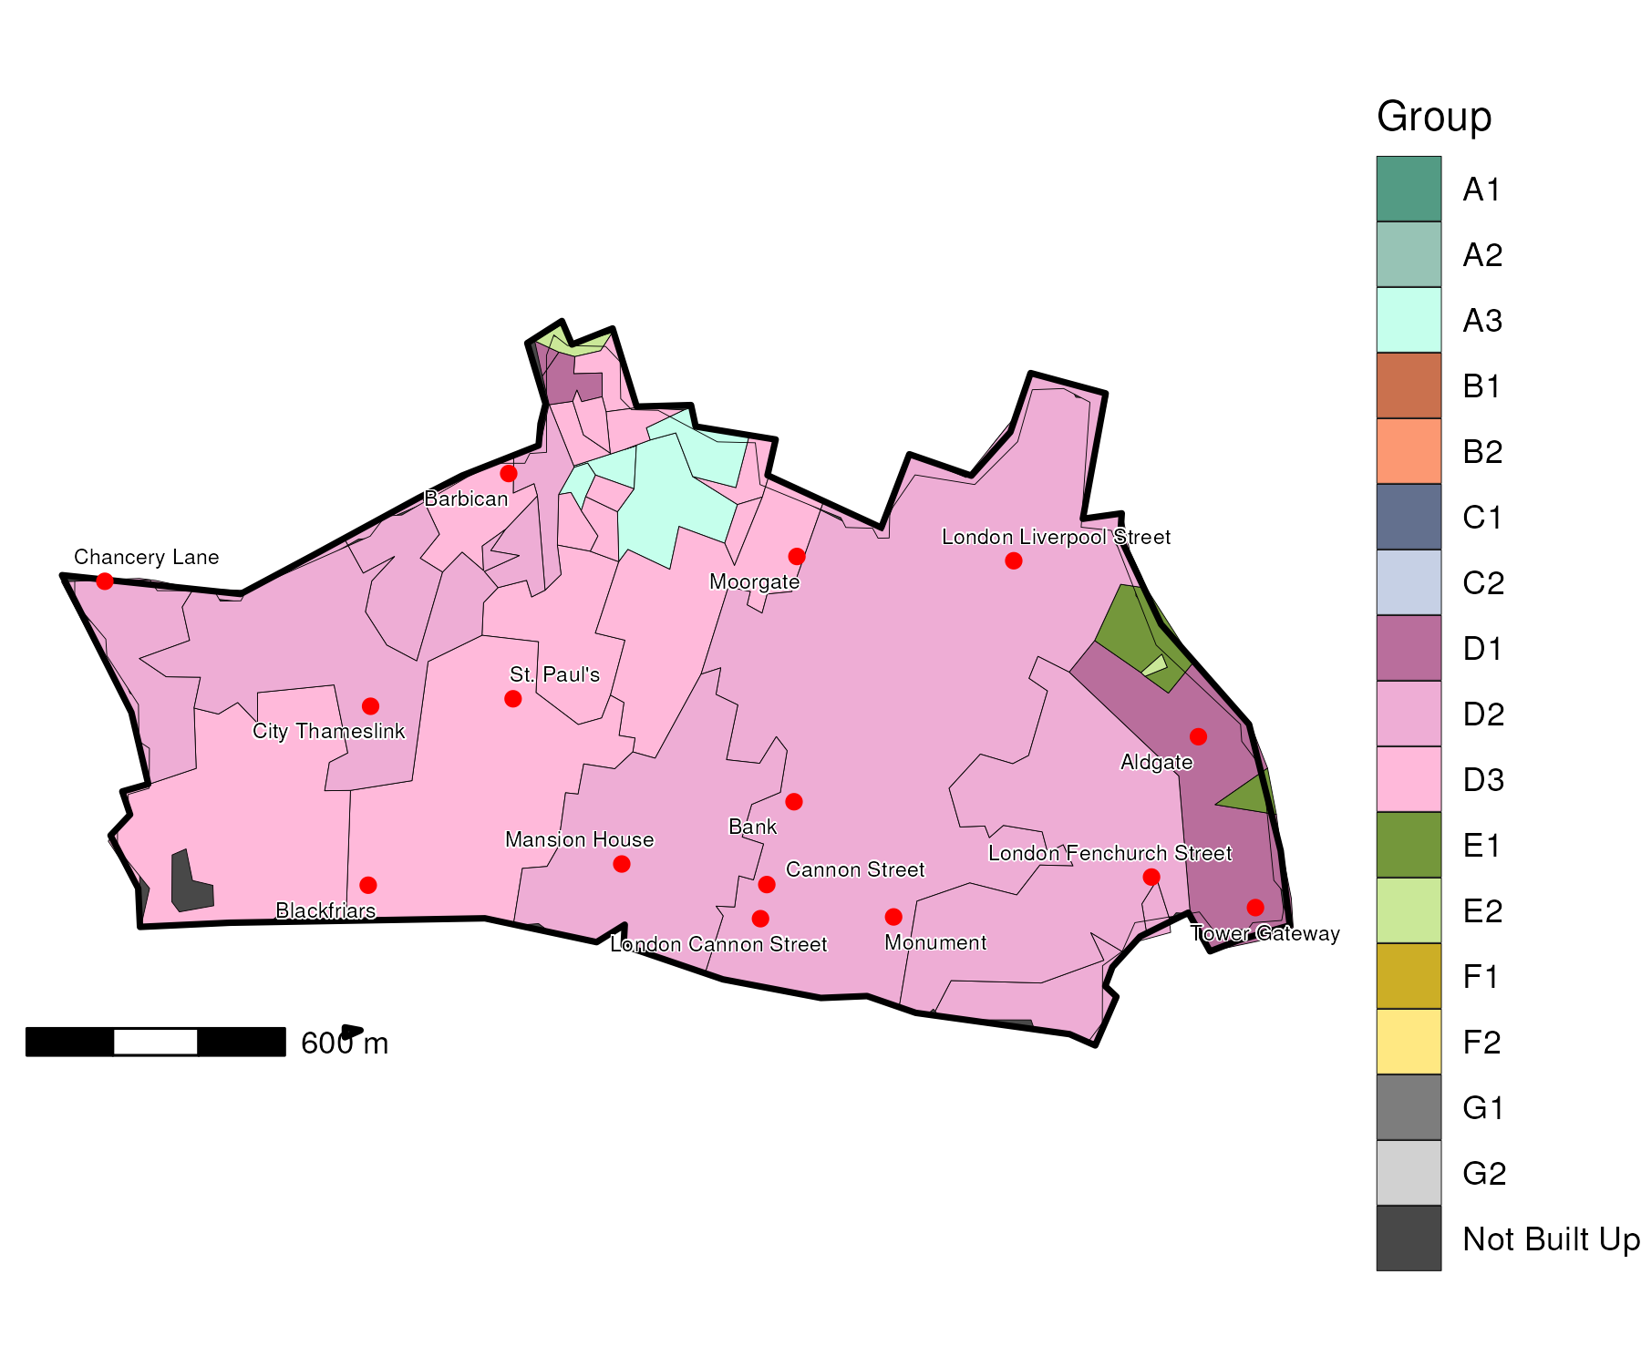

## Index Scores

The distribution of LOAC Groups within City of London relative to the London average can be shown by calculating an index score. If a distribution was the same as the London average the score would be 100. A score of 200 represents double the London average, and 50 a half. Scores that are less than 80 and greater than 120 are typically indicators of an interesting pattern to interpret, and are the thresholds used to describe the LOAC Super Groups and Groups. Where LOAC Groups are not present within a borough, the LOAC Group codes are 'greyed out'.

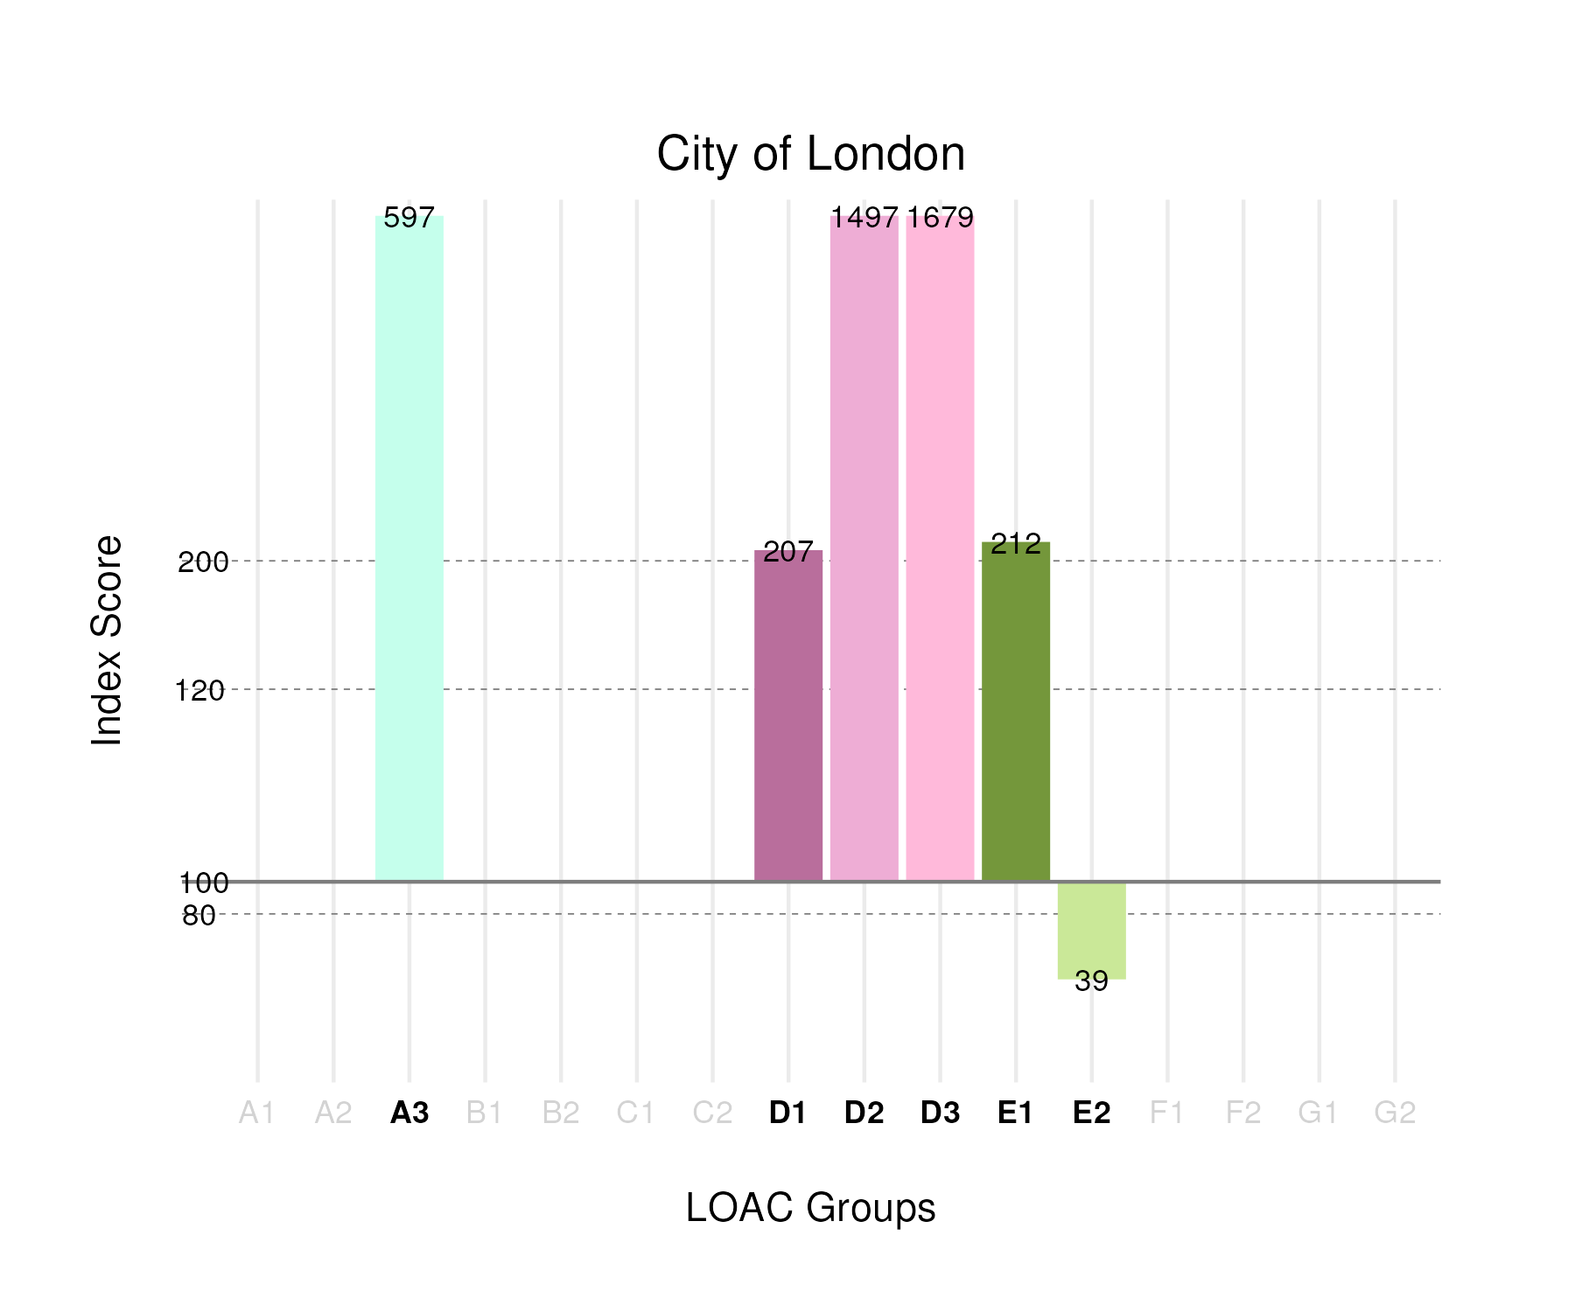

## Population Counts

The distribution of the population by LOAC Groups is shown in the following table.

| Group | Total Population (Census 2021) |
| --- | --- |
| A1 | 0 |
| A2 | 0 |
| A3 | 900 |
| B1 | 0 |
| B2 | 0 |
| C1 | 0 |
| C2 | 0 |
| D1 | 715 |
| D2 | 2,358 |
| D3 | 3,583 |
| E1 | 665 |
| E2 | 365 |
| F1 | 0 |
| F2 | 0 |
| G1 | 0 |
| G2 | 0 |